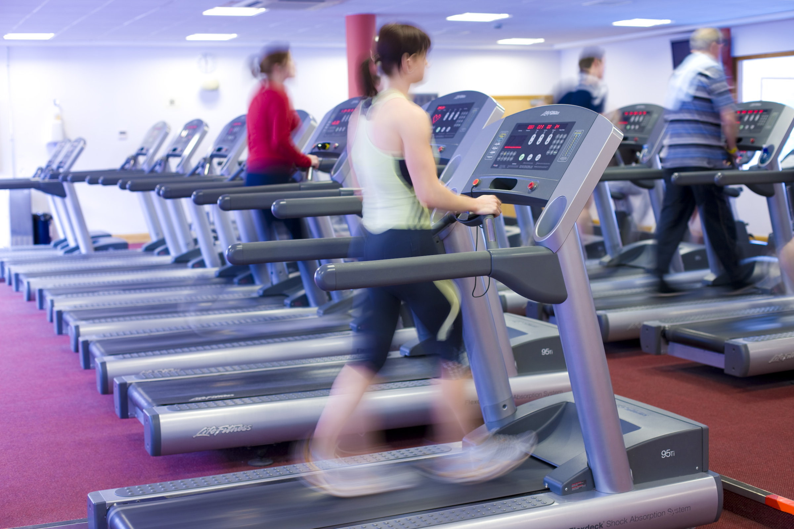



**MedEx**

**now available in**

**Loughlinstown Leisure Centre**

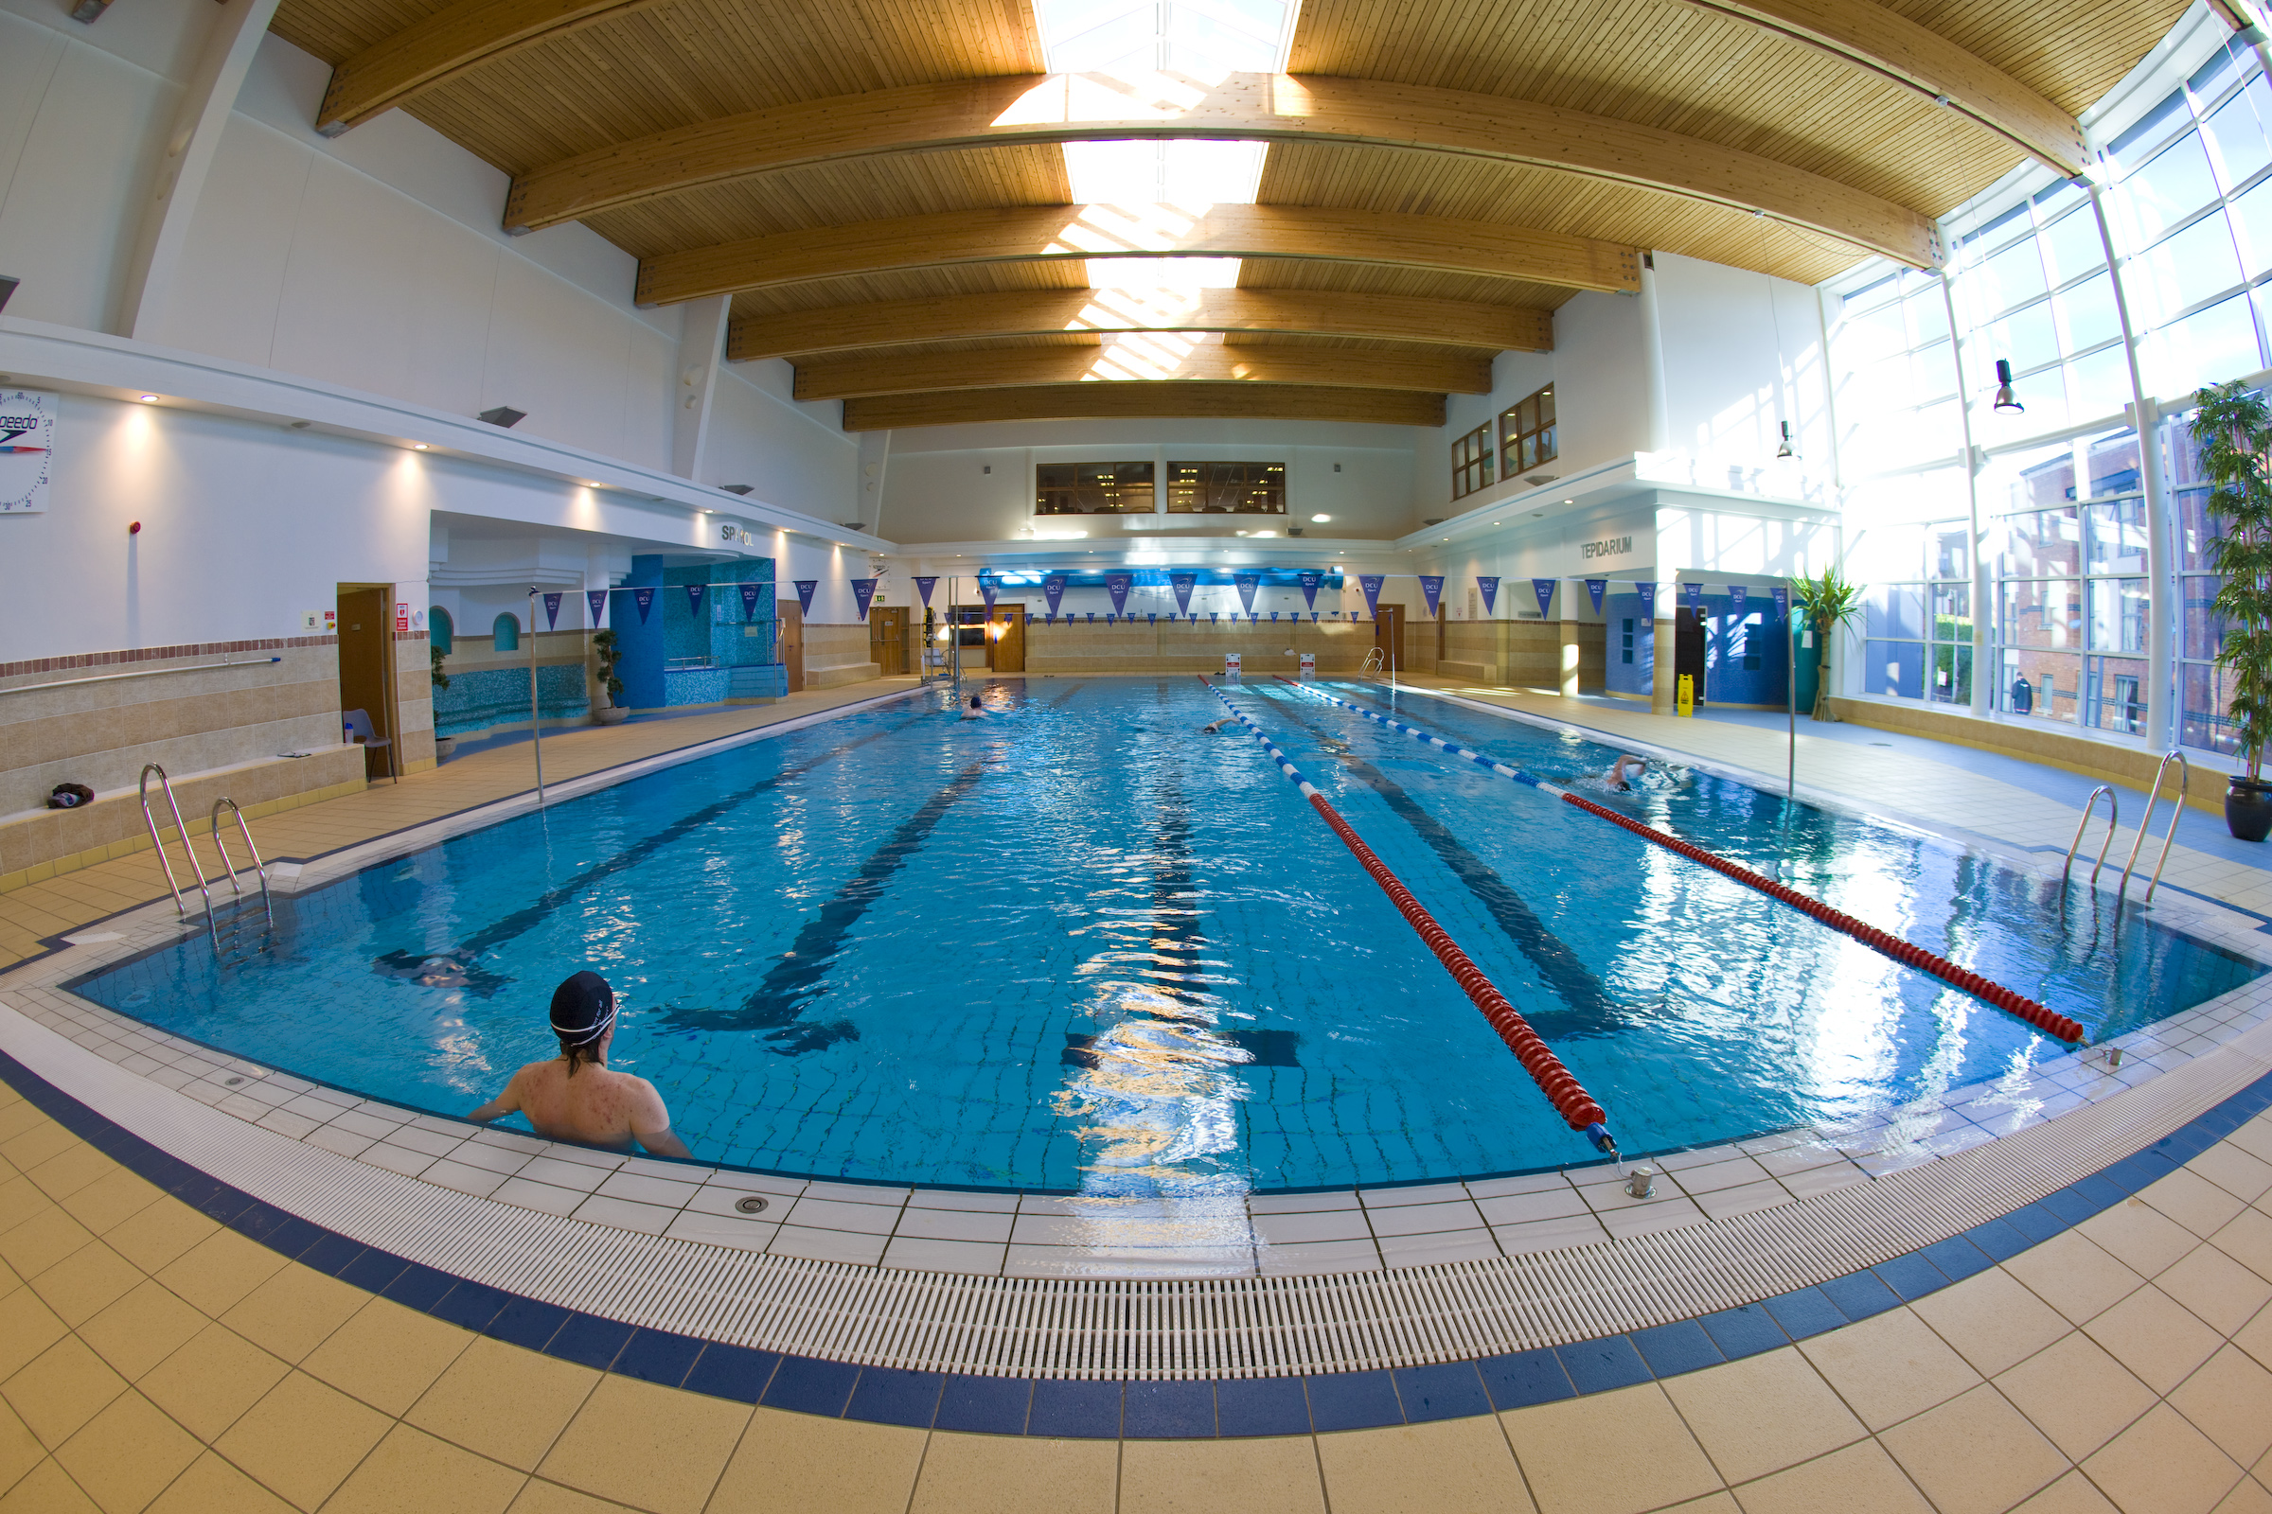

**DO YOU HAVE A LONG TERM (CHRONIC) ILLNESS?**

Much of the ‘unwellness’ and poor quality of life experienced by people with many different chronic illnesses is caused by becoming ‘deconditioned’ (or unfit), which itself is due to becoming progressively less physically active. This inactivity is harmful to your health and fortunately it can be reversed

**WHAT IS MEDEX?**

The MedEx programme offers supervised group exercise classes to people with many different illnesses. It is great fun, takes place in a friendly and safe environment and is run by trained staff. It doesn’t matter what your current level of fitness or activity is, or what illness you have. MedEx will help you to become more active. This will improve how you feel and how you function, both mentally and physically

Medical Director: Dr Noel McCaffrey

 For Information ring: 01 2823344 or speak with a member of your medical team

Participants will attend for

* **baseline (and repeat) assessments** of fitness / wellness
* **supervised and enjoyable exercise classes** **(**twice weekly) in a casual and really friendly atmosphere in a first class gym facility
* **educational seminars** on topics such as
  + - healthy eating
    - goal setting and behaviour change
    - dealing with common aches and pains

Reports will be sent regularly to your GP and hospital consultant



Loughlinstown Leisure Centre has excellent facilities and a staff with the experience, enthusiasm and expertise to assist people with various illnesses to take part in regular exercise, to become fitter and healthier and to enjoy an active life

|  |  |
| --- | --- |
|  |  |

**Cost**

**Class Cost: Medical Card Holder €7 / no Medical Card €8**

**Induction Session: €10**

**Retest session (after 3 months) €10**

Medical Director: Dr Noel McCaffrey