These guidelines have been set out to accompany the PHN Training Database workbook. This workbook contains the following worksheets:
- Mandatory (please note mandatory training is training that the staff must have to physically be on duty – not to be confused with recommended).
- Results
- Adult
- Child Health
- Child Health E-Learning
- Immunisation
- Corporate
- QS&R
- Management

Setting up the Training database:
When you open up the training database it will look like this:
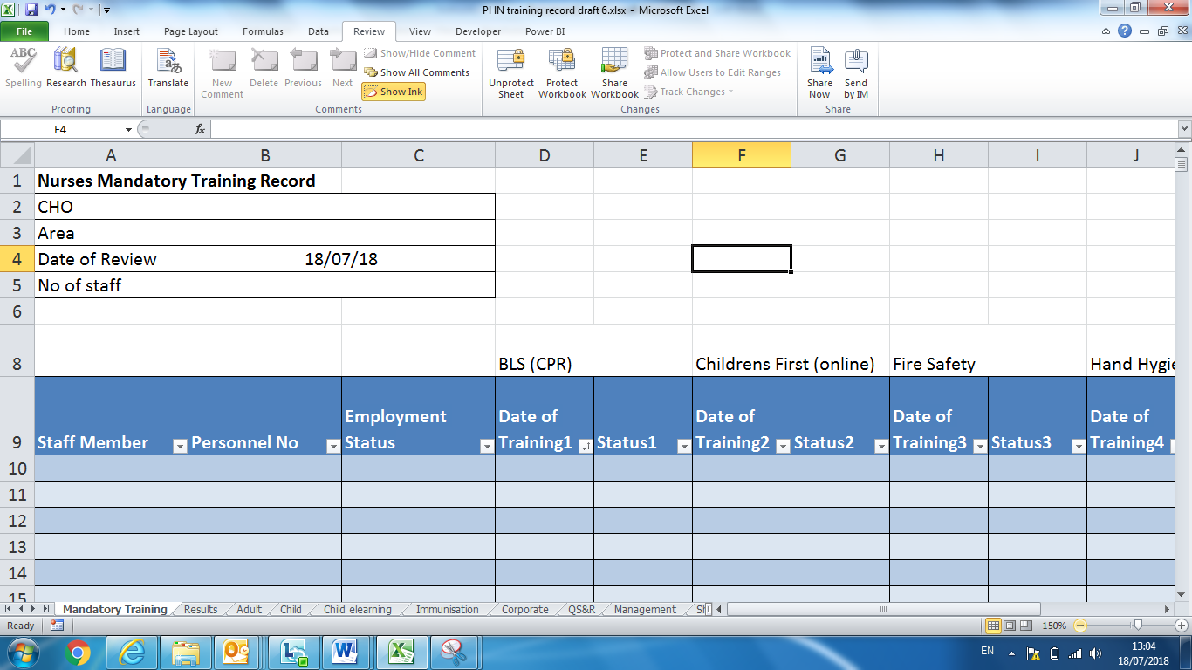
There is a tab for each of the different types of training: Mandatory, Adult, Child etc.

Click on the Mandatory Training Tab.
Fill in the following in the space provided:
- CHO Name
- Area Name
- No of staff (this will be the total number of staff on payroll in the year – it should include staff on leave and staff who retire/ resign during that year

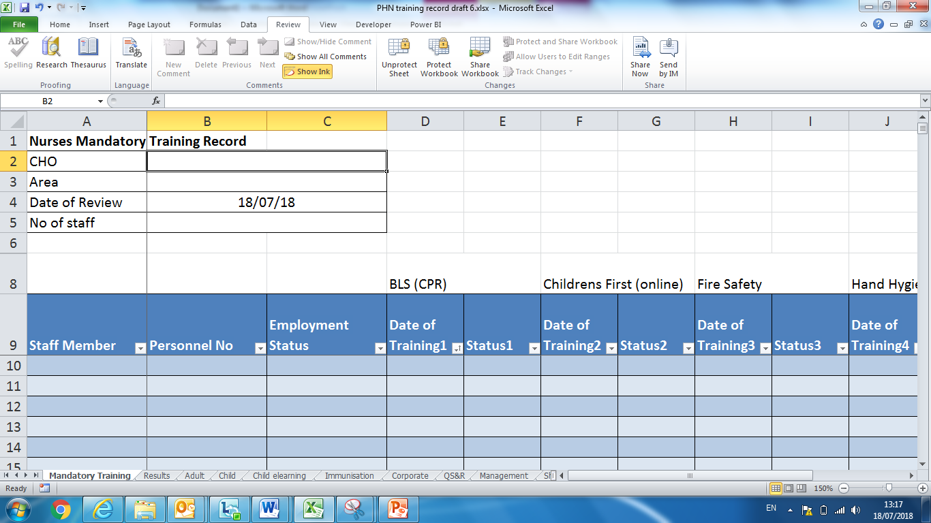
Fill in the staff names in column A under Staff Member
Click here and fill in the CHO name
Click here and type in the Area
Click here and type in the number of staff
Fill in the personnel number in column B under Personnel Number

- Fill in the staff names under the staff member column (column A)
- Fill in the personnel number under the personnel number column (column B)
- Under Employment status column (Column C) fill in the staff members status, there is a dropdown box with the following options:
- Currently working
- Long-term sick leave
- Maternity Leave
- Parental Leave
- Career Break
- Shorter Working Year
- Retired
- Resigned
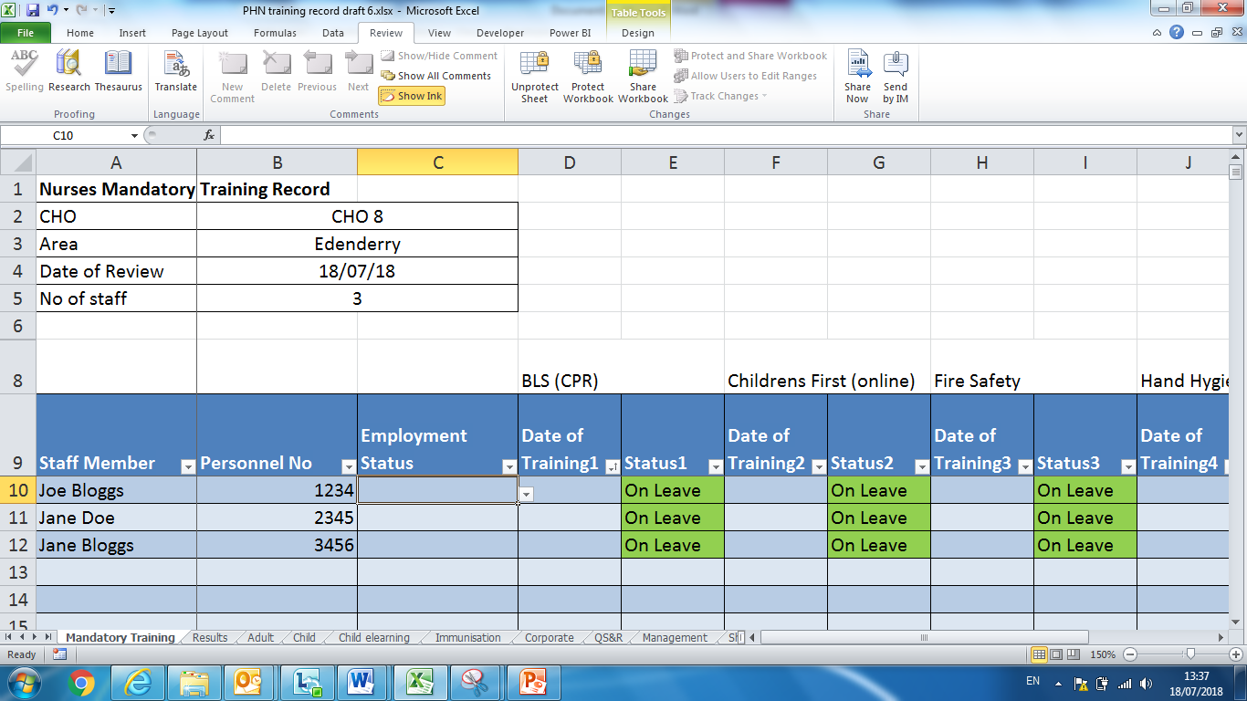
When you click in the cell for employment status a dropdown box will appear on the right hand side of the cell

When you click on the drop down box this is how it will appear. Select the option you want.
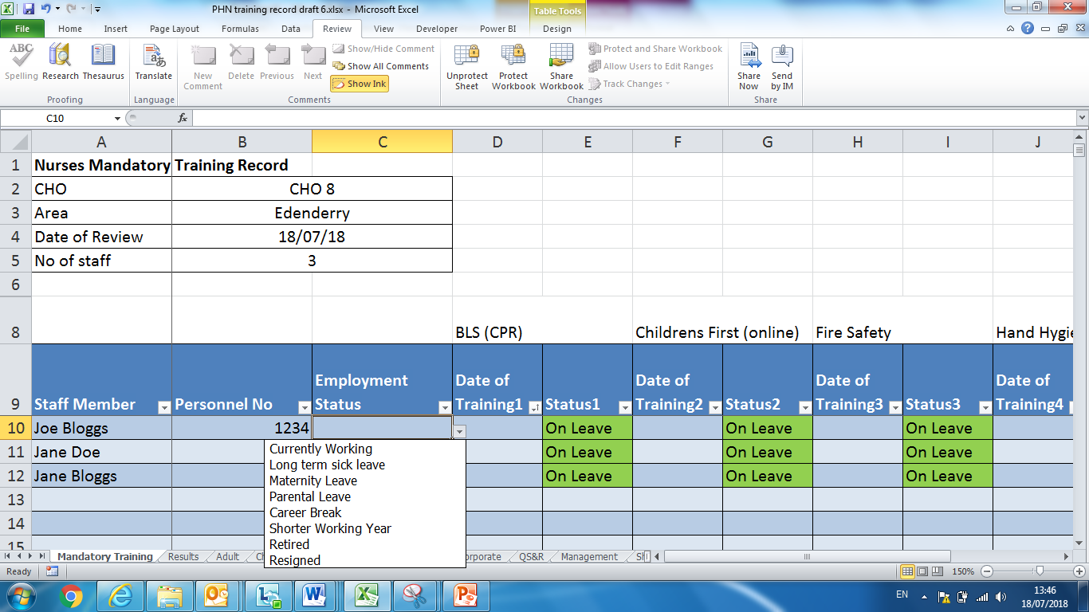
If currently working is not entered the status will automatically appear as ‘On Leave’. If ‘Currently working’ is entered the status of the training will be calculated. The date of the last training must be entered for each of the training or left blank is training has not taken place.
Then enter the dates when each of the training had occurred or leave blank if the staff member has not completed the training.
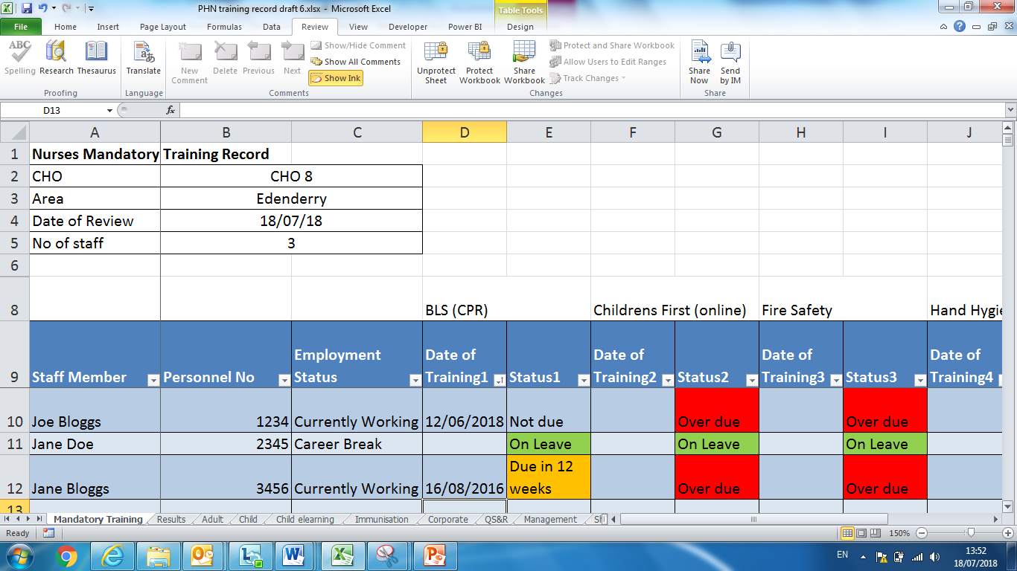
When you enter the date the status of the training will be worked out

Today’s date automatically appears in Date of Review. Each time the database is opened the status will update according to the date of training.

Filtering data:
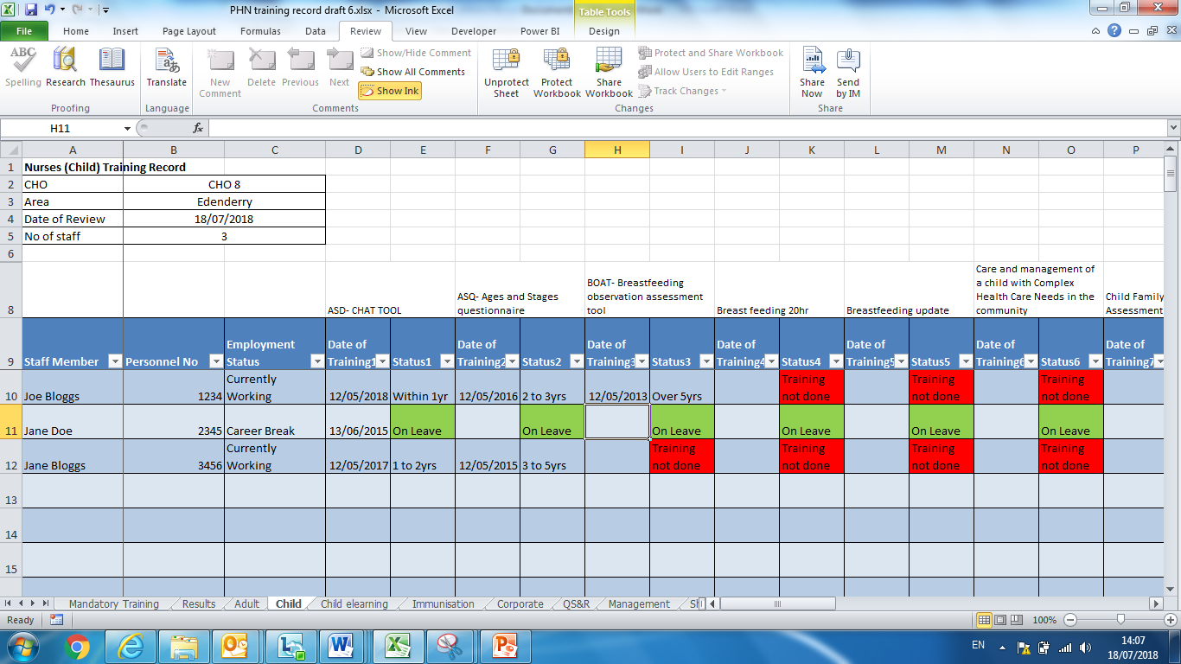
There is a tab at the bottom for the different types of training. The in the headings ‘Staff Member’. ‘Employment Status’, Status’ etc. and this allows you filter after you have entered data
These buttons in the headings allow you to filter the data
These buttons in the headings allow you to filter the data

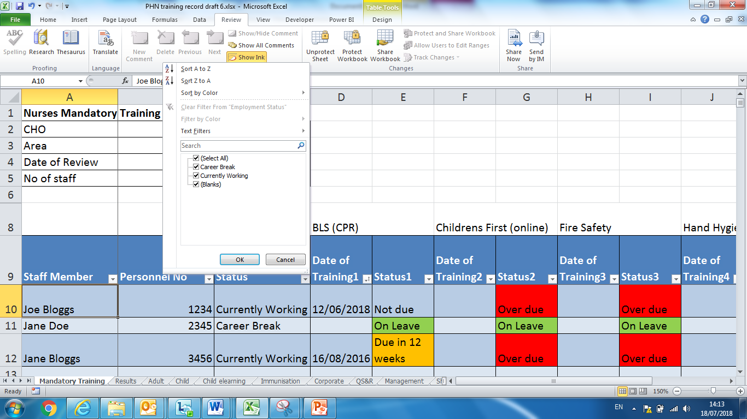
For Mandatory training the status can be: On Leave, Not due, Due in 12 weeks, Overdue
When you click on the filter button it gives you a list of the entered data. You can then select to only look at staff currently working

There are additional columns available to add other training types in the mandatory tab.
Now you only see the staff currently working. Likewise you can pick a training course and select the people who are over-due training
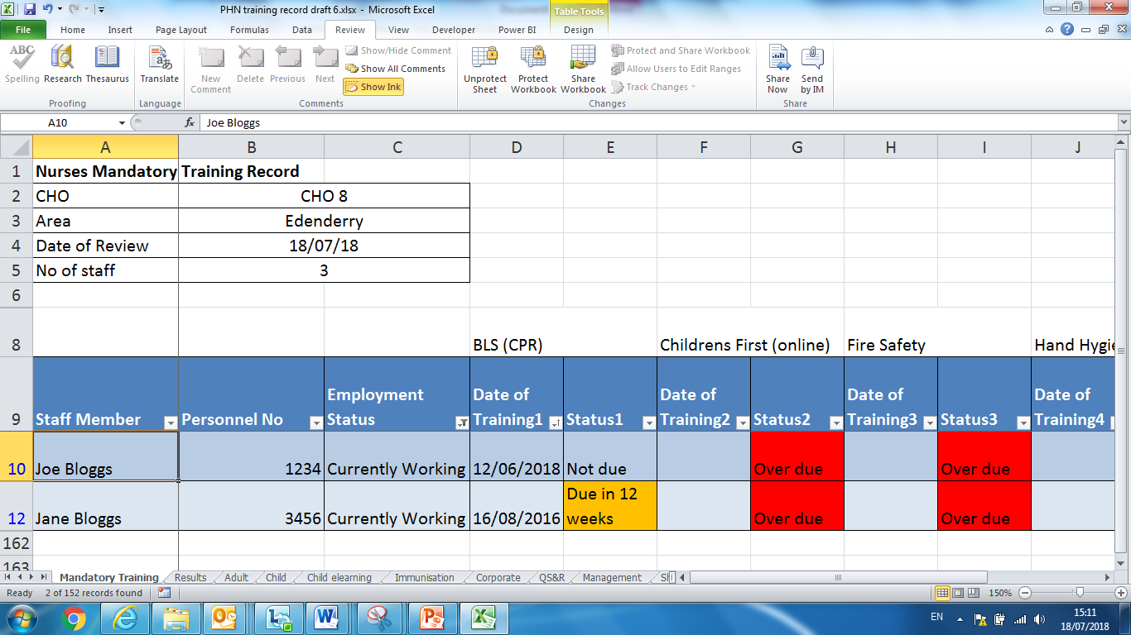
For Adult, Child, Child eLearning, Immunisation, Corporate, QS&R and Management - enter the date of training as above and the status will be recorded as: On leave, Training not done, within 1 yr, 1 to 2 yrs, 2 to 3 yrs, 3 to 5 yrs, Over 5 yrs.

Results tab:
This is the second tab in the workbook and reflects the total number of mandatory training completed by the department. This information is required for the purpose of Quality Patient Safety. All the data is automatically calculated according to the information entered on the Mandatory page and updates each time the page is opened.
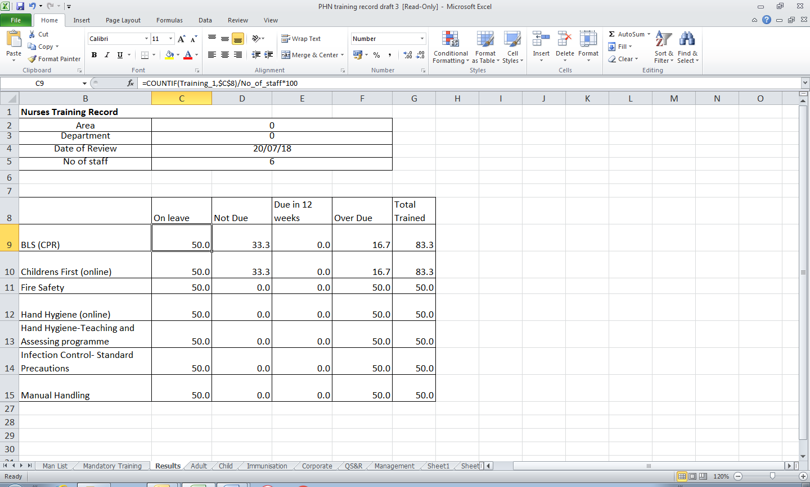
The stats are recorded for each training listed as the percentage on leave, % not due, % due in 12 weeks, % overdue and the total % trained .
Ongoing management of the Training Database:
At the end of the year the training database should be saved as:
CHO X, Area XX Training log 2024 (or the relevant year).
You should create a new database for the following year.
When you start a new year if you want to begin a new spreadsheet you will have to make sure you have the staff who are still employed in your area are still included. Take your existing spreadsheet and copy and paste it and re-name it as PHN training database 2025.
Right click on the PHN training database 2024 and click copy
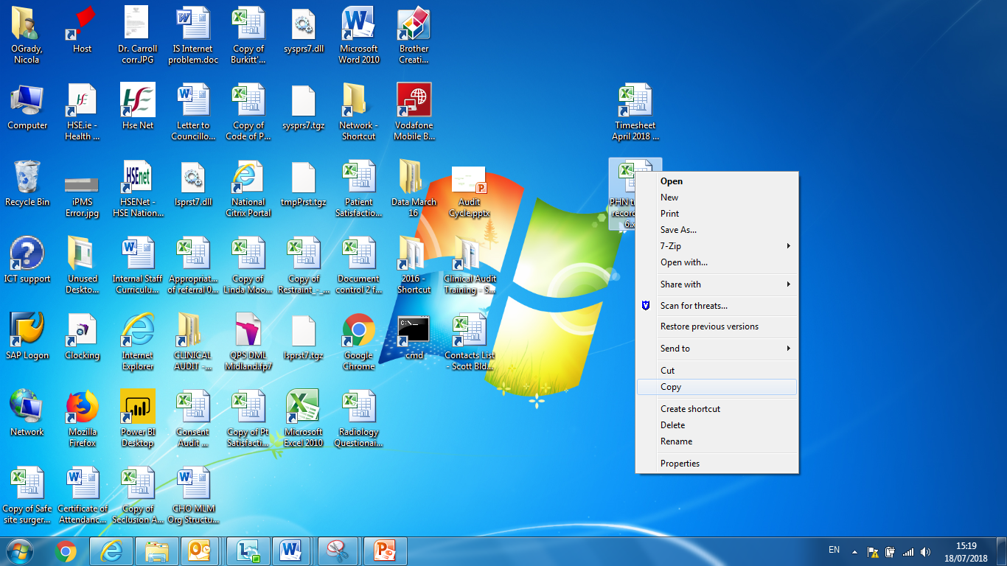
Once the files is copied, then click on paste the new files will appear as PHN training database 2024 – copy.xls
Right click on the new file and click on rename and name the database PHN training database 2025.
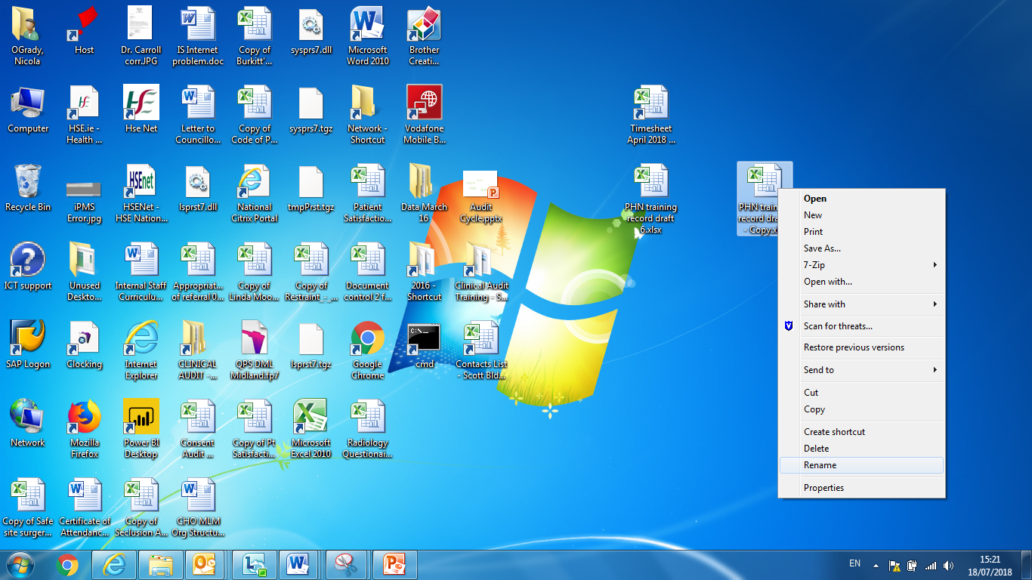
Then rename the spreadsheet as PHN training database 2025. This is an exact copy of the 2024 training database which you can filter to delete the retired and resigned staff members.
You could also open the existing spreadsheet and file save as a new name e.g. PHN training database 2025.
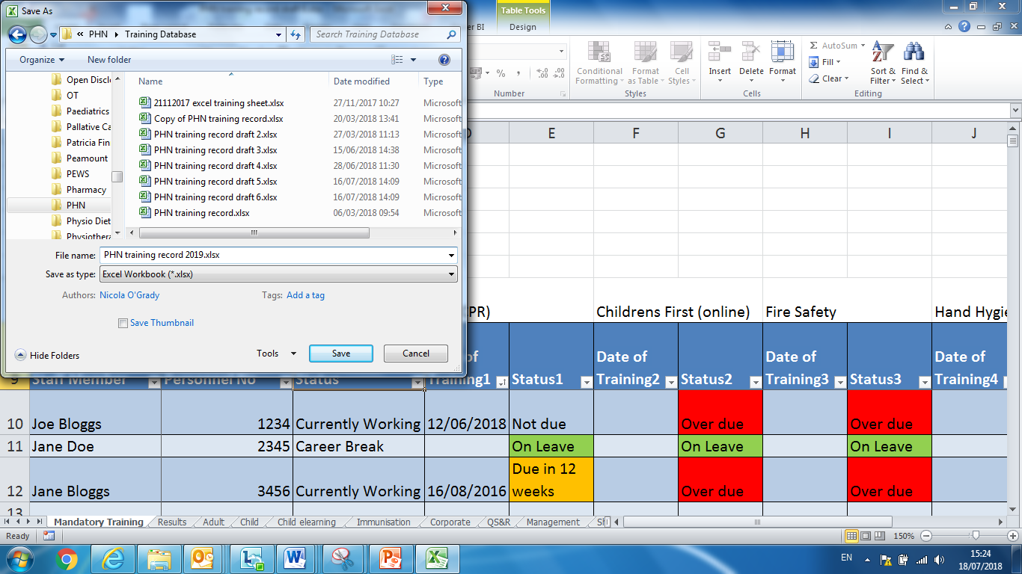

Make sure the 2024 PHN training database has been saved. Open the 2025 training database and then you can sort the data and remove filter staff that have retired or resigned. Go to the column Employment status and filter it by selecting the ‘retire’ and ‘resigned’ staff. This will select all the staff that have resigned or retired.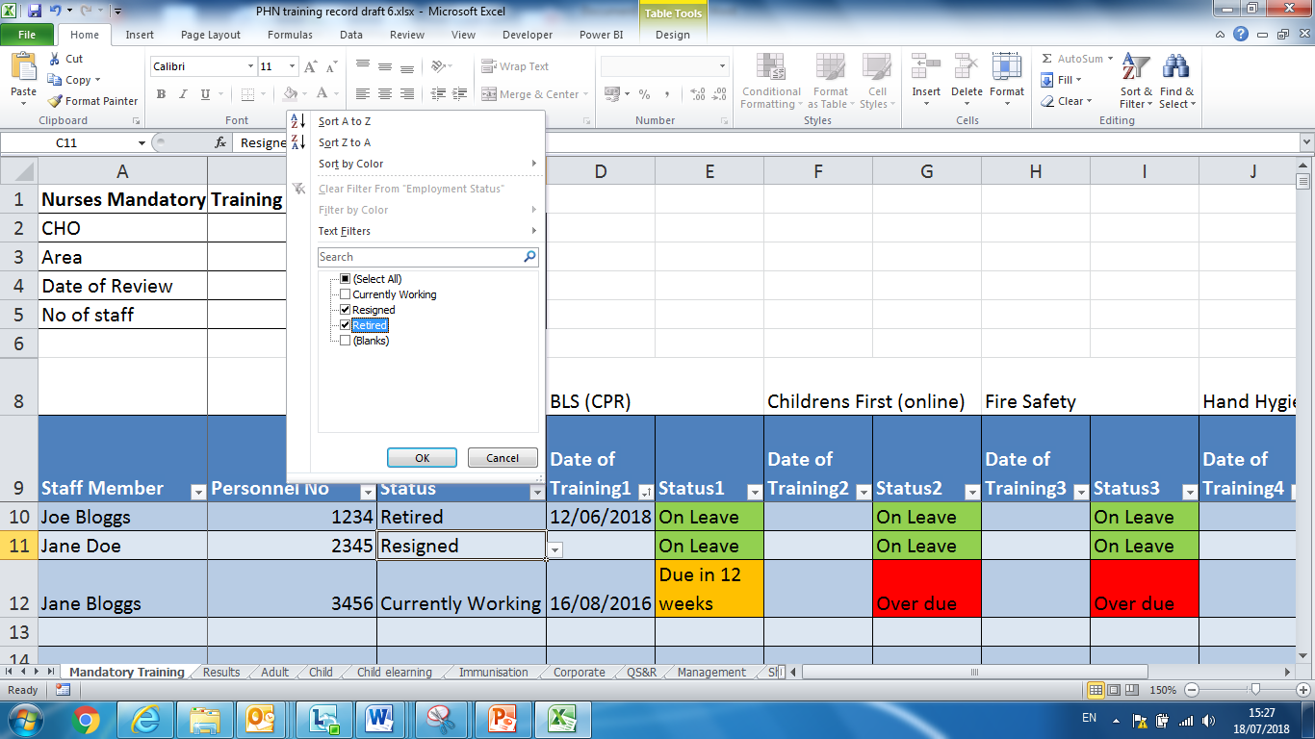
It it will look like this now.
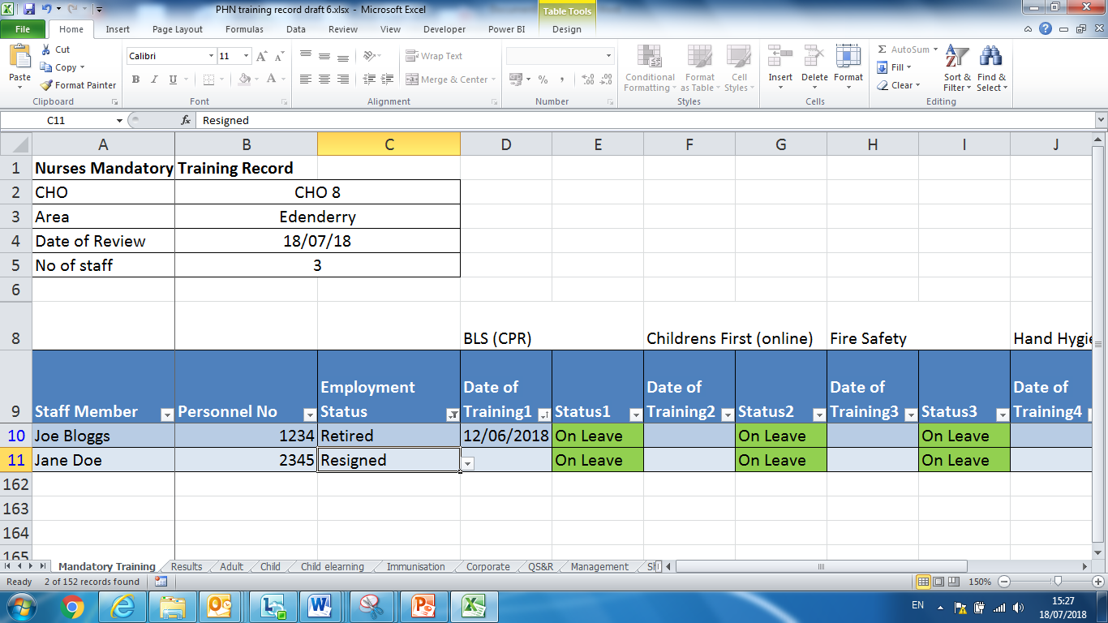 You can then delete the name ,personnel number , employment status and all training dates of anyone who has retired or resigned on the mandatory training sheet. You will have to do the same on the Immunisation and Management tab. They will automatically be removed on the other tabs.

Then go back to the employment column and select all the categories again

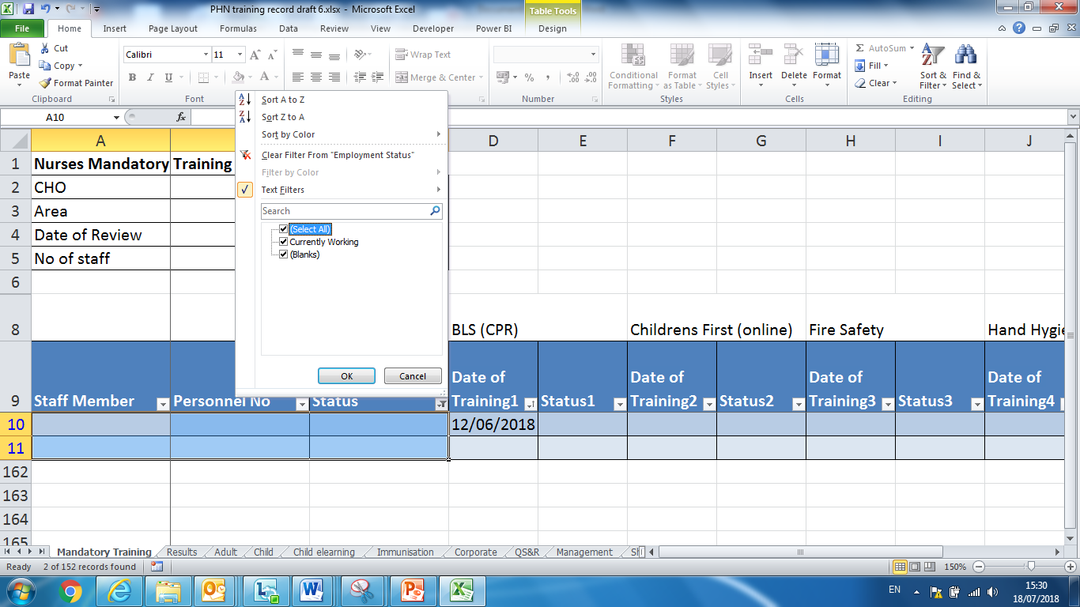
It will look like this:
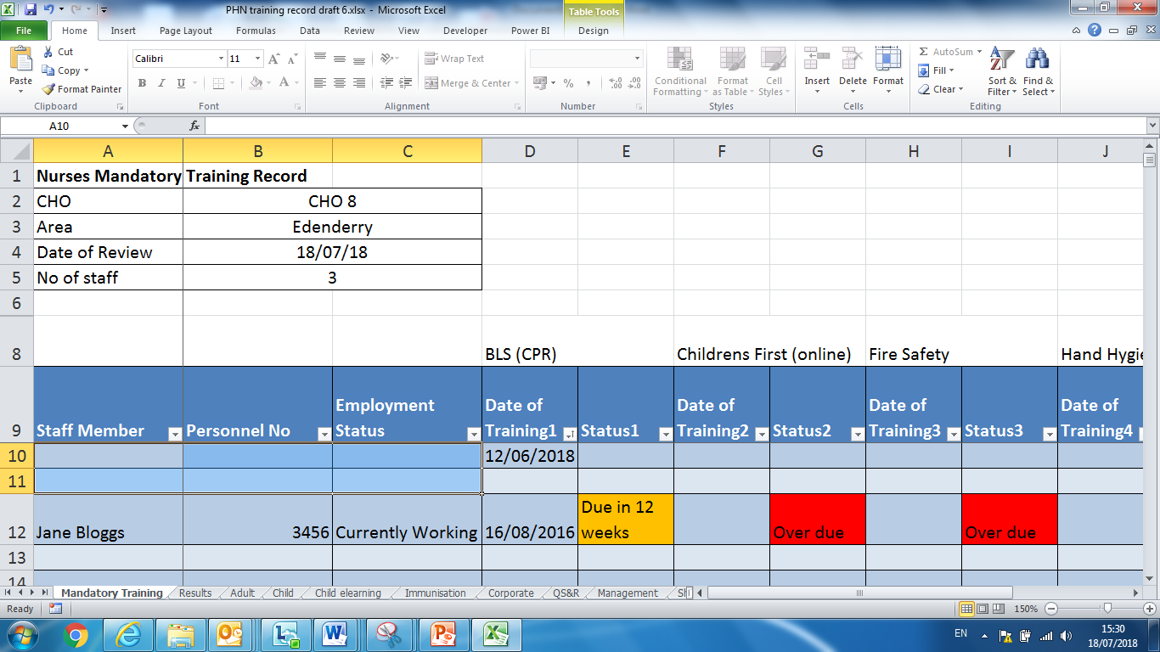
If new staff join enter there name, personnel number and employment status in the blank cells.

(Note all previous training records should be saved in an Archive folder and stored in your shared drive).

