How to Download and Save Digital Referral Form Templates

Follow these steps to:
- Save the new digital referral form template(s)
- Submit a referral to the Central Referral Office in Community Healthcare Organisation Dublin North City and County using the new digital referral forms.

- Download the Referral Form Template:
  - Click here to access the referral form template from the HSE website. Select the correct referral form from the two templates.
  - The referral form template will either open in your web browser or in a PDF Viewer like Adobe Acrobat on your PC/laptop, based on your device settings.

- Saving Forms that Open in a Web Browser:
  - If the referral form template opens in a web browser (like Chrome), click the "Download" button to save the file to your PC or laptop.
  - Depending on your browser, the download button may look like one of the two screenshots below.
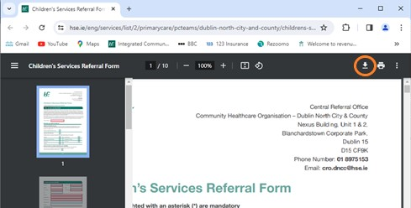
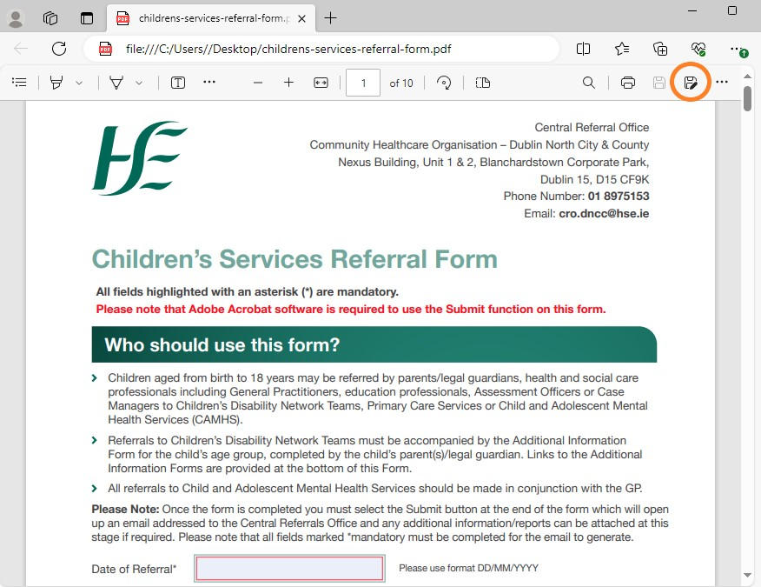

  - When asked to save, choose "Adobe Acrobat Document" from the "Save as Type" drop-down list.

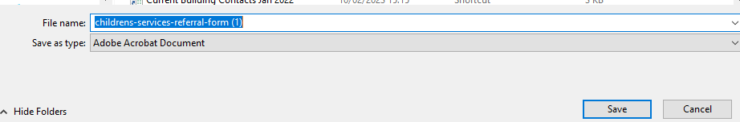

  - Save the referral form template to a folder of your choice or directly to your desktop.
  - Close the web browser and open the referral form template (which has been saved in the folder you chose).

- Saving Forms that Open in Adobe Acrobat or another PDF Viewer:
  - If the referral form template opens in a PDF viewer like Adobe Acrobat, use the "Save As" option from the Menu Tab on the top left to save the referral form template to a preferred folder.

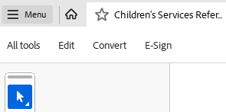

Note:
  - You only need to download the referral form template once and store it as a blank master template for repeated use.
  - Make sure that Adobe Acrobat (or other PDF reader) is installed on your computer for electronic form completion and submission.
  - To submit your referral form, click the Submit button at the end. If it does not attach to an email automatically, you can manually attach it to an email or print it and post to the address below.
    - Emailed referrals are preferred and can be sent to: cro.dncc@hse.ie
    - If the referral must be sent via post, please use the following address:
CHO DNCC Central Referral Office, HSE
Nexus Building, Units 4 & 5, Ground Floor, Block 6A, Blanchardstown Corporate Park 1, Dublin 15, D15 CF9K.
  - Organise your referral form template(s) in a folder structure for easy access. In the example below, the referral form template has been saved to a Masters Documents and Templates Folder:
