

**Routine Visiting Policy**

**St. Luke’s General Hospital**

**Carlow/Kilkenny**

**Visiting times**

are from

**2pm - 4pm**

and

**6.30 – 8.30pm daily**

Visiting is limited to one family member/nominated visitor per patient per visiting time – two visitors daily, one afternoon and one evening

Phoning the hospital to arrange a visit ***is no longer required*** unless specifically advised to in relation to visiting of patients located in a Covid 19 ward or in exceptional circumstances

Dear Patients & Visitors,

We are all too aware that visitors form an important part of your day and enhances the healing process.

During Covid19; strict visiting restrictions were in place for the safety of patients and staff.

However, due to further easing of hospital restrictions we are excited to implement our updated Routine Visitor Policy and welcome visitors back to our wards.



This policy reflects a balance between the needs of our patients, their visitors, hospital staff and hospital procedures.

The purpose of our policy is to prevent and control the spread of infection and to provide a safe, secure and comfortable environment for patients, staff and visitors.

**Visiting** is limited to one family member/nominated visitor per patient per visiting time

If there is a requirement for a **carer** to support a family member visitor, this will need to be agreed with the ward manager/nurse in charge as this may/may not be feasible in some large ward areas

There are **exceptional circumstances** where patients may require greater visitor support during their stay in hospital in terms of end of life, critical care and other exceptional circumstances. Any exceptional visiting arrangements will require the agreement of the ward manager and the family will be advised accordingly.



**Children under 16 years** are not allowed to visit the adult wards unless agreed in advance on strict compassionate grounds with the ward manager/nurse in charge.

We encourage the ongoing use of mobile phones and laptops to keep in touch with loved ones who may not be able to visit.

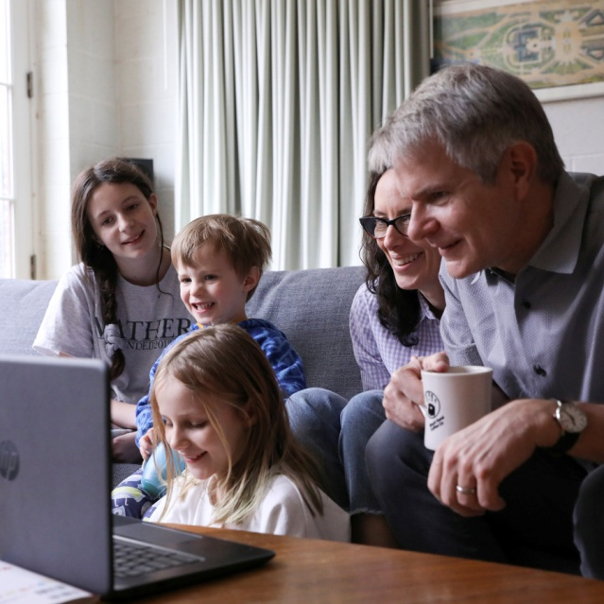

Visitors are requested to keep the **time spent** visiting as short as possible and not to exceed 1 hour duration.

Visitors must **remain at the bedside** of the patient they are visiting and not visit any other patient in the ward area

It is advisable that patients and families speak with the ward manager/nurse in charge if **unsure** or have any queries on the visiting arrangements.

**Infection control** measures are in place and it is mandatory for everyone anyone who visits a patient in the hospital to wear a surgical facemask at all times, to perform hand hygiene on entering the hospital and when leaving the ward you are visiting.

Please **do not** visit the hospital if you have any symptoms of Covid 19 (high temperature, cough, sore throat, shortness of breath, loss or change to your sense of smell/taste or generally feeling unwell).

Visitors may also take an antigen test at home prior to attending the hospital as an added protected measure for the patient they are visiting.

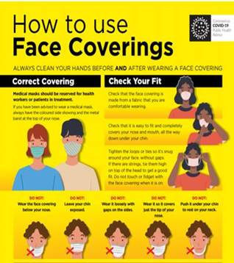

Your visitor **must not remove their mask** on arrival at your bed/room. Other PPE measures will be advised at ward level if needed.

We would ask that visitors **do not** sit or lie on the side of your bed and limit their interactions as much as possible; this includes other patients and all visitors.

**Please consider other patients’ needs for**

**rest and privacy at all times and to visit during visiting times only**



**Routine Visiting Policy | No Outbreak**

* **Visiting times are from 14:00 to 16:00 and from 18:30 to 20:30 daily**
* **Each patient is allowed two designated visitors daily; one afternoon visitor and one evening visitor – Support for visitor must be discussed at ward level prior to visit**
* **Your visitor may change from visit to visit**
* **Visitors must adhere to hand hygiene, social distancing and the wearing of a surgical mask (available on entry). Cloth masks are not permitted**
* **Children under 16 years are not permitted to visit the adult wards unless agreed in advance with the ward manager/nurse in charge.**
* **Any exceptional visiting arrangements will require the agreement of the ward manager and the family will be advised accordingly.**

##### **For end of life care**, there is no upper limit on the frequency or duration of visiting; this however is subject to the ability of the hospital to manage visiting safely.

##### Any staff member can request that visitors **leave** if the length of stay is over the agreed times. Visitors who **do not** adhere to guidance will be asked to leave and may be **declined subsequent** visits if there is a pattern of **non-compliance.**

##### Visitors must accept **responsibility** with respect to the **infection risk** that they may inadvertently be exposed to during the visit. Their safety depends in a large measure on their behaviour during the visit.

##### If needed visitors should be assisted by a staff member on wearing appropriate **PPE** and educated and supervised by a Health Care Worker for the donning and doffing of PPE. **Strict hand hygiene** must be adhered to at all times.

##### Visitors should **not visit if they have vomiting** **and/or diarrhoea or other infections** due to the risk of introducing infection to the patient and to the ward.

##### Visiting maybe **suspended during an Outbreak** of infection but will be reviewed on a case-by-case basis.

##### Visiting may also be **restricted in medical or emergency situations.**

##### **Visitors under the influence of alcohol and/or drugs will not be permitted onto the wards.**

##### Visitors are asked **not to use the toilets** used by patients. Ask a member of staff for directions to the nearest public toilet.

**Maternity & Paediatric Wards |** There are no changes to the current visiting arrangements in the Maternity and Paediatric departments.

The current visiting arrangements will be kept under review and will be updated in relation to any infectious disease outbreak, which may warrant visitor restrictions.

Thank you for your on-going co-operation | Quality Department | 1022 | EL