**HEALTH PASSPORT (HSE)**

**FEBRUARY 2025**



Contents

**About the Health Passport (HSE)** 3

**Who is the Health Passport (HSE) for?** 3

**How to get the Health Passport (HSE) App** 4

**Adding your photograph** 4

**Personal Information** 6

**Communication** 9

**Decision Making** 12

**Medical History** 14

**Food and Drink** 18

**Personal Care** 20

**Critical Information** 23

**E-mail Function** 24

**Edit Section** 25

**Other Functions** 26

**Other Important Information** 27

# **About the Health Passport (HSE)**

* The Health Passport (HSE) has been updated and has a new name in the App and google play store.

* It is now called Health Passport (HSE) in the App Store (for IOS) and Google Play Store (for Android).

* The Health Passport (HSE) helps people communicate important information about themselves with others in a healthcare setting

* The goal is to have a standard passport that healthcare professionals and persons with a disability recognise

* You can download the Health Passport (HSE) onto your phone and put in the most important information about you and your needs.

# **Who is the Health Passport (HSE) for?**

* The Health Passport (HSE) is for people with disabilities, their families and carers, GPs, health and social care professionals in hospitals and designated centres. This includes people with disabilities across all age groups and genders, living independently, at home with parents or other loved ones, and those living in designated centres in the community.

This enhancement has also ensured that the scope of the App will significantly increase to include any patients for whom communication is difficult (e.g. people with dementia, mental health issues, people from other countries who do not have English as their first language).

# **How to get the Health Passport (HSE) App**

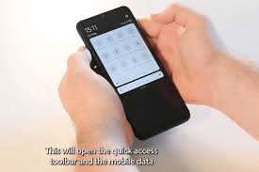

* If this is your first time using a smartphone it can be hard to get used to. This is a link to an easy read guide on Smartphone basics.

[AVISTA SMARTPHONE BASICS GUIDE](https://www.avistaehub.ie/wp-content/uploads/2022/05/Avista-Smartphone-Basics.pdf)

* You can download the App by typing in Health Passport (HSE) into the play store if using an android phone/tablet 

or into App store if you use and iPhone/iPad



# **Adding your photograph**

* The first section of the App is adding your photograph

* To Add your photograph just touch the circle section.

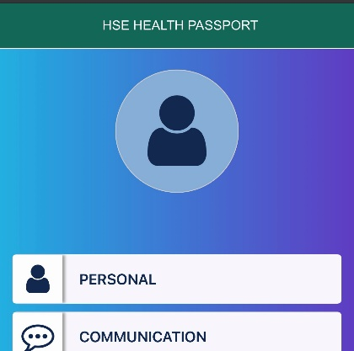

* Then you have the option to choose a photograph you already have on your phone or to take a photograph using your phone.

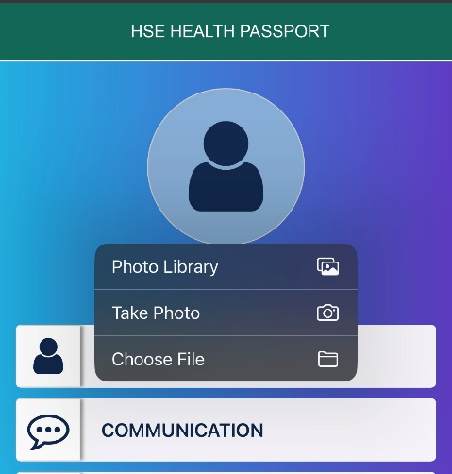

* Once you have either taken or chose a photograph click it and it will appear in your App.

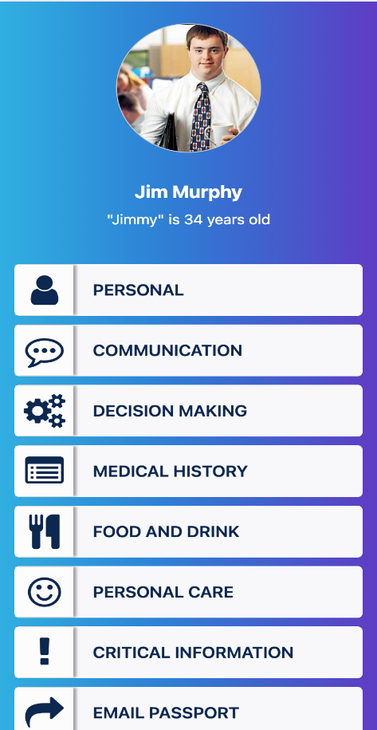

# **Personal Information**

* In this section you will add all your personal information, to tell a person all about you.

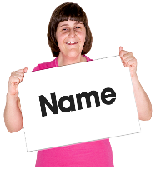

* **Name and what you like to be called.**

For example, my name is Michelle Brown, but I like to be called Shelley.

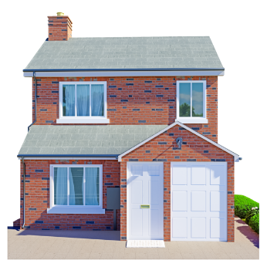

* **Where I Live**

For example: I live in my own home

I live with family

I live in a residential/community/nursing home.



* **Your Birthday**

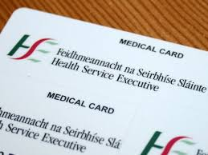

**\* Important information such as PPS and Medical Card Number**

These numbers are both on your medical card

If you need more help to find these, you can contact your local Social Welfare Office

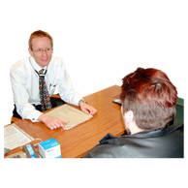

**\* Your Doctor/GP**

Here you put in your GP name and phone number.

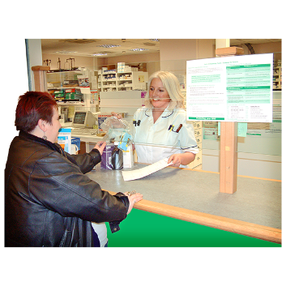

* **Pharmacy:**

Add the name and contact number of your regular pharmacy

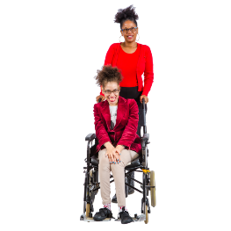

* **Carer/Support Worker** You can add the name of your Care/Support Worker here if that is relevant

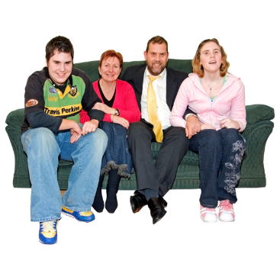

* **Family Information**:

You can add family information here



* **Religion**:

This is up to you if you want to fill it in, you can add your religion here for example Catholic, Islam, Judaism etc

# **Communication**

* Everyone communicates differently, in this section please tell us how you communicate with other people and what helps you understand information that other people are giving you.

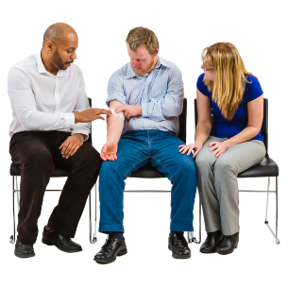

**\*** **How to reassure me when examining or caring for me?**

This section is to let people who don’t know you how to support you best when examining or caring for you.

For example: Speak Clearly and slowly, use my picture book, show me the things you need to use, explain the procedure to be simply. If the information is very important, please write it down for me.

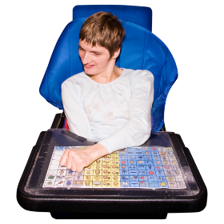

* **Supports I need to communicate?**

This can include picture books, verbal communication, hand signals, Lamh, Social stories etc.

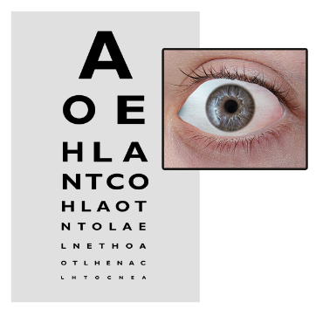

* **My Eyesight**

Do you wear glasses?

Do you have problems with your eyesight?

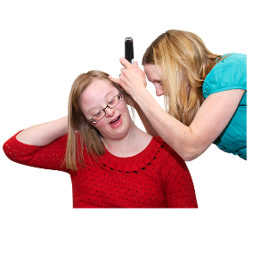

* **My hearing**

Do you have hearing in one or both ears?

Do you use hearing aid? Have you a cochlear implant? Etc

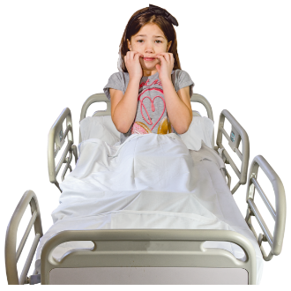

* **What I do if I am worried or afraid**

Pace, shout/scream, self-injure, cry etc.

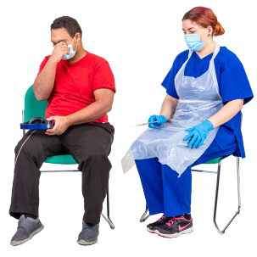

* **How to support me when I am worried or afraid**

Speak quietly/calmly, bring favourite item, TV/radio, offer food or drink, reassurance, review my Behaviour Support Plan.

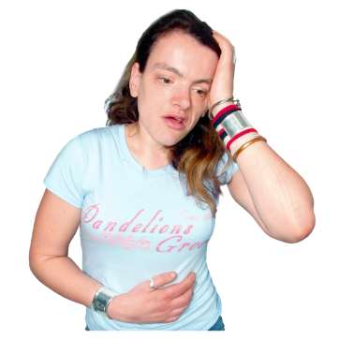

* **Things I do if I am sore or in pain**

Cry, Shout, point to area, I can use my pain scale and point to it 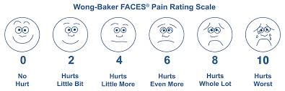

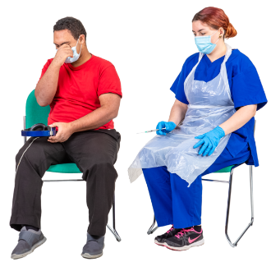

* **Things I do or use to keep me safe**

Fidget toys, stimming, comfort items, ear defenders, Listen to music, Pace up and down.

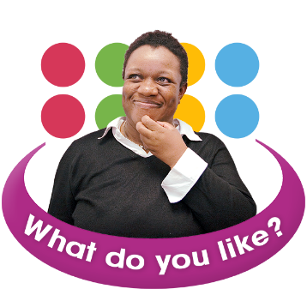

* **Things I like**

Music, sports, tv shows, films, smoking, reading books, dinner with friends, quiet spaces etc.



* **Things I do not like**

White coats, stethoscope, bright lights, hospitals, crowded rooms, noisy rooms, needles, smells etc

# **Decision Making**

A person looking at plan A and Plan B making a decision



* **What supports I need to make decisions**

Refer to communication section here also. You can talk here about things such as easy read guides, write down the information for me.

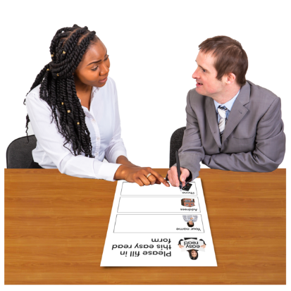

* **People who support my decision Making**

Co-decision maker, family members, advocacy groups

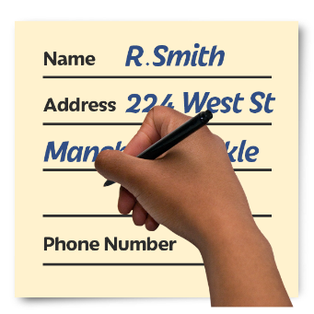

* **Any relevant contact information for decision making support**

Name and contact details of any relevant people to help you with decision making support.



**\* Do you have an Advance healthcare directive**

See link below from Decision Support Service with more information in easy read.

**SOME USEFUL INFORMATION TO ABOUT DECISION MAKING**

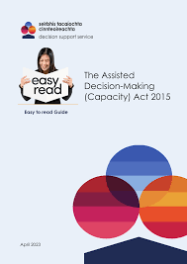

[THE ASSISTED DECISION-MAKING ACT 2015 (EASY READ)](https://decisionsupportservice.ie/sites/default/files/2023-05/DSS%20Easy%20Read%20-%2026%20May%202023.pdf)

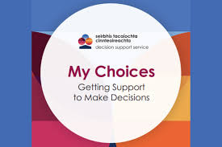

[MY CHOICES GETTING SUPPORTS TO MAKE DECISIONS](https://decisionsupportservice.ie/sites/default/files/2023-04/10919%20MHC%20DSS%20My%20choices%20-%20screen.pdf)

# **Medical History**



* **Other medical Professionals Involved in your care**

Add any other medical person who may support you for example Public Health Nurse, Psychologist, Psychiatrist, Dietician, Speech and Language Therapist, Occupational Therapist, Dentist, day centre, public health nurse, ALONE, Age Action

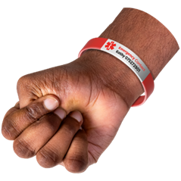

* **Things I’m Allergic to**

It is very important to put accurate information in this section include all allergies, when thinking about allergies think about all things that might make you feel itchy/have a rash/ make you feel sick as well as allergies that might need medical intervention such as EpiPen for Example: Latex, Amoxicillin etc

Also important to note any Drug interactions you might be aware of for example - I take Tegretol so I cannot take Klacid as they interact.



* **Past Medical History**

It is important to list all medical conditions you have now or had before. Record any previous surgery you might have had.

For example: I have Epilepsy, Hypothyroidism, Depression, etc. And in 2015 I had Breast cancer and had full Mastectomy

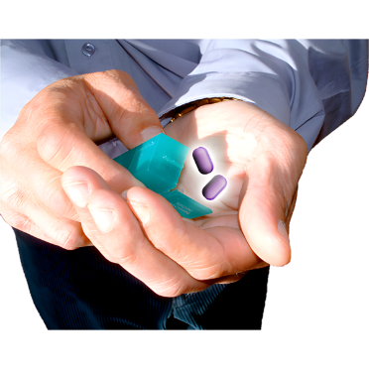

* **Supports I need to take Medication:**

Self-administer, prompts, one tablet at a time into my hand.

* **My Medications**

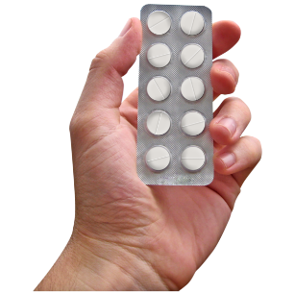

It is important to fill in all medication you take as Hospital Staff may not know what your GP has prescribed for you, and this can help make sure you’re supported to take all correct medication should you need hospital admission.

The sections in the Health Passport (HSE) are:

- Name of the medicine or supplement you take:

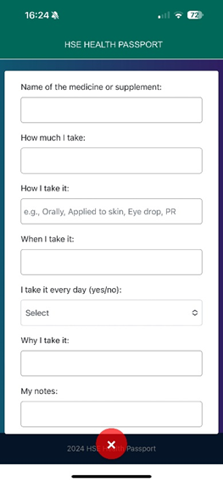For example, Epilim Chrono

- How much you take:

For example, 500mg

-How I Take it:

For example, Orally, Eye Drop etc

-When I take it:

For example, three times a day or you can specify time 8am 2pm 8pm

-Do you take it every day:

You can select answer Yes/No

-Why do you take it:

For example: For my Epilepsy

-Notes: put in any information about your medication

For Example: I take it with water.

It is crushed and taken with a yoghurt.

It needs to be taken before food.

* **Removing a medication from the list**

If you need to remove a medication from the list as you have finished your course or no longer need to take it, go into Medical History section main App screen (not edit section) and click the red x on the specific medicine. Before you delete the medication, you will get a notification to say are you sure you want to delete the medication.

A picture of how the medication looks when it is saved in passport
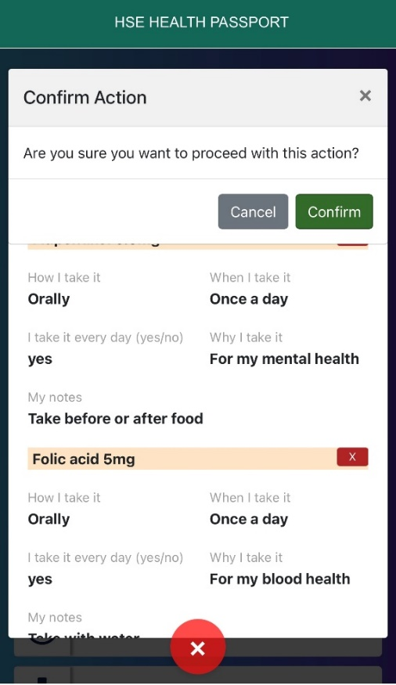

# **Food and Drink**

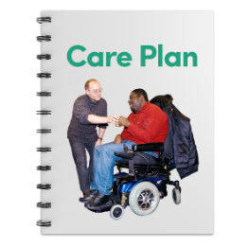

* **Speech and Language Therapy Care Plan**

Yes or no (if yes bring copy of most recent plan & date of last assessment on hospital admission or appointment)

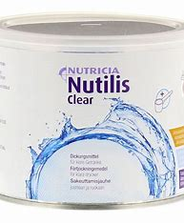

* **Fluid thickened – which thickener**

Yes/no

What Grade 0 to 4

Which thickener do you use (this should also be recorded in medication section)

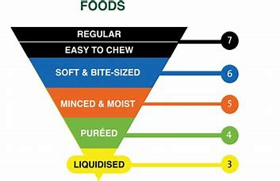

* **Do you have a modified Diet**

Yes or no and be clear which level for example soft bite sized, minced moist and liquidised.



* **Foods I like**

List foods you like to eat.

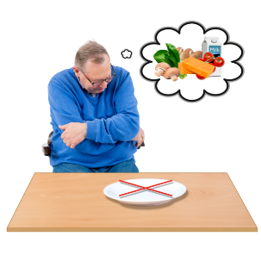

* **Foods I do not like**

List foods you do not like to eat.

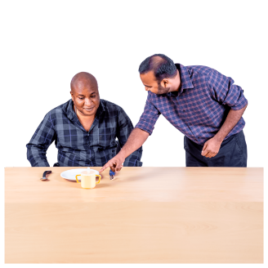

* **Support I need to eat and drink**

I eat independently, I need adapted cutlery, I need prompting to eat slowly, I need someone to support me to eat and drink.

# **Personal Care**

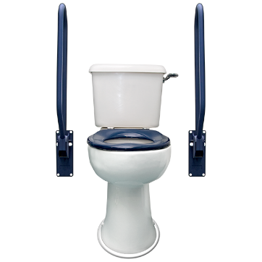

* **Support I need for toileting**

Add any information here to help to support you using the toilet, such walking support, personal hygiene, standing support (handrails etc), prompt to wash hands, need a call bell.

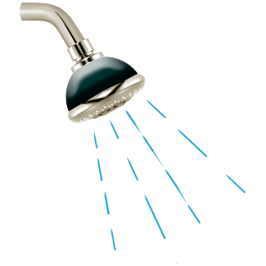

* **Support I need for Showering**/**Bath**

Supports needed in this area could include help with washing hair, help to dry back etc. You can also include time of day if you prefer example I like to shower in the morning before breakfast and medication.

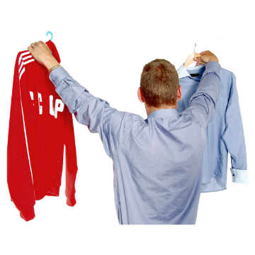

* **Support I need when dressing**

Here you can tell people if you need any help getting dressed or undressed. For example, I need help with my socks and tying my shirt buttons but can do the rest on my own

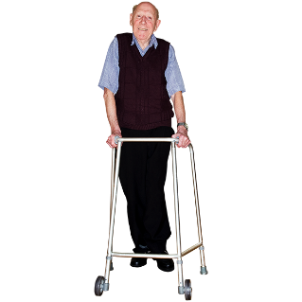

* **Support I need when Moving**

Include any mobility supports you use for example Walking Frame, Hoist, Wheelchair, walking stick.

You could also mention in this section any equipment such as Occupational Therapy recommended seating, cushioning, repositioning recommendations.

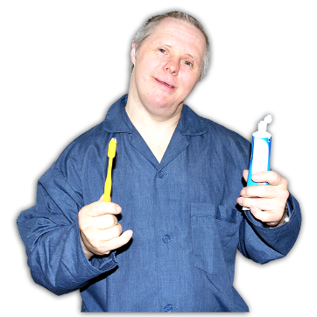

* **Support I need with my oral care**

You can include the type of toothbrush used such as electric or soft brush. Toothpaste used such as high fluoride, any mouth wash etc. You may need support around oral care such as prompting to brush teeth and encouraging oral care, and if you require any assistance you need to brush your teeth.

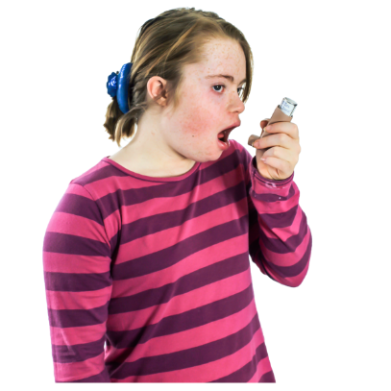

* **Support I need for breathing**

This section may include Nebulisers, C-Pap machine etc and positioning recommendations such as head of bed raised etc

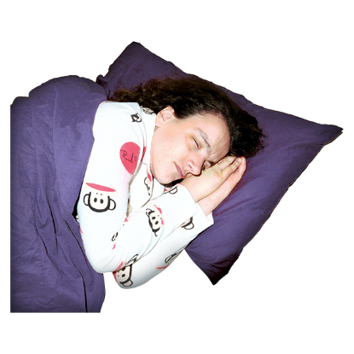

* **Support I need for sleeping**

List what helps you get a restful sleep, this can include positioning in bed (e.g. I lie on my left side), positioning of the bed (e.g. I like one side of my bed against the wall). Comfort needs such as night light, sound machines, comfort toys/blankets. Any medication/supplements you might need.

# **Critical Information**

**Critical Information About me**



Here you are free to type all information that is critical/very important to know about you and how best to support you when receiving care.

For example, If I am having an Xray I am frightened of all the big machines I need my support staff to stay with me.

I need to wear my headphones and listen to my music when you are taking my bloods to distract me.



# **A computer with a envelope on the screen saying emailE-mail Function**

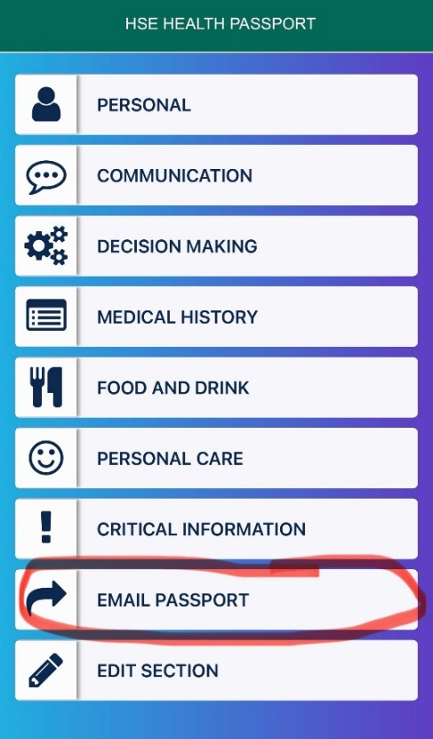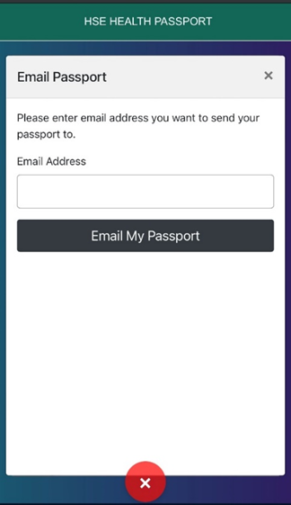

The email function on the Health Passport (HSE) App, allows you to send information to another person who is supporting you. You Click email tab on the App and select email. Enter the email address of the person you would like to share the information with.

This can be used for different appointments for example if you don’t want to bring your phone/tablet to the appointment you can email the passport ahead of time. If the healthcare professional has your passport before the appointment, they can review your passport and arrange supports for you. For example, turning down the lights, making sure there is a hoist, etc

# **Edit Section**

The “Edit section” this is the area where you go to type in or update your information in the passport it allows you to go to whichever section you want to complete 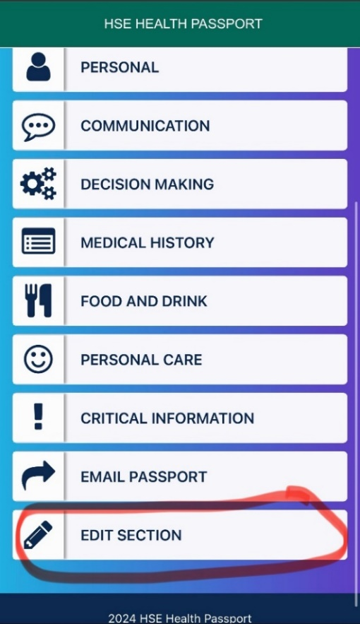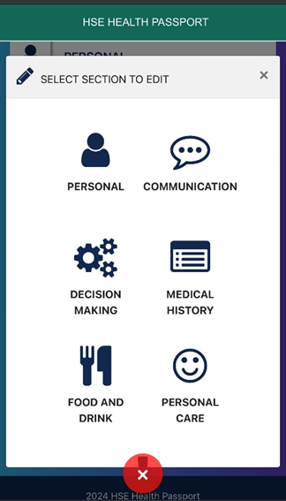

If you need to put in information around my decision-making touch that section.

You can save any information at any time by clicking Save & Exit, you do not have to put in all the information at one time.

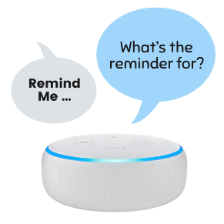

# **Other Functions**

**Reminder Function**

There has been a reminder function added to the Health Passport (HSE) App. This reminder is set to alert you after four months to check and update any information you might need to. If you have no information to change you can just ignore the notification.

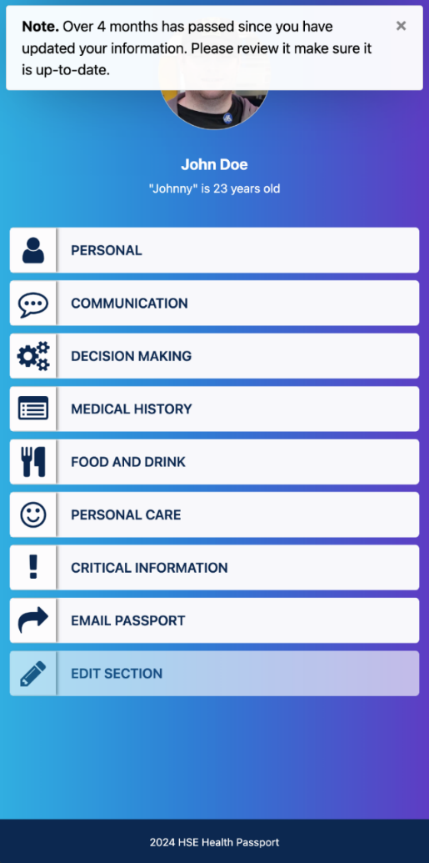

# **Other Important Information**

* It is very important to take care of your phone/ipad/tablet that you have the Health Passport (HSE) on as your personal and private information is saved on it.

* You could have a password on your phone to stop anyone who might find your phone from looking at your information without your consent.

* It is important to keep your phone/ipad/tablet battery charged if you are going to need to use your Health Passport (HSE) to communicate with someone.

* If your battery might empty you can always email the passport ahead of time to make sure your important information is known.

* This is your Health Passport (HSE), and no one should be entering information without your consent.

* If you have any questions about the Health Passport (HSE) please contact [Health.Passport@hse.ie](mailto:Health.Passport@hse.ie)