Health Passport Information Easy Read
 | The Health Passport App is for anyone who needs support with health appointments.
 | The app can be used by anyone who finds it hard to communicate their needs to health care staff.
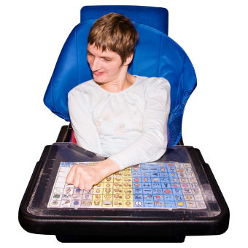  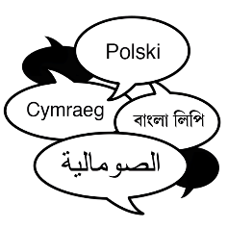 | For example, it can be used by people with disabilities, dementia, mental health issues, and people who do not have English as a first language.
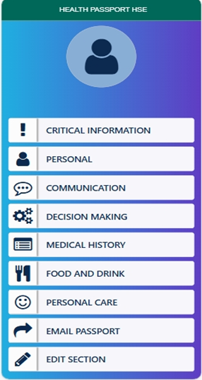 | This is what the app looks like.  It has sections on critical information, personal information, communication, decision making, medical history, food and drink, personal care, and the function to email the passport.
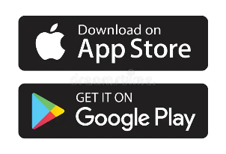 | You can download the Health Passport App in the App Store or the Google Play Store.
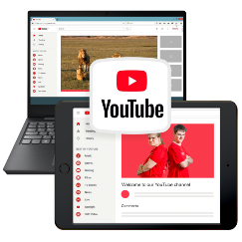  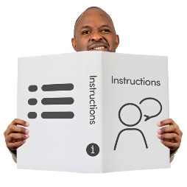 | There is a guidance document and Youtube video to support you to fill in the passport.
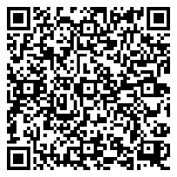  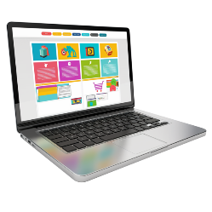 | Scan this QR code to the Health Passport webpage for the guidance, Youtube video and contact information.

