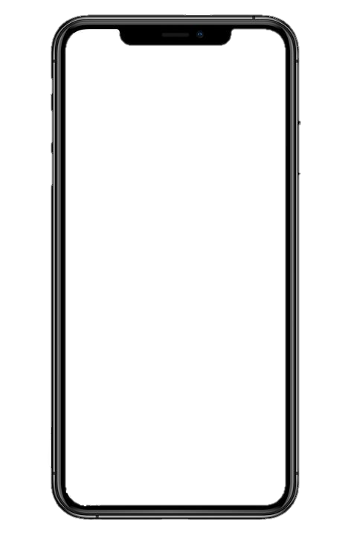

**HEALTH PASSPORT (HSE) APP**

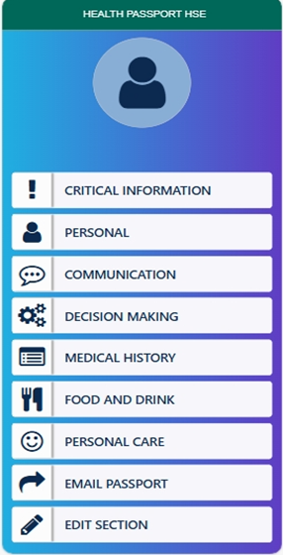

**WHAT IS THE HEALTH PASSPORT (HSE) APP?**

**The Health Passport (HSE) App was originally published in 2019 to recognise the challenges that exist for persons with a disability accessing health care and communicating their needs.**

**In 2023, the HSE Disabilities Quality Improvement team (DisQI) commenced a project to enhance and update the Health Passport (HSE).**

**The App now includes additional content and functions, with sections on Critical Information, Personal, Communication, Decision Making, Medical History, Food and Drink and Personal Care.**

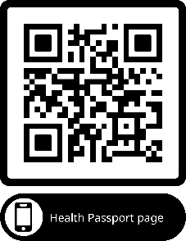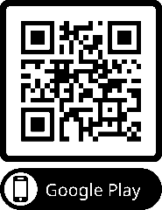

**WHO WAS INVOLVED IN UPDATING THE HEALTH PASSPORT (HSE) APP?**

**The DisQI Team along with an Expert Advisory Group including Disabled People, Families, Nursing Staff, Social Care Workers, Pharmacists, Speech and Language therapists etc. commenced the project focusing on the App layout and Content.**

**Focus/Testing groups were carried out in several areas including Disability services, GP Practices, Day Services, A&E and other acute hospital environments. The project also consulted with Disabled Person Organisations.**

**DOWNLOAD THE APP**

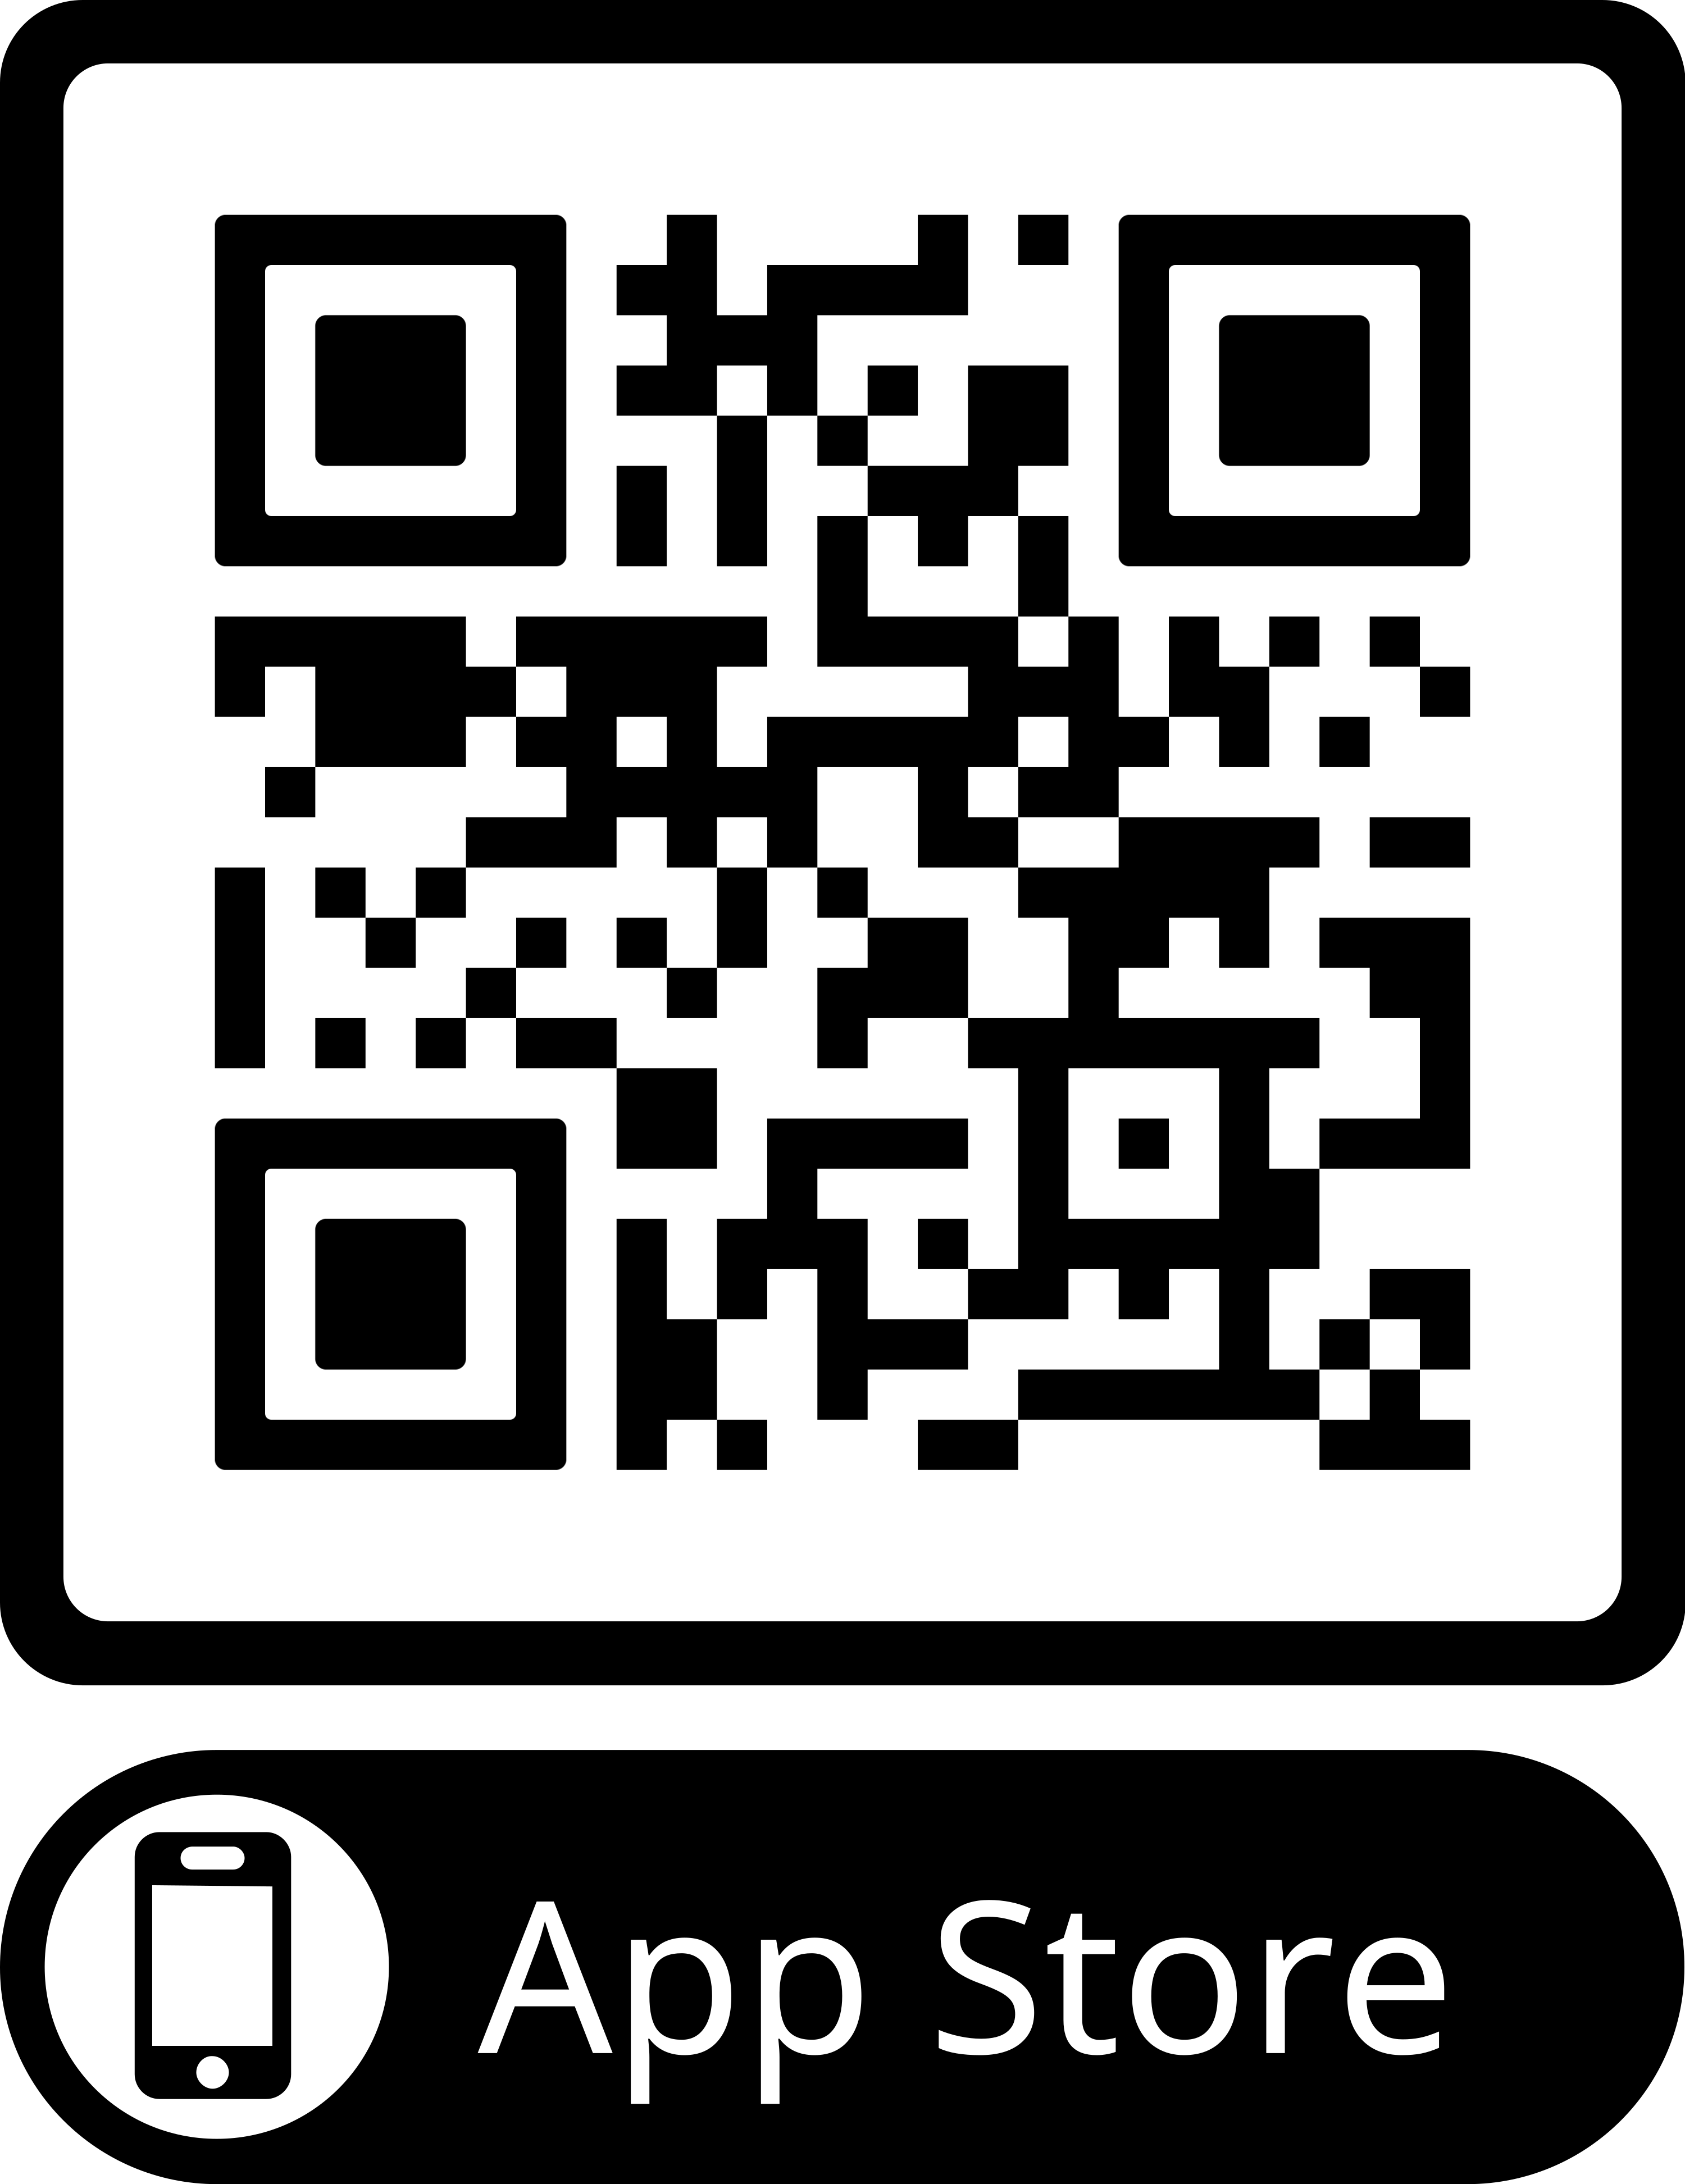

**WHO IS THE HEALTH PASSPORT (HSE) APP FOR?**

**This update has also ensured that the App can be used by any adult/child for whom communication is difficult (e.g. people with disabilities, dementia, mental health issues, people from other countries who do not have English as their first language).**

**HOW TO COMPLETE YOUR HEALTH PASSPORT (HSE) APP**

**There is a guidance document and Youtube video to support you to fill in the passport. If you have any questions, contact:**[**Health.Passport@hse.ie**](mailto:Health.Passport@hse.ie)

Scan QR code to find the guidance, video, and more information on the webpage.

**WHAT HAS BEEN UPDATED IN THE HEALTH PASSPORT (HSE) APP?**

* **New Layout with tabs**
* **Updated email function.**
* **Medication list input.**
* **Reminder Function.**
* **Read/Edit tab.**