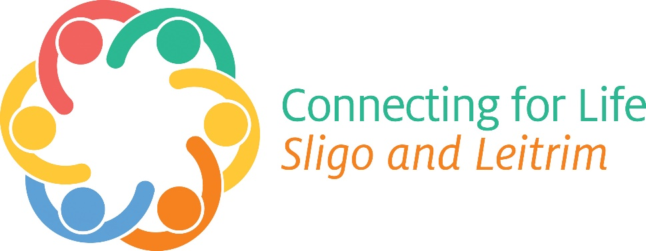

**Connecting for Life Sligo and Leitrim, call for applications for funding, 2021**

HSE National Office for Suicide Prevention and Connecting for LifeSligo/Leitrim are seeking applications for once off funding of up to a maximum of €5,000 from local community and voluntary groups. This funding is aimed at initiatives to reach at risk/vulnerable groups in relation to improving their mental health and wellbeing, and reducing the risk of suicide and self-harm.

* Download the application form here: <http://www.connectingforlifesligoleitrim.ie>
* For further details contact: [thomas.mcbride@hse.ie](mailto:thomas.mcbride@hse.ie)

Closing date for receipt of applications is **5 pm on Friday 8th of October.**