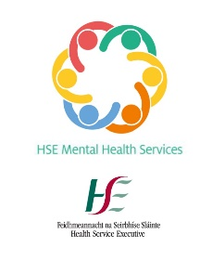
Patient Voices:
Mental illness and homelessness,
perspectives from lived experience
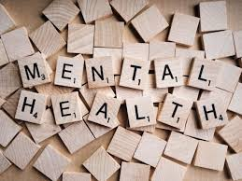
Have you experienced
mental health difficulties while homeless?

Would you be willing to speak with us?
We are a new Inclusions Mental Health Team in Dublin South City.
If you have had assessment or treatment by Psychiatry services:
- in an Emergency Department,
- in hospital or
- in a community Outpatient Clinic/Day Hospital,
…your experience could help us design a new model of inclusive mental health care for people in difficult social circumstances.

What would I have to do?
If you take part you will be invited to meet one of our team and chat to them. Tell us about your experiences and give us your opinions on what you would like to see in a mental health service.
Your feedback will be kept anonymous.
If you are interested, please speak to your Keyworker, Nurse or Doctor for a flyer with more detailed information.

