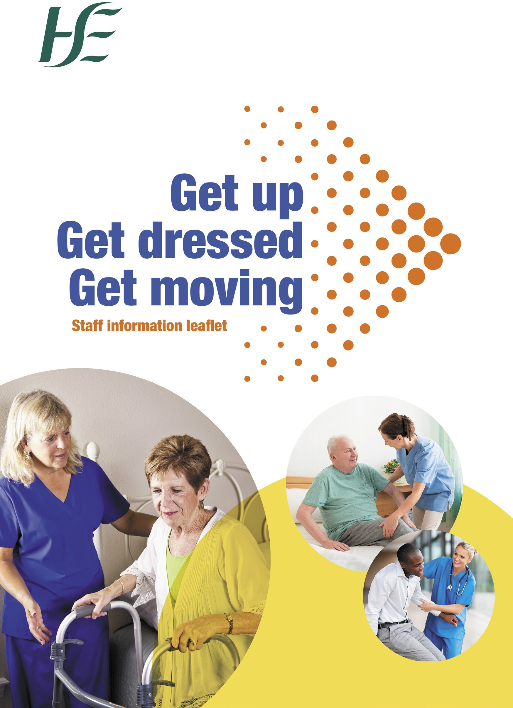

**Insert logo here**



**Your questions answered about helping patients to get moving**

All evidence shows that when patients get up, get dressed and get moving, they keep muscle strength and have better outcomes. This is particularly important for older people. In the muscles of people over 80, 10 days bedrest can lead to significant muscle loss, which can impact their chances of returning home and can increase their chance of being discharged to a nursing home.

This leaflet will help answer questions and address concerns you may have about helping patients get up, get dressed and get moving.

Bedbound patients lose 1 – 5% of their muscle strength every day they are in bed.

* Bedrest can lead to:
  + the development of skin breakdown, pressure sores (bed sores), confusion and fatigue
  + almost a 50% greater chance of a patient needing help with daily living activities one month after they leave a health setting
  + 5 times the risk of needing institutional care on discharge

**What are the benefits of getting up, getting dressed and getting moving?**

When a patient gets up, get dressed and gets moving, they may have less risk of:

* Getting an infection
* Losing mobility and agility
* Losing fitness and strength

2



**Why do patients want to stay in bed?**

There are many reasons why patients might want to stay in bed.

* They do not understand the benefits of getting up and getting moving.
* They see hospitals as a place for bed rest and think they shouldn’t get up.
* The hospital ward environment does not encourage activity.
* Patients feel they are ‘sick’ and so feel passive about their care instead of feeling like an empowered, active participant.

**How do I encourage patients to get up, get dressed and get moving?**

The best way to help patients understand the benefits of getting up, getting dressed and getting moving is through simple, informed

conversations. These conversations are a good time to discuss specific needs that may be addressed by moving. (For example, if someone is constipated, gentle exercise can help get things moving.)

Setting personal goals that can be reviewed are also a good way to encourage a patient to take part in their own recovery.

Some patients may choose to remain in bed – and patient choice is at the centre of high-quality care. But having a meaningful, informed

conversation about getting up, getting dressed and getting moving will

help people make informed choices.

3



**What if patients prefer to wear pyjamas while in hospital?**

Many patients and their families think they must wear pyjamas in hospital. We need to change this belief by encouraging and helping our patients to wear their day clothes. This will:

* improve their confidence when out of bed
* help them move more
* help their recovery and lead to earlier discharge home

It is also important that patients have clean clothing. We can remind family members or carers to replace soiled clothes.

**Won’t this cause more work for staff?**

Independent patients require less input from staff and getting up, getting dressed and getting moving promotes and maintains patient independence.

At the start, you may need to provide a little more assistance to get people going. But this will encourage independence. And the weaker, frailer or more sedentary a patient is, the more they have to gain from a small amount of movement, little and often. It is not about just walking with all patients – simple bedside exercises can be very beneficial. For some, regular ‘sit to stand’ practice can be a very simple yet powerful exercise. Speak to your ward physiotherapist for more ideas.

4

**Don’t patients need a physiotherapy review before I can mobilise them?**

No, they really don’t. Patients only get referred to the ward physiotherapist if they are off their mobility baseline or have specific rehabilitation needs such as a recent fracture or a neurological impairment.

Because spending time in bed in hospital can lead to functional loss, it’s important that walking or other movement is included in a patient’s daily care plan. It is better and more effective to keep a patient mobile from the moment they are admitted to hospital, where this is appropriate.

When you are incorporating movement into a daily care plan, first speak with the patient, family members or carers to establish normal mobility levels. If the patient is usually independently mobile, encourage them to get moving as soon as possible. If their mobility has deteriorated or they are at risk of deteriorating, refer them to a physiotherapist as soon as possible.

**Doesn’t movement increase the risk of falling?**

Older people in a hospital have a high risk of falling. But we know that remaining in bed weakens muscles, and this can lead to an increase in falls.

It is much better to support patients to remain active, strong and resilient. If they do fall, they are less likely to severely injure themselves and are better able to recover. Remember: anybody can fall. But by staying strong we can recover faster.

When patients spend more time in bed or immobile, they can also lose their confidence and develop a fear of falls. A fear of falling can often be more disabling than the fall itself. By encouraging movement, we reduce the risk of this potentially disabling loss of confidence.

5

