Lynch syndrome testing pathway: Guidance for the Gynaecological Cancer (Endometrial Cancer, Endometrioid or

Clear Cell Ovarian Cancer) tumour conference
Standard Operating Procedure (SOP) Template

June 2025

National Cancer Control Programme King’s Inns House, 200 Parnell Street, Dublin 1. D01 A3Y8
NCCP-COM-111

Standard Operating Procedure (SOP) Template
Tel: 01 8287100
Email: info@cancercontrol.ie www.hse.ie/cancer
Twitter: @hseNCCP
Lynch syndrome testing pathway:
Guidance for the Gynaecological Cancer (Endometrial Cancer, Endometrioid or Clear Cell Ovarian Cancer) tumour conference

Lynch syndrome testing pathway: Guidance for the Gynaecological Cancer (Endometrial Cancer, Endometrioid or Clear Cell Ovarian Cancer) tumour conference

Standard Operating Procedure (SOP) Template

Name of Tumour Conference:
Principal hospital:
Day, time and frequency of meeting:
Scope of meeting: | National  □ | Hospital Group  □ | Other region/ Group  □ | Hospital Specific  □
Other hospitals involved in tumour conference:
Chair
Co-Chair/Deputy Chair
Last updated
SOP is available locally at: | Insert Location / URL for location of SOP on hospital site

Version | Date | Updates Made | Author | Reviewer

This document can be used in conjunction with the NCCP Gynaecology Tumour Conference – Standard Operating Procedure Guidance; https://www.hse.ie/eng/services/list/5/cancer/profinfo/tumour- conference-sops/
The templates can be amended locally.
Objective
This SOP relates to delivery of the Lynch syndrome testing pathway, from diagnosis, of endometrial, endometrioid or clear cell ovarian cancer to diagnosis of Lynch syndrome. The guidance is for endometrial, endometrioid or clear cell ovarian cancer tumour conferences. It outlines the diagnostic pathway and individual tumour conference’s responsibilities.
General Principles
- Each gynae tumour conference team should identify a responsible local lead for the Lynch syndrome testing pathway (a ‘Lynch champion’), who may identify specific tasks for others within the tumour conference team.

- All newly diagnosed endometrial, endometrioid or clear cell ovarian cancer patients who are identified as likely to have Lynch syndrome should be offered genetic testing. This could be mainstreamed genetic testing offered in-house by trained Healthcare Professionals (HCPs) or by referral to the Specialist Cancer Genetics Service.

Standard Operating Procedure Part 1: The tumour testing pathway

Initial tumour assessment for Lynch syndrome
- Every patient with a new diagnosis of endometrial, endometrioid or clear cell ovarian cancer should have their first available tumour sample tested for the expression of the four mismatch repair (MMR) proteins done by MMR immunochemistry (IHC).

- IHC should be performed in the first available biopsies, but may be performed in surgical resection specimens where biopsies were not available/previously tested.

- MMR IHC results should be discussed and documented during the tumour conference meeting.

Action following MMR IHC results
  - MMR IHC assesses the expression of the four MMR proteins: MLH1, MSH2, MSH6, and PMS2. If there is a loss of any of these proteins, then further diagnostic tests are indicated.

  - All patients with a tumour sample with loss of MMR protein expression but without loss of MLH1 should now be be offered pre-test counselling and genetic testing for Lynch syndrome. This action should be documented in the tumour conference meeting outcome (go to section d).

Further testing for tumour samples with loss of expression of MLH1 or loss of MLH1+PMS2 on MMR IHC
  - Tumour samples with loss of MLH1 expression will require further testing with MLH1 promoter hypermethylation.
o Methylation testing of MLH1 should be ‘reflex’ arranged by the tumour conference team pathologist who reports the IHC MMR.

  - Once the result is available, the tumour conference team should arrange further tumour conference discussion.

    - If the tumour sample is absent of MLH1 promoter hypermethylation the patient may have Lynch syndrome and should immediately be referred for genetic testing.

    - If the tumour sample shows that MLH1 promoter hypermethylation is identified, then it is unlikely that the patient has Lynch syndrome (pathway stops).

Pre-test counselling and genetic testing for Lynch syndrome
  - For eligible patients, the tumour conference team should refer the patient for pre-test counselling and genetic testing, either mainstreamed locally or to the Specialist Cancer Genetics Service.

  - Eligible patients should be informed by the tumour conference team member that they will receive a genetic assessment. The patient’s GP should be informed that a referral has been made (Appendix 1).


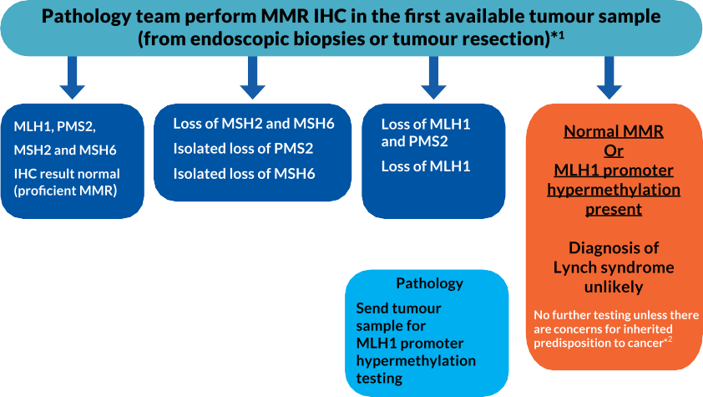
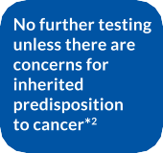
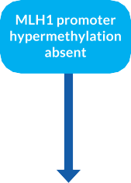

Part 2: Delivering mainstreamed genetic counselling and testing for Lynch syndrome
  - If you don’t have a mainstreamed service in place, patients should be referred to the Specialist Cancer Genetics Service for pre-test counselling and testing.
  - Before offering ‘in-house’ mainstreaming, a member of the local gynae tumour conference team should have completed the HSeLanD online training for mainstreaming or equivalent.
  - The tumour conference team HCP who performed the genetic counselling should contact the patient and give them their genetic result and advise on next steps.
  - Patients should be referred to the Specialist Cancer Genetics Service;
- If a Pathogenic Variant/Likely Pathogenic Variant was identified.
- If a variant of uncertain significance (VUS) was identified.
- No Pathogenic Variant/Likely Pathogenic Variant was identified. Somatic testing does not suggest sporadic cancer.
- No Pathogenic Variant/Likely Pathogenic Variant identified. Somatic testing suggests sporadic cancer but patient has a strong family history.



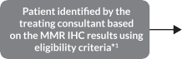


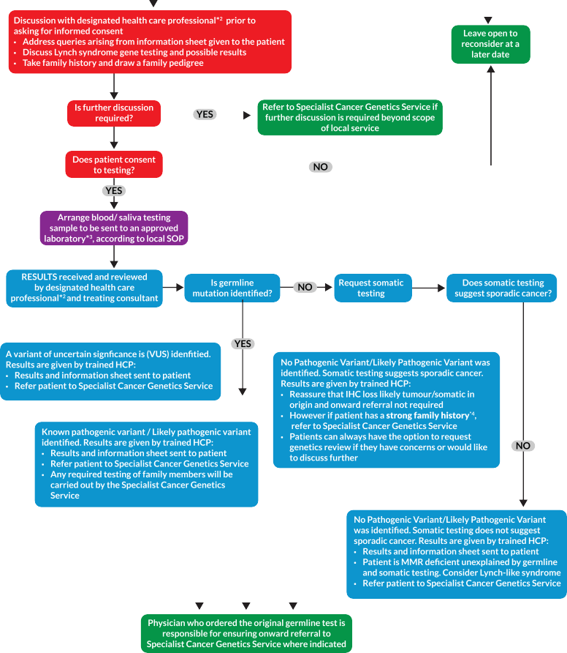

- References

Implementing a universal testing pathway for Lynch syndrome in colorectal, endometrial and endometrioid or clear-cell ovarian cancer, NCCP, 2023; https://www.hse.ie/eng/services/list/5/cancer/profinfo/hereditary-cancer- genetics/
NHS long term plan: The NHS England handbook for cancer alliances (2020) ‘Implementing Lynch syndrome testing and surveillance pathways: A handbook for Cancer Alliances’;
https://www.england.nhs.uk/publication/implementing-lynch-syndrome-testing- and-surveillance-pathways/

Lynch syndrome quality improvement project; https://rmpartners.nhs.uk/our-work/improving-diagnostic-treatment- pathways/lynch-syndrome-quality-improvement-project/
Lynch syndrome training website;
https://www.e-lfh.org.uk/programmes/the-national-lynch-syndrome- project/#:~:text=This%20programme%20is%20available%20on,lynch%2Dsyndr ome%2Dproject).
Lynch syndrome training supporting documents;
https://rmpartners.nhs.uk/our-work/improving-diagnostic-treatment- pathways/lynch-syndrome-quality-improvement-project/lynch-syndrome-early- diagnosis-pathway-endometrial/
Lynch syndrome patient information website;
https://rmpartners.nhs.uk/our-work/improving-diagnostic-treatment- pathways/lynch-syndrome-quality-improvement-project/lynch-syndrome- information/

Appendix 1

Hospital’s Header Here Dr GP
Address

Date: .....................................................

Dear Dr ,

Mr/Mrs/Ms has been discussed in our gynaecological tumour conference meeting. According to current guidelines for patients with hereditary gynaecological cancer. Patient name requires pre-test counselling and possible genetic testing for Lynch syndrome for the following reason:

IHC result shows loss of □

If loss of MLH1, further testing performed □

Result:
MLH1 promoter hypermethylation absent □
We are offering the patient germline genetic testing for Lynch syndrome. Kind regards,

Referrer signature

cc. Patient

cc. Trained member of the multidisciplinary team

Note: All information in this booklet is correct at time of publication



Document name: Lynch syndrome testing pathway: Guidance for the Gynaecological Cancer (Endometrial Cancer, Endometrioid or Clear Cell Ovarian Cancer) tumour conference
Standard Operating Procedure (SOP)
Version No:
V1
Produced by:
HSE National Cancer Control Programme
Issue date: Review date:
June 2025
June 2028

