Name:
Address:

DOB:
HCRN:
Ward:

Primary Consultant:

Assessment: Extravasation

Details of Extravasation
Setting where extravasation occurred:  In patient Day ward Ward name: Community Details: | Is there an interpreter present? yes no  Interpreting service  Family member/friend N/A
Date and time of:  Drug administered ______________  Extravasation identified ______________  Infusion/bolus stopped ______________ | Extravasation identified by Patient Nurse Other:
 | Name of drug extravasated:
 | Dose prescribed:
Classification of drug: DNA binding Vesicant Non DNA binding Vesicant Irritant
Non Vesicants (Neutrals)

Administration Technique: Bolus Infusion via mechanical pump Infusion via gravity
Ambulatory pump

Prior to extravasation was there:
Free flow of infusion present Resistance on plunger of bolus syringe Other:

Intravenous Access Device
Intravenous Cannula cannula size: PICC Hickman
Port Huber needle length & gauge: Other:

Line secured with a fixation device: Yes No |  | Insertion site:
How many attempts to cannulate If applicable:  Was it on the same limb as the extravasation?  Yes No | Where on the limb in relation to the extravasation was the previous puncture site?  If applicable  Proximal Distal Medial/Lateral
Process and frequency of line patency confirmation prior to and during drug administration:
Blood return present pre administration Yes No
Blood return checked and present as per protocol Yes No
Other details including description and quality of blood return:

Initial Intervention/management
Steps | Action | Done | Details
1 | Stop administration of bolus or infusion immediately but do not remove PIVC or Huber needle
2 | Ask another member of staff to inform the medical team/specialist nurse
3 | Disconnect infusion/syringe from IV device
4 | Avoid putting any pressure on the site
5 | Aspirate as much of the drug as possible via the PIVC or Huber needle with a syringe |  | Approximate amount aspirated:
6 | Observe the area. If there is spillage on the surface of the skin, wash area with warm soapy water and remove any affected clothing immediately
7 | Apply hot or cool packs as per local policy |  | Hot Cool N/A  Time applied:________________  Time removed:________________
8 | Remove line as per local policy
9 | Mark the extravasation site with a marker suitable for use on skin
10 | Describe appearance of PIVC or Huber needle if removed
11 | As per drug specific classification management, proceed with treatment as per policy |  | Details of drug/topical treatment administered:  Time:
12 | Measure the extravasation site |  | Diameter (mm):  Length(mm):  Width(mm):
13 | Consider medical photography
14 | Administered analgesia as required
15 | Inform a member of the medical team if not notified in step 2 |  | Name of person notified:
16 | Early Warning System completed | Yes No N/A
Note: Please complete an incident report form
Reviewed by: Name: Title:
Recommendations made:

Surgical/Plastics consult required? Yes No Consult requested? Yes No
Details:

Initial Extravasation Site Assessment
Please tick all initial signs and symptoms experienced by patient
Pain | Swelling | Stinging | Tingling
Itching | Blistering | Erythema | Ulceration
Venous discolouration | Skin discolouration | Fluid leakage | Induration
Necrosis | Cold sensation | Sensory alteration/loss | Burning
Patient reported symptoms:

Please indicate location of extravasation by using the diagram below
Arm/hand: Right Left arm
Chest (Site of portacath): Right Left
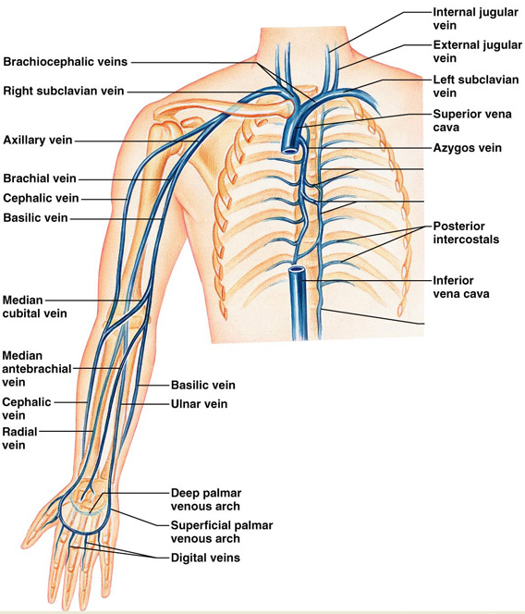

See appendix 1 for Grading Scale
Time
Skin colour
Skin integrity
Skin temp
Oedema
Mobility
Fever
Pain
Initials
NMBI pin

Medical Photography
Please attach photo here | Comments

Discharge
Frequency of dressing changes: |  |  | Dressing type:  Topical treatments:  Including hot/cold packs:
Factors to consider that may influence wound healing:

Education provided to:

Required teaching points: Sign/symptoms of necrosis Sign/symptoms of sensory loss ROM exercises Monitoring temperature Topical care Protection from sunlight Other:

Teaching aids used: Written Verbal Demonstration

Multidisciplinary/Community Services Referrals
Referrals Made | Comments
Details of next appointment for extravasation follow up
Date: |  | Time: |  | Reason:
Assessment completed by: NMBI pin:

Extravasation follow up Use Appendix 1
Date/time: |  |  |  |  |  | Medical Photography Day:
Skin colour |  |  | Mobility |  |  | Please attach photo here
Skin integrity |  |  | Pain
Skin Temperature |  |  | Fever
Oedema |  |  | Patient reported symptoms:
Diameter (mm)

Length(mm)

Width(mm)
Describe appearance of extravasation site:
e.g. Appearance of wound bed, colour odour, granulation

Is there any presence of necrosis? Details:

Sensation present? Details:

Education provided to:
Details:

Teaching evaluation: Patient can articulate understanding Can demonstrate understanding
Requires further education
Early Warning System completed Yes No NA
Multidisciplinary/community service referrals
Referrals made |  | Comments
Details of next appointment for extravasation follow up
Date |  |  |  | Time |  |  | Reason
Signature: Print:

Extravasation follow up Use Appendix 1
Date/time: |  |  |  |  |  | Medical Photography Day:
Skin colour |  |  | Mobility |  |  | Please attach photo here
Skin integrity |  |  | Pain
Skin Temperature |  |  | Fever
Oedema |  |  | Patient reported symptoms:
Diameter(mm)

Length(mm)

Width(mm)
Describe appearance of extravasation site:
e.g. Appearance of wound bed, colour odour, granulation

Is there any presence of necrosis? Details:

Sensation present? Details:

Education provided to:
Details:

Teaching evaluation: Patient can articulate understanding Can demonstrate understanding
Requires further education
Early Warning Score completed Yes No NA
Multidisciplinary/community service referrals
Referrals made |  | Comments
Details of next appointment
Date |  |  |  | Time |  |  | Reason
Signature: Print:

Signature Bank
Name | Signature | Initials | Role | NMBI Pin

Appendix 1: Grading Scale for Monitoring Extravasation

Grading Scale For Monitoring Extravasation
Grading | 1 | 2 | 3 | 4 | 5
Skin colour | Normal | Pink | Red | Blanched area surrounded by red | Blackened
Skin integrity | Unbroken | Blistered | Superficial skin loss | Tissue loss & exposed subcutaneous tissues | Tissue loss & exposed bone/muscle with necrosis crater
Skin temp | Normal | Warm | Hot
Oedema | Absent | Non- pitting | Pitting
Mobility | Full | Slightly limited | Very limited | Immobile
Temperature | Normal | Elevated | Please indicate actually temperature
Pain (1-10) | No pain | Mild pain | Moderate pain | Severe pain | Worst pain possible
Grading scale for monitoring extravasation, Royal Marsden Manual of Clinical Nursing Procedures, 9th Edition, 2015

Please check your local hospital policy for drug classification

