Name:
Address:

DOB:
HCRN:
Ward:

Primary Consultant:

Assessment: Pre Systematic Anti-Cancer Therapy (SACT)
(To be completed before each cycle of SACT)

Study participant Yes No
Trial Name_________________ Trial Nurse_________________

Cycle 1 Day 1 only: SACT consent form signed? Yes No

Therapy Plan
Primary Diagnosis: | NCCP Regimen: |  |  | Is there an interpreter present? Yes No  Interpreting Service  Family member/friend NA
Allergies/sensitivities: | Cycle number: |  |  | Weight:  Height:  BSA:  Calculated by/verified by:  /
Review frequency: | Cycle day:
Radiotherapy: Yes No NA Start date:
Concomitant Radiotherapy: Yes No NA Start date:
 |  | Yes | No |  | Comment
Has the patient been admitted to hospital or seen their GP since their last treatment? |  |  |  |  | If applicable, discuss with senior medical/nursing staff prior to continuing treatment
Any patient infection control alert/issues?
Are all investigations as per SACT regimen complete?
Are any investigations requested?
Is there any change from the patient current scheduled therapy plan? |  |  |  |  | Changes made:
Is this a permanent change to the patient’s therapy plan?
Is there any change to medication?
Is there a history of an adverse event on a previous cycle?

Peripheral Intravenous Cannulation Insertion Record
Time |  | Number of attempts to cannulate?
Cannula size |  | Patient tolerance of procedure
Site |  | Initial/NMBI pin

Central Venous Access Device (CVAD) Record
Please complete CVAD assessment form

Patient Adherence and Education to Oral Anti-Cancer Medicine (OAM) (as applicable)
See appendix 1 for MOATT | Yes | No | Comments
MOATT Key Assessment Questions
MOATT Patient Education
MOATT Drug Specific Education
MOATT Evaluation

Toxicity grading (Version ___)
CTCAE | Grade |  |  |  |  | CTCAE |  |  |  | Grade
 | 0 | 1 | 2 | 3 | 4 |  |  |  |  | 0 | 1 | 2 | 3 | 4
Anorexia |  |  |  |  |  | Infection
Arthralgia |  |  |  |  |  | Mood alteration
Arthritis |  |  |  |  |  | Mucositis/stomatitis
Bleeding |  |  |  |  |  | Myalgia
Bruising |  |  |  |  |  | Nausea
Cough |  |  |  |  |  | Pain
Chest pain |  |  |  |  |  | Palmer/Planter Syndrome
Confusion/cognitive disturbance |  |  |  |  |  | Peripheral motor neuropathy
Constipation |  |  |  |  |  | Peripheral sensory neuropathy
Diarrhoea |  |  |  |  |  | Pruitis
Dyspnoea/Shortness of breath |  |  |  |  |  | Rash
Eye disorders |  |  |  |  |  | Renal and urinary disorders
Fatigue |  |  |  |  |  | Tinnitus
Fever |  |  |  |  |  | Vomiting
Hearing impaired |  |  |  |  |  | Weight loss
Hyperthyroidism
Hypothyroidism
Other
Performance status
 |  |  |  | Yes |  |  | No | N/A | Comments
Vital Signs/EWS/INEWS completed? |  |  |  |  |  |  |  |  | Score:
MST Score completed? (see appendix 3) |  |  |  |  |  |  |  |  | Score:
Have all necessary bloods been completed? |  |  |  |  |  |  |  |  | FBC U&E Liver profile Bone profile Coagulation Screen Iron Studies TFTs CRP Virology Cortisol Glucose Other Details:
Tumour markers as per medical instruction
Blood results reviewed and satisfactory to proceed with treatment?
Urinalysis results
Sample sent to lab?
HCG test complete? |  |  |  |  |  |  |  |  | Results:

SACT Administration
 | Yes | No | N/A | Comments
Blood return present prior to commencing and throughout treatment? |  |  |  | Fill out extravasation form if necessary
SACT fully infused without any adverse events |  |  |  | Please document additional details in notes section if required
Is ambulatory SACT pump attached correctly?
Is ambulatory SACT pump attached, is clamp open?
Assessment completed by: NMBI pin:

Discharge
 |  | Yes |  |  | No | N/A | Comments
Does the patient require admission? |  |  |  |  |  |  | Location:
Does the patient require a follow up telephone call?
Has intravenous cannula/Huber needle been flushed & removed? |  |  |  |  |  |  | Time removed:  Any complications?  VIPs score prior to removal:
Has spill kit been given to patient?
Safe handling and disposal of cytotoxic drug information leaflet given?
Did the patient receive a discharge prescription?
If the patient is for G-CSF, is administration arranged?
Multidisciplinary/Community Services Referrals
Referral made | Comments
Details of next appointment
Date: | Time: |  | Reason:
 |  |  |  | Yes |  | No | NA | Comments
Have blood requests for next appointment been given to patient?
Have community based pre-treatment assessments been requested?
Assessment completed by NMBI pin

Date | Time | Notes | Initials/NMBI pin

Signature Bank
Name | Signature | Initials | Role | NMBI Pin

Appendix 1: MOATT© - MASCC Teaching Tool for Patients Receiving Oral Agents for Cancer

Key Assessment Questions
1 | What have you been told about this treatment plan with oral medications?  Verify that the patient knows that these oral agents are for cancer and are taken by mouth.
2 | What other medications or pills do you take by mouth?  If you have a list of medicines, go over the list with the patient.  If you do not have a list, ask the patient what medicines he/she is taking (both prescription and nonprescription), as well as herbal and dietary supplements, complementary therapies, and other treatments.
3 | Are you able to swallow pills or tablets? If no, explain.
4 | Are you able to read the drug label and provided information?
5 | Are you able to open your medicine bottles or packages?
6 | Have you taken other pills for your cancer?  Find out if there were any problems taking the medications or any adverse drug effects.
7 | Are you experiencing any symptoms, for example nausea or vomiting, that would affect your ability to keep down the pills or tablets?
8 | How will you fill your prescription?  Delays in obtaining the pills may affect when the oral drugs are started.

Special considerations when assessing patients receiving oral agents for cancer:
When teaching the patient, you may need to adapt your teaching to accommodate special considerations, such as age, a feeding tube, vision problems including colour blindness, dietary issues, or mental health problems (dementia, depression, cognitive impairments).

Patient Education
Generic education for all oral drugs
Discuss the following items with the patient and/or caretaker
1 | Inform any other doctors, dentists, and healthcare providers that you are taking pills or tablets for your cancer.
2 | Keep the pills or tablets away from children and pets and in a childproof container.
3 | Keep the pills or tablets in the original container, unless otherwise directed. It could be dangerous to mix them with other pills.
4 | Wash your hands before and after handling the pills or tablets.
5 | Do not crush, chew, cut or disrupt your pills or tablets unless directed otherwise.
6 | Store your pills or tablets away from heat, sunlight, and moisture. These can break down the pills or tablets and make them less effective.
7 | Have a system to make sure you take your pills or tablets correctly.  Give the patient some ideas, such as using a timer, clock, or calendar.
8 | Make sure you have directions about what to do if you miss a dose.
9 | If you accidentally take too many pills, or if someone else takes your pills or tablets, contact your doctor or nurse immediately.
10 | Ask your nurse or pharmacist what you should do with any pills or tablets you have not taken or any that have passed their “use by” date.  The patient can be asked to bring unused pills or tablets back to the next visit.
11 | Carry with you a list of medicines that you are taking, including your cancer pills or tablets.
12 | Let us know if you have a problem with getting your pills or paying for them.
13 | Be sure to get your refills ahead of time, and plan for travel and weekends.

Drug-Specific Education
Whichever tool is used to educate the patient, include the following drug-specific information. You can complete the form provided below and give it to the patient using reference material you have on the specific pills or tablets.
1 | Drug name (generic and trade)
2 | What the drug looks like
3 | Dose and schedule:  How many different pills?  How many times a day?  For how long?
4 | Where to store the pills or tablet  Be specific, for example, away from heat (not in the kitchen), humidity (not in the bathroom), and sun (not on the window sill).
5 | Potential side effects and how to manage them  Include lab evaluations or any medical tests that will be used for drug monitoring.
6 | Any precautions that should be discussed
7 | Any drug or food interactions
8 | When and whom to call with questions  Give names and phone numbers here.

Evaluation Date: .…/.…./…….
Ask the patient and/or caregiver to answer the following questions to ensure that they understand the information you have given them.
1 | You have received a lot of information today.  Let’s review key points.
2 | What is/are the name(s) of your cancer pills or tablets?
3 | When will you take your cancer pills or tablets?
4 | Does it matter if you take your pills or tablets with food or not?
5 | Where do you plan to keep your pills or tablets?
6 | When should you call the doctor or nurse?
7 | Do you have any other questions?
8 | When is your next appointment?
9 | For problems, contact:

Appendix 2: ECOG Status

ECOG Status
ECOG score 0 | ECOG score 1 | ECOG score 2 | ECOG score 3 | ECOG score 4
Fully active, able to carry on all pre-disease performance without restriction | Restricted in physically strenuous activity but ambulatory and able to carry out work of light or sedentary nature, e.g. light house work, office work | Ambulatory and capable of all self-care but unable to carry out any work activities. Up and about more than 50% or waking hours | Capable of only limited self –care, confined to bed or chair more than 50% of waking hours | Completely disabled Cannot carry on any self- care. Totally confined to bed or chair

Appendix 3: MST Score

How to use The Malnutrition Screening Tool (MST) 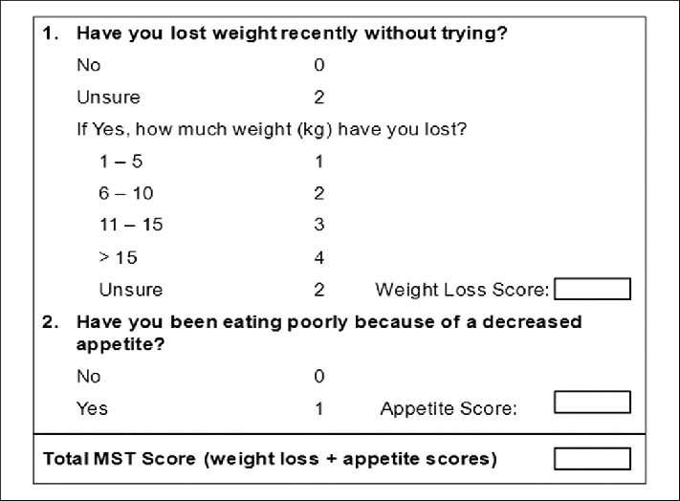

Step 1: Determine Weight Loss
- Ask patient if weight loss has occurred
- If unsure:
  - Compare current weight to previous recorded weight
  - Seek evidence of recent weight loss: loose fitting clothing/jewellery/dentures
  - Use clinical judgment in estimating degree of weight loss based on response
  - Enter a score of 2 for unsure only if the above fail to clarify.
Step 2: Determine Reduced Appetite
- Ask the patient
  - Are you eating less food at mealtimes than usual?
  - Are you eating less often in the day?
  - Do you have chewing or swallowing difficulties?
  - Clarify with care giver if required.

Step 3: Determine score
- Weight score + Appetite score = MST Score

Risk Identification
MST Score | Malnutrition Risk | Action
0 | Not at Risk | Rescreen at next SACT infusion
1 | Not at Risk | Rescreen at next SACT infusion
≥2 | At risk of Malnutrition | Follow local malnutrition risk policy

Appendix 4: Visual Infusion Score (VIPS)

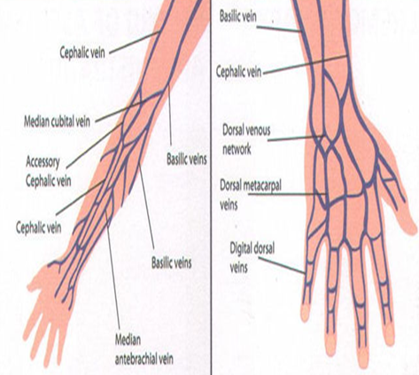
Visual Infusion Phlebitis Score (VIPS)
Condition of site | Score
IV site appears healthy | 0
One of the following is evident:  - Slight pain near IV site  - Slight redness near IV site | 1
Two of the following are evident:  - Pain at IV site  - Erythema  - Swelling | 2

Use the latest version of CTCAE unless otherwise stated in a specific clinical trial
European Cooperative Oncology Group (see appendix 2)
Abbreviations; EWS=Early Warning Score; INEWS=Irish National Early Warning System
Visual Infusion Score, INS 2011(See appendix 4)
“Permission to use the MASCC Oral Agent Teaching Tool (MOATT) granted by the Multinational Association of Supportive Care in Cancer (MASCC).”
Oken M, Creech R, Tormey D, et al. Toxicity and response criteria of the Eastern Cooperative Oncology Group.Am J Clin Oncol. 1982;5:649-655.
Ferguson et al. Development of a valid and reliable malnutrition screening tool for adult acute hospital patients. Nutrition. 1999 Jun;15(6):458-64.
INS (2011) Infusion Nursing Standards of Practice. Journal of Infusion Nursing. Supplement. 34(1s).

