**NCCPinfo Mailbox**

* Generic queries
* Booklets
* Summit and meeting announcement
* Regarding palliative
* Referrals

**Contacts**

For information on Thriving/surviving/recovery/ CTS query, publication, policies, procedure, treatment changes, up-to-date information, send to:

|  |
| --- |
| Update info on statement of account in shared drive and the  password is **Clericalteam**  Webex:Th@nkfu!1  <https://mailm.hse.ie/owa/>  patodirector |

[bernie.oloughlin@cancercontrol.ie](mailto:bernie.oloughlin@cancercontrol.ie)

[lisa.marry@cancercontrol.ie](mailto:lisa.marry@cancercontrol.ie)

[pauline.robinson3@cancercontrol.ie](mailto:pauline.robinson3@cancercontrol.ie)

[cathleen.osborne@cancercontrol.ie](mailto:cathleen.osborne@cancercontrol.ie)

[louise.mullen@cancercontrol.ie](mailto:louise.mullen@cancercontrol.ie) *****main

**For information on Palliative Care**

[eileen.nolan@cancercontrol.ie](mailto:eileen.nolan@cancercontrol.ie)

[louise.mullen@cancercontrol.ie](mailto:louise.mullen@cancercontrol.ie)

[terry.hanan@cancercontrol.ie](mailto:terry.hanan@cancercontrol.ie)

**Sample email:** *Hi Eileen*

*Please refer to email from Ms. Shanice Murphy*

To register for programme

**Guidelines Team -** Guidelines [guidelines@cancercontrol.ie](mailto:guidelines@cancercontrol.ie) Maeve Cusack <maeve.cusack@cancercontrol.ie>;

[**catherinep.duffy@hse.ie**](mailto:catherinep.duffy@hse.ie)

[**info@cancercontrol.ie**](mailto:info@cancercontrol.ie)

[eileen.nolan@cancercontrol.ie](mailto:eileen.nolan@cancercontrol.ie)

Sample of email:

Dear Sir/Madam,

I write in relation to the above mentioned, HSE publication. I would like to know when this leaflet was FIRST published? A NCCP Copyright mark in the bottom corner shows a date of 2017. I presume this was an update of same as the accompanying Pigmented Lesion GP Refferal Form shows a date of 2015.

**For breast: email**

**Guidelines Team -** Guidelines [guidelines@cancercontrol.ie](mailto:guidelines@cancercontrol.ie) Maeve Cusack <maeve.cusack@cancercontrol.ie>;

Hi

I would like to request referral forms for the Breast clinic at Beaumont Hospital please

Kind regards

Sample of Respond:

Dear Team.

Please refer to email below and advise.

Thank you.

Lara

**Complaints**

[Marie.Cox@cancercontrol.ie](mailto:Marie.Cox@cancercontrol.ie)

**Ivanti Self Service:** Otherwise you can contact them at <Tel:(0818)(300)(300)> and follow the prompts.

To log IT requests should you experience any issues with logons, email, error messages etc.

<https://nsdselfservice.healthirl.net/selfservice.bridgeIT>

Sample of response

Dear Team

Please refer to email below and advice

Many thanks

Good Afternoon Betty,

I can confirm that Prof. Ó Laoide can be contacted at [patodirector@cancercontrol.ie](mailto:patodirector@cancercontrol.ie). If there is anything else I can assist you with, please don’t hesitate to contact me.

Dear All

Please refer to email below and advice, or redirect where necessary.

Many thanks

Thank you for your email. I can confirm that your email has been forwarded to Dr O’ Laoide for his consideration.

Thank you for your email.

I have redirected this and they will revert to you in due course.

For booklets sample of email:

Good Afternoon Stephanie,

I acknowledge receipt of your email and I would be delighted to arrange to send out those booklets when I get onsite next. Due to the current pandemic, I am working predominantly from home. I will let you know when I send them out.

**Sample of request: this was forwarded to -** FW: Colorectal Cancer Patient Passport

[cathleen.osborne@cancercontrol.ie](mailto:cathleen.osborne@cancercontrol.ie); [lisa.marry@cancercontrol.ie](mailto:lisa.marry@cancercontrol.ie); [pauline.robinson3@cancercontrol.ie](mailto:pauline.robinson3@cancercontrol.ie)>; [Carmel.Sheehy@cancercontrol.ie](mailto:Carmel.Sheehy@cancercontrol.ie); [frances.neville@cancercontrol.ie](mailto:frances.neville@cancercontrol.ie)>

Hi all,

I would be so grateful if I could get some assistance on the rolling out of the passport within our hospital.  Is there a criteria for the rolling out of it and also is there any necessary audits I need to do with it's use.  I hope to initiate it's use within the coming weeks.

Regards.

**Respond:**

Hi Mary

I acknowledge receipt of your email and have sent to the relevant Team for follow up

Kind Regards

Alison

Webex installation link:

<http://pndcsdwikiapp01.healthirl.net/dokuwiki/doku.php?id=start:self-service&redirect=1#tab_install_software>

Dear all,

I would like to coordinate a minutes review meeting to finalise the minutes

for the last HG forum meeting held on 13/12/2021.

I would like to suggest Monday at 9:30am or 11am as the next meeting for

this group will be held next Wednesday 22.12.21 and this minutes will be attached

to the invite to be sent out.

Please let me know what suits for you.

Thank you.

Lara

**Draft minutes – NCCP Cancer Services Update meeting 18 01 22 (from Inez)**

Hi all

Please find attached draft minutes from the cancer services update meeting on 14th December.

If you have any amendments/corrections, please let me know.

The next meeting is scheduled for Tuesday 21st December at 2pm.

Many thanks

File location:

S:\National Director Office\Cancer networks and regions\Internal Group on networks and regions\Meetings\09 12 21

NCCP operational meeting – Cancer service update

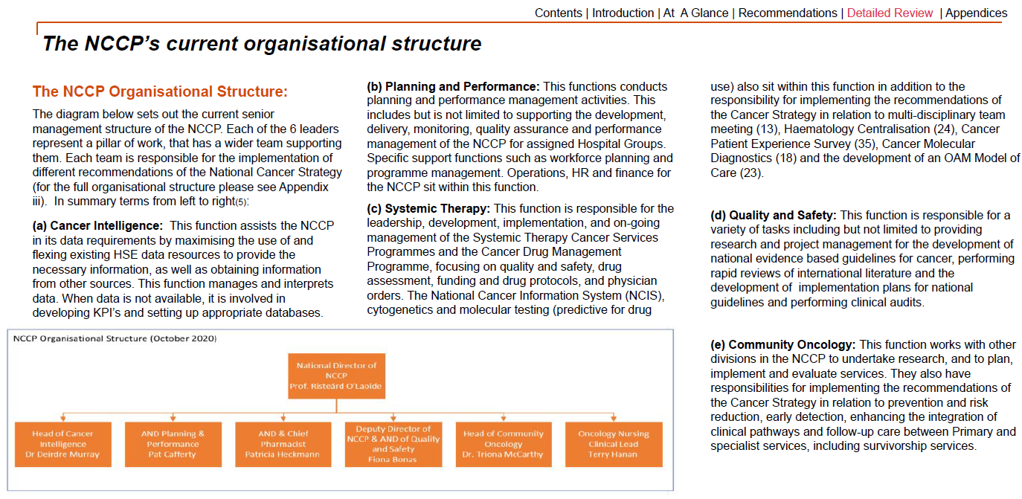

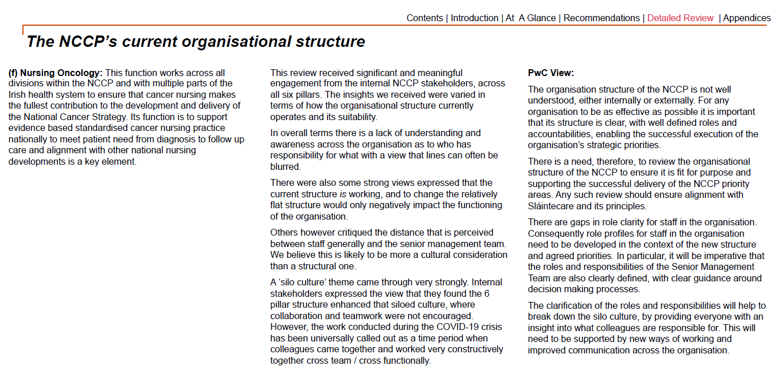

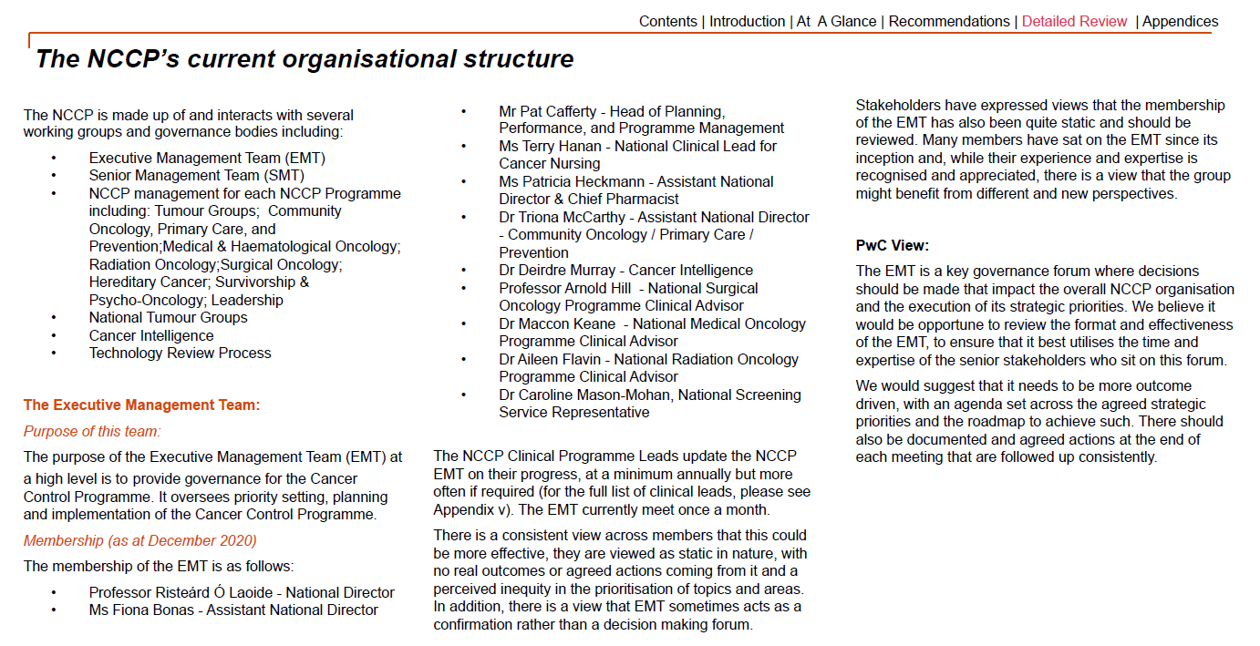

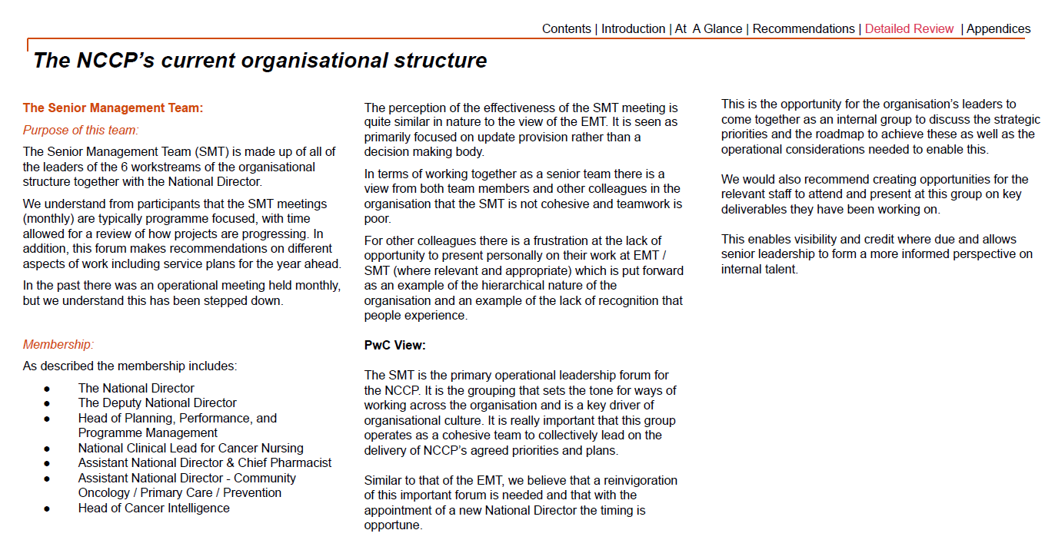

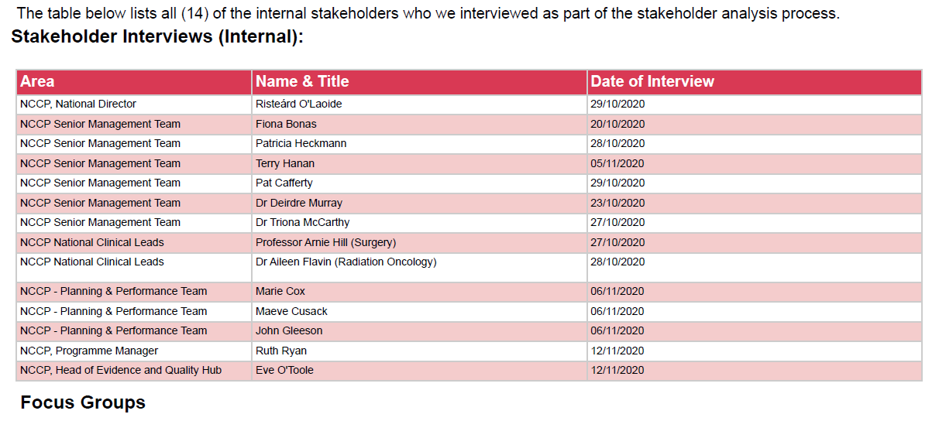

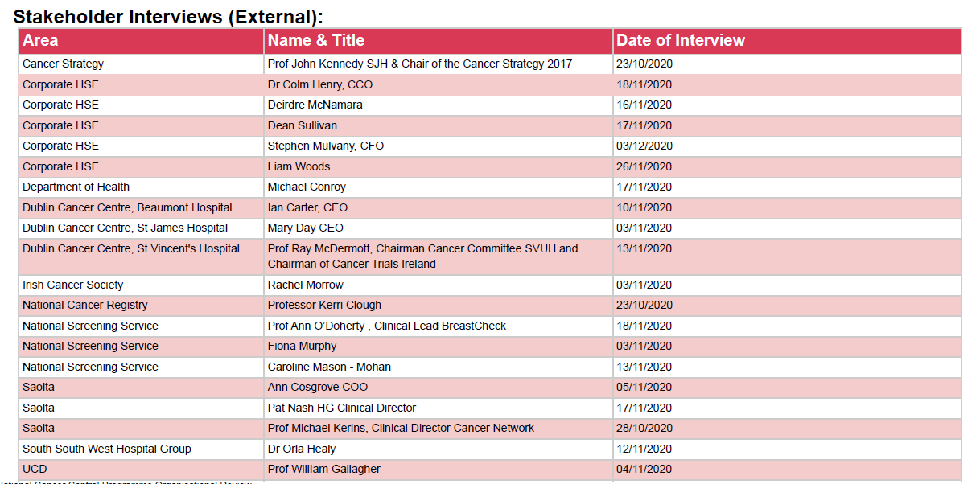

Dear Karen,

Thank you for your email.

Unfortunately this booklet is currently under

review at present and unavailable for circulation at this time.

Apologies for same.

Lara

