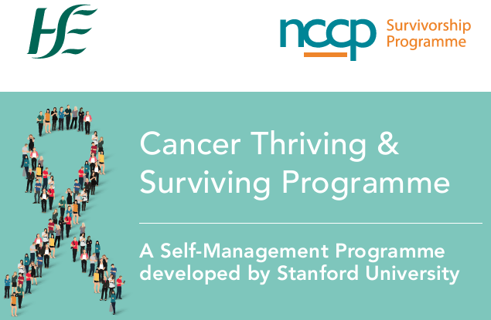

|  |  |  |  |  |  |  |
| --- | --- | --- | --- | --- | --- | --- |
| Start Date | **Location Details** | | **Morning/**  **Afternoon/ Evening** | | **In person/**  **Online**  **Delivery** | |
| 5th September 2023 | **The Marie Keating Foundation**  01 6283726 | | Evening | | Online | |
| 6th September 2023 | **Solas Cancer Support**  **Waterford**  051 304 604 | | Evening | | In person | |
| 13th September 2023 | **ARC Cancer Support**  **Cork**  021 4276688 | | Morning | | Online | |
| 15th September 2023 | **Hope Cancer Support Centre**  **Enniscorthy**  053 923 8555 | | Afternoon | | In Person | |
| 18th September 2023 | **Cuisle Cancer Support**  **Portlaoise**  [057 8681492](tel:057%208681492) | | Morning | | In person | |
| 20th September 2023 | **Cancer Care West**  **Galway**  091 540040 | | Morning | | In person | |
| 21st September 2023 | **Gary Kelly Cancer Support Drogheda**  041 9805100 | | Morning | | In person | |
| 26th September 2023 | | **Purple House Cancer Support**  01 2866966 | | Afternoon | | Online | |
| September 2023 | | **Recovery Haven Kerry Cancer Support**  066 719 2122 | | Time TBC | | In person | |
| September 2023 | | **Mid-West Cancer Support Limerick UHL**  061 485 163 | | Afternoon | | In person | |
| 6th October 2023 | | **Beaumont RCSI Cancer Centre, Beaumont Hospital**  01 852 8478 | | Morning | | In person | |
| 12th October | | **ARC Cancer Support**  **Dublin**  01 215 0250 | | Morning | | Online | |
| 12th October | | Mercy University Hospital  Cork  021 4274076 | | Morning | | Online | |
| 16th October | | St Vincent’s University Hospital, Dublin  01 221 5496 | | Morning | | Online | |
|  | |  | |  | |  | |
|  | |  | |  | |  | |
|  | |  | |  | |  | |
|  | |  | |  | |  | |
|  | |  | |  | |  | |