Application Form

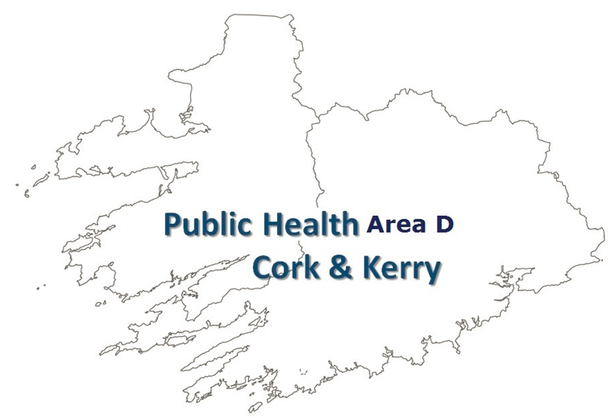

Cork / Kerry Mental Health Promotion
Project Grant

Application Form 2022
Funded by the Area Director of Public Health, HSE South Area D (Cork & Kerry)
and supported by HSE Cork Kerry Community Healthcare - Mental Health Services, Psychology, Suicide Prevention, Social Inclusion and Health Promotion & Improvement Department

Application Form

Stage 1

This form should be submitted by voluntary/non-statutory agencies when applying for funding from the HSE

For Office Use Only
HSE Application Reference Number

Section 1 - Organisation Details & Contacts
(Items shaded yellow are compulsory entry)
If compulsory entries are not completed, the entry cannot be made on SPG Online.
Name of Organisation
(This should be the official or Registered Legal Entity name)
Trading Name (known as)
(if different from above)
Address of Organisation  (This should not contain the  personal name or address of  an individual e.g. secretary) |  |  | Line 1
 |  |  | Line 2
 |  |  | Line 3
 |  |  | Town
 |  |  | County
 |  |  | Eircode
Telephone Number |  | Fax Number |  |  |  |  |  | Contact e-mail |  |  | Website
Other organisational detail – if relevant |  |  |  |  | Name |  |  |  |  | Address
Parent Organisation Details
(where your organisation is a subsidiary of a national organisation)
Franchise Organisation Details
(where your agency is operating as a franchise)
Affiliation Organisation Details
(where your organisation is affiliated to other agencies / bodies)
Organisation Officer Contact Details
Officer |  |  |  | Name |  |  |  |  |  | Address (If different to org. address above)
Chief Officer / Director or appropriate senior official
(include title in name)
Chairperson
Secretary of Board
Treasurer

Application Contact Details
Organisation Key / Main Contact Details (This should be the person who has overall responsibility for this application and resultant funding arrangement and will act as key contact person with the Executive)
Title
Name
Address

Email
Phone |  |  |  |  |  |  | Mobile
Authorised Signatory Contact Details
(The person authorised by your organisation to sign the Funding Arrangement should this application be sucessful) – Chairperson or Equivalent
Title
Name
Address

Email
Phone |  |  |  |  |  |  |  | Mobile

Section 2 - Organisation Overview
Status /Structure of Organisation
 | Yes | No | Tick Yes / No as Appropriate
Is your Organisation a registered Charity? |  |  | If Yes please provide Charity Regulatory Authority Number >
Is your Organisation registered with Revenue for Charity Tax Exemption? |  |  | Please provide Revenue CHY Number >
Is your Organisation a registered Company? |  |  | If Yes please provide Company Number (CRO Number) >
Is your Organisation a Statutory body?
Is your Organisation a voluntary or community “Not for Profit” organisation? |  |  | If No please describe your organisation >
 |  |  | If Yes & you are neither a Registered Charity / Company or Statutory Body please give details of your organisations structure/status >

Organisation Overview -History & Background
What year was your Organisation established?
To qualify for HSE funding your organisation must have a written constitutional document (for small organisations information on how to create a constitution is in the guide for small agencies available on the HSE Web site.) http://www.hse.ie/eng/services/Publications/Non_Statutory_Sector/

Please provide details of the type of constitution document governing your organisation.
Document type |  | Tick appropriate box
Written Constitution (Formerly memorandum and articles of association)
Other (Describe below)
You may be requested to submit a copy of your constitutional document.

Organisation Mission Statement
Provide details of your organisations mission statement (Primary purpose)
Organisation Aims & Objectives
(Please provide an overview of your Organisation’s aims & objectives referring to Articles of Association where applicable)
Organisation Structure
Please outline your Management Organisational structure by diagram (separate sheet may be attached)
Organisation Current Staffing
Please provide details of your current (Pre this application) Staffing.
 | Number |  | Number
Paid Full Time |  | Paid Part Time
CE / Supported Employment Schemes |  | Volunteers (unpaid)
Other (Provide detail)

Section 3 – Funding Application Details
 |  |  |  |  |  |  | Yes |  | No
Is this application to support a new project?
If this application is to support a new project is it once off?
 |  |  |  |  |  |  | Commencement Date: |  | End Date:
If the Project is once off please provide dates.
Please indicate the Geographical / Catchment area covered.
Catchment Area |  |  |  | Tick | Provide details of area covered
Regional Area
Local Area
Care Group
Please tick specific Care Group relating to this funding application and detail high level activity to be provided.
Tick | Tick if to be Provided > | Direct Health/ Social Care Service Provision | Advocacy |  |  | Information/Advice / Counselling support/ Self Help/  Training |  | Community or Social / Activity / Group |  | Research
 | Mental Health Promotion - General
 | Mental health promotion specific to infancy, childhood and young people (0-25 yrs) in Cork & Kerry
 | Mental health promotion specific to the working age pop and older people in Cork & Kerry
 | Mental health promotion specific to socially excluded groups in Cork & Kerry.
 | Mental health promotion specific to the Community in Cork & Kerry (to incorporate the Belonging Well Theme

Funding Application - Aims & Objectives of funding application (Purpose for use)
Describe the project/service through this funding application for which grant is now being sought, or summarise here and attach details of project/service on a separate page/document. Please set out clearly what the money will be spent on. (additional sheets may be added in any area where necessary)
What aspect of Mental Health Promotion through this funding application does this project address?
Outline the expected benefits / outcomes of the project of this funding application that will address a specific population cohort?
Outline how the service / project will integrate with other agencies and organisations of this funding application
Indicate how this Proposal represents Value for Money of this funding application

Funding Application

Funding Requirements
 |  |  | Yes | No |  | Details
If this is an existing service has it been previously funded by the HSE?
If this is an existing service not previously funded by the HSE, please provide details below of previous funding source, and provide an explanation for cessation of funding.
Previous Funding Source |  | Amount € |  |  | Reason for cessation
Other State Funding – List each separately

Fundraising – provide description

Philanthropic funding – describe

Service User Charges – describe

Other (Please specify)

 |  |  |  |  |  |  |  | Yes | No
Has your Organisation previously applied for funding for this or a similar project from the HSE or another public source? If yes, please set out details below:-
Has your Organisation previously applied for funding for this or a similar project from private sources? If yes, please set out details below:-
Total Amount of Funding Sought from the HSE  Details to be set out in the attached Projected Financial Summary for this Application |  |  |  |  |  |  |  | €
Tax Clearance Details
If your organisation is not a registered charity with a charity number and the funding sought is over €10,000 a tax clearance certificate is required (Please ensure it is attached with this application).
Tax Clearance Reference Number | Tax Clearance Date |  |  |  |  |  | Tax Clearance Access Number
Insurance Details
Please see notes below regarding Insurance requirements. Evidence of the Organisation’s insurance may be sought by the HSE.

Please tick the box if the Organisation is compliant with requirements below

If the amount of funding sought from HSE is below €250,000, please confirm that the Organisation will be in a position to comply with the HSE requirements for insurance contained in Section 10.1 of the Grant Aid Agreement as follows:

The Organisation undertakes to have sufficient insurance coverage in respect of all services or activities it delivers when using the Grant. The extent and adequacy of the insurance cover is a matter for the Organisation and its insurance advisors
Financial Documentation
(The documentation listed should be attached with this application)
- Latest Annual Accounts prepared in accordance with Irish statutory requirements.
(Please note that these Accounts must be audited if an Organisation’s yearly total income
or total expenditure is over €150,000. Unaudited Income & Expenditure accounts must
be submitted where audited accounts are not available)

- External Auditors Management Letter of previous year
(mandatory in organisations with annual income or expenditure over €150,000)

- Completed Projected financial Summary for this Application (see appendix 1 below)

Signed on Behalf of Organisation
Chairperson | Treasurer
Name | Name
Signed | Signed
Date | Date

Appendix 1
Projected Financial Summary for this Application
Projected Financial Summary for this Application
Grant Request Amount
Other available funding
*Detail*
Total Funding
Total Expenditure
List as required

Checklist | Yes | No | N/A
* N/A Blacked out indicates that the requirement is mandatory | Tick | Tick | Tick*
Fully Completed Application Form- To be enclosed

Charitable Status Number or Tax Clearance Certificate - To be enclosed
(if grant is over €10,000)
Insurance
(Please tick if compliant according to requirements outlined on page 8)
Annual Accounts of Previous Year - To be enclosed
Audited Accounts must be submitted by Organisations with a yearly total income or total expenditure of over €150,000

External Auditors Management Letter of Previous Year- To be enclosed
Mandatory in organisations with annual income or expenditure over €150,000
Service Activity Report for Previous Year- To be enclosed

Completed Projected Financial Summary (Appendix 1) for this Application - To be enclosed
Access Admission Discharge policy- To be enclosed
Annual Report /Chairman’s Statement – Most Recent Year - To be enclosed

Constitutional Document – confirmation that written format in place
(It is a requirement that your organisation has a written document outlining the aims and objectives, organisational structures, etc. – Guidance is available in the Guide for small agencies section of the HSE Web site. https://www.hse.ie/eng/services/publications/non-statutory-sector/explanatory-guides.html )

Checklist for Application

This checklist must accompany all applications. Please ensure that all information required above has been furnished and that the documents below are enclosed to ensure that applications are processed as quickly as possible

