Guidance for COVID-19 in Social Care Group Homes and Residential Care Services – Disabilities

1. Introduction
Data from international Covid-19 outbreaks has identified significant levels of mortality and morbidity in high-risk groups. Therefore, particular attention is required when considering how the needs of vulnerable people are managed to support prevention, identification and clinical management scenarios arising within them.
Structured approaches to supportive care and anticipatory planning may also affect the course and disease outcomes although evidence at this stage of the outbreak is limited in this regard. Be aware that within the changing nature of the epidemic clinical guidance regarding management may change quite quickly and keep updated with relevant sites at www.hse.ie and www.hpsc.ie.

Who is this guidance intended for?
Healthcare workers and managers delivering care in residential settings where the main model of care delivery is non-medical. This includes
- Transitional Living Units & Supported Living Services for people with disabilities
- Disability-care settings including;
- Low Support Community Residence where individuals who are independent in many all areas of their everyday living skills. The residents generally have a supervisor/care staff who plays a supportive role in their care. In this scenario, carers may visit the individual but are not there 24 hours a day.
- Medium support community residence where residents have moderate levels of independence but may require some assistance or support for certain activities. This would include transitional living units and supported living services.
- High support community residence where individuals can live in the community but who require 24-hour supervision/support for a variety of reasons. Individuals can be supported in their own homes or in group settings.

Not included in this guidance are;
- Those with disabilities in receipt of home support. This cohort are included in specific guidance document
- Those in receipt of MDT or therapeutic supports in their home. Recommendations in relation to these supports and alternative models of care for delivery of these services are being finalised.
- Maximum support group homes for those with complex presentations and congregated settings. These services are generally nurse-led. A separate guidance document for this cohort is available.

This document gives general advice on the management of those with disabilities in community settings. It also gives specific advice for named scenarios and includes supporting information in appendices.

Social Care Group Homes and Residential Services are services delivered by health care professionals who are not clinically trained i.e. services are not delivered by medical or nursing professionals. Medical cover is provided by either the individual service users GP or GP providing cover to the house/facility. As such, care that is provided does not include symptom monitoring, clinical investigations, clinical management of service users. While some carers can administer medications, this is only the case if the medication is prescribed for the individual. As such, it would be recommended that paracetamol PRN should be prescribed for all those receiving care in the community. All clinical decisions will be deferred to the individual’s GP.

Care homes/residential services are not expected to have dedicated isolation facilities for people living in the home but they should implement isolation precautions when someone in the home displays symptoms of COVID-19 in the same way that they would operate if an individual had influenza. If isolation is needed, a resident’s own room can be used. If a dedicated isolation facility is required and not available in the home or across the organisation, the matter should be escalated to the local Disability Manager for follow up in line with HSE Operational Pathways of Care for the assessment and management of patients with Covid-19.

PPE are ONLY required when close contact with a person with confirmed or suspected COVID-19 cannot be avoided i.e. when carrying out personal care.

The unnecessary use of PPE will deplete stocks and increases the risk that essential PPE will not be available colleagues when needed. This guidance DOES NOT RECOMMEND use of surgical facemasks in situations other than for contact with patients with droplet transmitted infection including COVID-19. Please see appendix 1 for details on PPE.

2. General Information

Coronavirus disease 2019 (COVID-19) is a new illness that can affect your lungs and breathing. While most people with COVID-19 develop mild or uncomplicated illness, approximately 14% develop severe disease and need more medical and oxygen support and 5% may require admission to an intensive care unit. Coronavirus is spread in sneeze or cough droplets. In order to get infected, the virus has to get from an infected person's nose or mouth into the eyes, nose or mouth of another person. It can take up to 14 days for symptoms of coronavirus to appear.

The main symptoms to look out for are:
- a cough - this can be any kind of cough, not just dry
- shortness of breath
- Myalgia or muscle pain
- Fatigue /tiredness
- Fever equal to or above 38^{O} /Chills

Less Common Symptoms

Anorexia | Sputum production | Sore throat
Dizziness | Headache | Rhinorrhea
Conjunctival Congestion | Chest pain | Haemoptysis
Diarrhoea | Nausea/vomitting | Abdominal Pain

Risk Factors for severe disease

Ischaemic heart disease | Chronic heart failure | Hypertension
Diabetes | Chronic Lung Disease | 1ᵒ or 2ᵒ immunosupression
Cancer | Age >60 with disability | Frailty

Red flags: Urgent need to contact GP

Fast Breathing i.e. >30 breathes/min | Difficulty Breathing | Person becomes confused or disorientated
Person feels dizzy or lightheaded/faint and/or has chest pain |  | Person hasn’t passed urine >12 hours

How they test for COVID-19
Throat and nose swab for laboratory detection of virus is the method used to confirm the diagnosis. Although the test is considered generally reliable when taken in symptomatic people the test is not perfect and reliability depends on sample quality (a properly taken swab). This means that a person who has been exposed to the virus can test negative initially before they show symptoms and tests may need to be repeated, particularly if the person has been in close contact with another person confirmed as being COVID-19 positive.

On confirmation of a diagnosis of COVID-19 further investigations may be considered appropriate to assist with management. Decisions about any further tests should be made by the service users GP.

Further information on COVID-19 is available on the HSE website at: https://www2.hse.ie/conditions/coronavirus/coronavirus.html
This guidance is aimed to support Disability Services on how to;
- Implementing best possible infection prevention and control practice
- Protect staff and individuals with disabilities who they are supporting in the community
- Look after COVID-19 positive service users and escalate to the appropriate care.

3. General Measures to reduce the risk of accidental introduction of COVID-19 to a client/service user
Current information suggests that COVID-19 can spread easily between people and could be spread from an infected person even before they develop any symptoms. For these reasons we suggest greater attention to cleaning and general hygiene, social distancing measures such as visitor restrictions, limited social mixing generally and especially indoors in communal areas as well as greater support to those with chronic illness/ disability. The following are some general recommendations to reduce the spread of infection in a home or facility:

  - Close attention to national guidance set out on preventative measures for COVID-19 by all staff, residents and visitors on www.hscp.ie including ;
- Informing all staff of the signs and symptoms of COVID-19 and advise them of actions to take if they or any close family members develop symptoms and to follow HSE guidance.
- Inform service users of the symptoms and what they should do if they aren’t feeling well. Please see appendix 3 for some easy read supporting information on symptoms
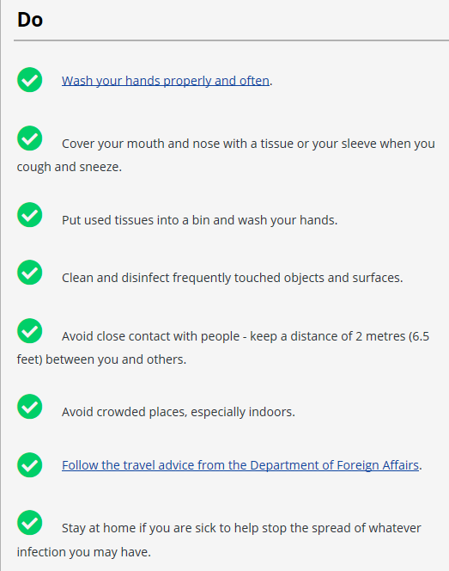
- Careful attention to hand hygiene with provision of hand sanitiser and or hand washing facilities at all entrances (where practical to provide sinks)
- Coughing / Sneezing into tissue / elbow crook
- Visitor notices advising of hand hygiene measures before, during and after visiting
- Visitor notices advising against visitors attending if they have been in contact with COVID-19 cases and if they have fever or symptoms of respiratory tract infection and until at least 48 hours after symptoms have resolved
- While the positive impact of seeing friends and family is acknowledged, this needs to be balanced against the need to keep service users sage and as such there will be the need to introduce visitor restrictions in event of COVID- 19 outbreak. A log of all visitors should be kept.
- Where possible facilitate alternative ways of engaging with friends and family (e.g. Skype / Facetime)
- Appropriate Social Distancing measures being observed by staff and as appropriate for service users within homes/facilities where clinically appropriate
- Careful attention to hand washing with provision of hand washing and hand sanitizer at all entrances and strategic points.
- Contractors on site should be kept to a minimum
- Increase cleaning regime and ensure all hard surfaces that are frequently touched such as door handles, keyboards, telephones, hand rails, taps and toilet fittings are cleaned regularly with a household detergent.

  - If a member of staff if concerned that they may have COVID-19, they should refer to HSE guidance. If advised to self isolate at home, they should not visit or care for individuals until it is safe to do so. Please see appendix 5 for information on workplace exposure. Staff and managers should also refer to Health Surveillance & Protection Centre (HSPC) website for the most current information in terms of recommendations in relation to healthcare workers including derogation for essential healthcare workers. Please see appendix 3 for guidance on self-isolation for staff
  - Regular infection prevention and control training for staff with emphasis on Standard Precautions (including hand hygiene) and including the appropriate use of personal protective equipment.
  - Outings with service users/clients or any care off site should be reduced in accordance with public health advice and policy.
  - Service users health passports should be updated in case of requirement to transfer to another setting or changes to regular staffing. See link for same https://www.hse.ie/eng/services/news/media/pressrel/launch-of-the-hse-health-passport-mission-possible-short-film.html
  - Appoint designated staff to care for COVID-19 resident for each shift. The service should maintain a log of all staff members caring for service users with COVID-19
  - Ideally care equipment should be dedicated for the use of an individual. If it must be shared, it must be cleaned and disinfected between use.
  - Efforts should be made to explain the changes in practice to the service user in so far as possible. To this end, please see appendix 2 which includes some easy read materials which may be useful
  - Prepare a service preparedness plan that reflects staff training in infection prevention & control (IPC) measures, contingency planning for outbreak management including isolation measures and cleaning procedures. These should be in line with HIQA guidance (see appendix 4) This should include;
    - Having a plan for dealing with people who become ill with symptoms including how they will be isolated from other service users & who to call for medical advice (the individuals GP or GP providing cover to the service)
    - Having a plan for how the setting will manage core services in the event of either service user or care staff becoming unwell

4. General advice regarding service users/clients suspected or infected during COVID-19 epidemic in any disability setting
Where resident/ service user presents in these facilities as clinically suspect for Covid 19 status procedures to be applied:
    - As per the current Health Protection Surveillance Centre (HPSC) guidance, contact should be made with the individuals GP if the individual is suspected to have Covid 19 based on having symptoms of fever (high temperature – 38 degress Celcius of above) or chills and one of the following symptoms;
    - A cough (this can be any kind of cough, not just dry
    - Shortness of breath
    - Breathing difficulties
    - The staff member should also contact the service manager. The service manager should contact area Disability Manager also.
    - Testing will be prioritised as follows;
    - Close contacts of a confirmed care
    - Healthcare workers
    - Those in at-risk groups
    - There may be some people for whom the other testing procedures, e.g. testing centres, are not an option. This could include people with particular medical needs but also some people for whom the anxiety of using that avenue could result in behaviours of concern. In such instances, the GP should contact the National Ambulance Service to request Covid- 19 home assessment and testing on electronic health. Alternatively, there may be the option of outreach from local community assessment hub once established & operational.
    - Where possible, the service user and their family should be involved in all discussions with GPs regarding referral of potential cases and appropriate discretion used in the application of clinical criteria to residents being referred for testing.
https://www.hpsc.ie/a-z/respiratory/coronavirus/novelcoronavirus/algorithms/COVID-19%20Risk%20Assessment%20and%20Management%20of%20patients%20who%20phone%20v3.0.pdf.
    - In all service settings, the service user with possible COVID 19 should be isolated while awaiting results with precautions as advised in current guidance using standard precautions. Visitors should be restricted while the individual is in isolation
    - In general, service users/clients who are COVID-19 Positive should be managed in their homes/facilities in line with recommendations.
    - Transfer to hospital/intermediate care is only appropriate where essential i.e. where there is a high likelihood that the person will require and benefit from full mechanical ventilation. Decisions to transfer should be discussed in advance with service user/client, their families/carers in conjunction with their GP & documented. Any service user/client requiring hospitalisation who they believe may have COVID-19 should be flagged with the receiving hospital beforehand to discuss their individual care needs relating to their disability.
    - Decisions regarding care should be individualised to the service user/client.
    - In the case of an outbreak of COVID-19 within a residential service, the service should be closed to all new admissions during time of the COVID outbreak
    - Proactively manage communications with service users/client, staff, families and others. Refer all for guidance from www.hse.ie and www.hscp.ie

Management of service users with confirmed COVID-19 status in residential services (including their own home)

There is currently no ‘treatment’ for COVID-19. The approached taken in managing patients is symptom management. Symptoms which can be managed in a non-clinical setting include temperature management.
- Health Care Assistants are able to provide medication to service users once they are included on the individuals’ prescription. To this end, paracetamol PRN should be added to all prescriptions.
- In general, if single occupancy rooms are available they should be used. If this is not feasible, multiple patients with confirmed COVID-19 can be cohorted into the same room or unit of accommodation
- Service users/clients should be encouraged to drink and eat
- They should be advised to stay in their room as much as possible and avoid contact with others until they have had no temperature for five days and it’s been 14 days since they first developed symptoms.
- Their symptoms should be checked regularly. If they become more unwell their GP should be contacted by phone. If it is an emergency, contact an ambulance and tell them there is a confirmed case of COVID-19.
- While it is discouraged, if a service users has to go into the same room as other people they should try to be in the space for as short a time as possible, and keep a distance of at least one metre (3 ft) away from others and be encouraged to clean their hands regularly & should wear a mask.
- If they can, they should use a toilet and bathroom that no one else uses. If this is not possible, the toilet and bathroom should be kept clean as per specific HPSC guidance i.e. either 2-step clean (using detergent first, then disinfectant) or 2-in-1 step clean (using a combined detergent/disinfectant) is required. Additional information is available at https://www.hpsc.ie/a-z/respiratory/coronavirus/novelcoronavirus/guidance/infectionpreventionandcontrolguidance/RCF%20Guidance%20March%2021%202020%20Final%20noag.pdf
- They should be advised to clean their hands regularly especially before eating and after using the toilet and to follow respiratory hygiene practices as outlined in the boxes above.
- They should be advised not to share food, dishes, drinking glasses, cups, knives, forks and spoons, towels, bedding or other items that they have used with other people in the facility.
- Ideally crockery and cutlery should be washed in a dishwasher (if one is available) or if a dishwasher is not available then wash with washing up liquid. Rubber gloves should be worn to wash the items.
- All surfaces, such as counters, table-tops, doorknobs, bathroom fixtures, toilets and toilet handles, phones, keyboards, tablets, and bedside tables, should be cleaned every day with your usual cleaning product. Follow the instructions on the manufacturers label and check they can be used on the surface you are cleaning. Environmental cleaning/disinfection of self-isolation facilities when person leaves facility

Infection Prevention and Control Measures

Note. Implementing infection prevention and control practice is extraordinarily difficult with service users who are unable to comply with requests from staff. In that setting the only practical approach is to apply the key principles of infection control as much as possible.

If an individual is unwilling/unable to comply with testing for COVID-19 and they are symptomatic, they should be managed as if they have confirmed case as described above.

A specific sub-group is being established to look at supports for those with behaviours that challenge and to make recommendations on how to ensure safety of the individual, staff and other service users

Scenario | Guidance
Management of a service user who is identified as a COVID- 19 Contact  (No symptoms)  This applies to both group settings and situations where a person is being cared for in their own home. It also applies to all levels of support | - In a group setting, service users should be requested to avoid communal areas and wait in their room for their period of observation (until 14 days after exposure) and until Public Health advice confirms the service user can resume normal activity  - If they have to go into the same room as other people they should try to be in the space for as short a time as possible, and to keep a distance of at least one metre away from others and be encouraged to clean their hands regularly.  - If they can, they should use a toilet and bathroom that no one else uses. If this is not possible, the toilet and bathroom should be kept clean.  - They should be advised to clean their hands regularly  - They should be advised not to share food, dishes, drinking glasses, cups, knives, forks and spoons, towels, bedding or other items that they have used with other people in the facility.  - Ideally crockery and cutlery should be washed in a dishwasher (if one is available) or if a dishwasher is not available then wash with washing up liquid. Rubber gloves should be worn to wash the items.  - Service user may go outside if appropriate, alone or accompanied by a staff member maintaining a distance of at least 1m (2m when possible) however unnecessary outings should be avoided.  - Staff members who can avoid physical contact and maintain a distance of at least 1 m do not require apron, gloves or mask but should attend to hand hygiene  - Standard precautions should be used at all times for all service users in particular hand hygiene.  - Staff members providing direct care e.g. changing incontinence wear, assisting with toileting, providing personal hygiene, bathing/showering, transferring a person etc should wear long sleeved disposable gown, facemask, gloves as per standard precautions. Eye protection is recommended when there is a risk of blood, body fluids, excretions or secretions splashing in to the eyes. Where possible limit time (interventions of 15 mins) and distance exposure( 1m)  - Staff members should monitor at least four times per day and record if the resident has developed symptoms of infection  - Testing should be considered for service users who develop symptoms i.e. sudden onset of temperature (above 38C) without other apparent explanation or other relevant symptoms of acute respiratory tract infection  - Testing for COVID-19 is not indicated in service users with long standing stable cough or shortness of breath for which there is an another clinically apparent cause.

Scenario | Guidance
Management of a service user who develops fever (above 38ᵒC) or symptoms of acute respiratory tract infection  This applies to both group settings and situations where a person is being cared for in their own home. It also applies to all levels of support | - In a group setting, such service users should be requested to avoid communal areas and wait in their room until assessed.  - Staff member who observes the symptoms should contact the relevant Person In Charge  - Contact the individuals GP in relation to potential testing  - If testing for COVID-19 is required the GP or Medical Officer will arrange testing either at testing centre or through the National Ambulance Service home testing service.  - Where COVID-19 is not suspected to be the primary cause of symptoms, and testing is not considered appropriate the service user should avoid communal areas until 48 hours after resolution of respiratory symptoms or fever or until another cause of fever that does not requires specific infection prevention and control precautions is apparent  - Residents may go outside alone if appropriate accompanied by a staff member maintaining a distance of 1m if appropriate. If coughing, the resident should wear a surgical mask. If no mask is available, they should be asked to cover mouth with tissue when coughing.  - Staff members providing direct care e.g. changing incontinence wear, assisting with toileting, providing personal hygiene, bathing/showering, transferring a person etc should wear long sleeved disposable gown, facemask, gloves as per standard precautions. Eye protection is recommended when there is a risk of blood, body fluids, excretions or secretions splashing in to the eyes. Where possible limit time (interventions of 15 mins) and distance exposure( 1m)  - Staff members who can avoid physical contact and maintain a distance of 1 m do not required apron, mask or gloves but should attend to hand hygiene  - If testing for COVID is considered necessary, then proceed as below regarding suspect COVID-19 case

Scenario | Guidance
Management when testing of a resident for COVID-19 is considered necessary (Suspect Case)  This applies to both group settings and situations where a person is being cared for in their own home. It also applies to all levels of support | - The service user should be considered as a suspect COVID-19 case  - In a group home setting, every attempt should be made to introduce ‘self-isolation’ for the service user. As discussed previously, self isolation in non-clinical residential services generally mean isolation in the service user’s own bedroom.  - The service user should avoid communal areas but may go outside alone or accompanied by a staff member maintaining a distance of 1m if appropriate. If coughing, the resident should wear a surgical mask. If no mask is available, they should be asked to cover mouth with tissue when coughing.  - In a group setting, group activities should be suspended pending test results. If this is not possible given the overall welfare of residents activities may be conducted with small groups of residents with maintain of social distance as much as possible. (for example unaffected residents may be able to access communal areas or go outside in small groups on a rota basis with avoidance of direct contact or close contact)  - Service users should stay in their room as much as possible and minimise contact with others pending test results  - Service users should be encouraged to perform hand hygiene and respiratory hygiene and cough etiquette  - Healthcare workers working directly with the service user, or within the service should increase their attention to hand hygiene and respiratory hygiene and cough etiquette  - Visiting should be restricted to absolute necessity  - Public outings should be avoided  - Public health should be informed and testing should be arranged according to the agreed process as quickly as possible  - In a group setting, care for the service user who is awaiting testing should be delivered by a single nominated person on each shift. Where an individual is being supported to live at home, the number of carers per 24 hours should be reduced where feasible to avoid additional unnecessary exposure  - In a group setting, if more than one service user requires testing consider feasibility of having one nominated person on each shift care for those service users awaiting testing  - In addition to Standard Precautions, the person caring for the service user should use apron, gloves and a surgical mask when within 1 m of the resident. These should be provided by the service  - The service user should be encouraged to wear a surgical mask if available or otherwise, if possible, to cover the mouth and nose with a tissue when a staff member is within 1 m  - In addition to standard precautions if delivering direct care of the service user (close physical contact), contact & droplet precautions should be applied (staff members should wear a gown, surgical mask, and gloves and eye-protection if there is an assessed risk of splashing of blood or body fluids). Bins for disposal of equipment should be provided by the service  - If the test is reported as negative for COVID-19 management of the service user should be as for other respiratory tract infection/illness

Scenario | Guidance
Management if a service user tests positive for COVID-19  This applies to both group settings and situations where a person is being cared for in their own home. It also applies to all levels of support | - In a setting with more than one service user, all group activities should be suspended. If this is not possible given the overall welfare of residents activities may be conducted with small groups of residents with maintain of social distance as much as possible. (for example unaffected residents may be able to access communal areas or go outside in small groups on a rota basis with avoidance of direct contact or close contact)  - Service user should be supported with respect to self-isolation in their own bedroom.  - The service user should avoid communal areas until 14 days after onset of illness and with five days free of fever (or in line with current HPSC guidance).  - The service user but may go outside alone if appropriate or accompanied by a staff member maintaining a distance of 1m if appropriate. The service user should wear a surgical mask.  - Staff members who can avoid physical contact and maintain a distance of at least 1 m do not require apron, mask or gloves but should attend to hand hygiene  - Service users should be encouraged to perform hand hygiene and respiratory hygiene and cough etiquette  - Healthcare workers should increase their attention to hand hygiene and respiratory hygiene and cough etiquette  - Visiting should be restricted to absolute necessity  - Care for the service user who has tested positive should be delivered by a single nominated person on each shift  - In a group setting, if more than one service user has tested positive consider feasibility of having one nominated person on each shift care for those service users who have tested positive and any patients awaiting testing  - In addition to Standard Precautions, staff who are providing direct care need to implement Contact and Droplet precautions ( apron, gloves and a surgical mask) when within 1 m of the service user for a brief period to perform a simple task  - The service user should be encouraged to wear a surgical mask if available or otherwise, if possible, to cover the mouth and nose with a tissue when a staff member is within 1m.  - If care of the service user requires close physical contact, in addition to Standard Precautions, staff members should wear a gown, surgical mask, and gloves and eye-protection if there is an assessed risk of splashing of blood or body fluids

Scenario | Guidance
Management if more than one service user in a facility tests positive for COVID-19 i.e. potential COVID- 19 outbreak | - Public Health should be informed as soon as possible of all suspected and confirmed outbreaks of COVID-19. (This is a legal obligation)  - HIQA will also require notification (NF02 form)  - Contact should also be made with Disability Operations  - A decision to convene an outbreak control team will be agreed between the Residential Service/facility and Public Health.  - Daily Outbreak Control Team OCT meetings are likely (at least initially) to report on outbreak control measures and updates on potential and confirmed new cases  - Outbreak control measures should be implemented as soon as possible  - Staff must ensure that Standard Precautions are reinforced and Droplet and Contact Precautions are implemented immediately, if not already in place  - Identify appropriate area for isolating and cohorting of isolated cases where possible  - Local hospitals and National Ambulance Service notified (in event of anticipated service user transfer) by senior nurse in charge.  - Identified outbreaks should be notified to GP/ MO/ OOH services  - GP / MO to liaise with local treating acute hospital physicians where appropriate in decisions re transfers  - GP to monitor clinical condition for change and follow national guidance on criteria for hospital/intermediate care centre admission where this is the ongoing treatment plan  - Care planning should reinforce all infection prevention and control measures to cover eventuality of hospital / other facility transfer  - Consider cancelling non-essential outward movement of service users  - Close the facility to new residents and transfers if possible  - Close the facility to all non-essential visitors

Scenario | Guidance
Management of transfer of service user to hospital/  intermediate care for treatment of COVID-19  This applies to both group settings and situations where a person is being cared for in their own home. It also applies to all levels of support | - A person who is COVID-19 positive with severe symptoms should be transferred to an acute hospital/intermediate care centre for management of their symptoms on the advice of their GP/GP assigned to the service. Decision making should be documented in writing. Family members should also be involved in decisions around transfer to hospital.  - Depending on the severity/acuity of their presentation an ambulance should be called.  - Acute hospital/intermediate care centre should be notified about the planned transfer and given summary information on the individual’s current status as well as care needs.  - Family should be notified immediately  - Where feasible, a staff member can transfer with the service user to the hospital, however where this is not possible, a hospital ‘passport’ which describes the individuals needs in terms of cognition/communication etc should travel with them (please see link for information on same https://www.hse.ie/eng/services/news/media/pressrel/launch-of-the-hse-health-passport-mission-possible-short-film.html)  - Individual should be asked to wear surgical mask  - When transferring a person and unable to maintain 1m distance and likely to have direct contact, the healthcare worker should use PPE as described previously. If able to maintain physical distance, the health care worker should maintain hand hygiene but no PPE required.  - Once an individual with COVID-19 leaves the facility the room where they were isolated the room should not be cleaned or used for one hour and during this time the door to the room should remain closed.  - Ensure all surfaces that the service user came in contact with are cleaned.  - The person assigned to clean the room should wear gloves (if available), either disposable latex free gloves or household gloves, then physically clean the environment and furniture using a household detergent solution followed by a disinfectant or combined household detergent and disinfectant for example one that contains a hypochlorite (bleach solution). Products with these specifications are available in different formats including wipes.  - No special cleaning of walls or floors is required.  - Cleaning of communal areas If a service user spent time in a communal such as dining room, reception area, play area, or used the toilet or bathroom facilities, then these areas should be cleaned with household detergent followed by a disinfectant (as outlined above) as soon as is practicably possible.

Scenario | Guidance
Management of service user being repatriated from acute hospital post COVID-19  This applies to both group settings and situations where a person is being cared for in their own home. It also applies to all levels of support | If admission to acute hospital/intermediate care centre for symptom management is indicated, the individual service user should be supported to returning to their residence as soon as they are medically stable and can have their care needs managed outside of the acute hospital setting.  Ideally they should be COVID-19 negative, however if they are still positive they should be managed as outlined in the guidance above

Scenario | Guidance
Management of those with profound disability (in a non-clinical setting). Please note that a separate document outlining care of individuals on nurse led services for those with disabilities | The guidance outlined above applies to those with profound disability. The main differing elements include;  - The need for more than one carer at any given time. As such, the guidance with respect to allocating one carer to the individual may not be feasible. This group of patients also generally require more personal care and as such, maintaining a distance on >1m will not be possible. Where a resident is showing symptoms of COVID-19, steps should be taken to minimise the risk of transmission through safe working procedures. Staff should use personal protective equipment (PPE) for activities that bring them into close personal contact, such as washing and bathing, personal hygiene and contact with bodily fluids. Aprons, gloves and fluid repellent surgical masks should be used in these situations. If there is a risk of splashing, then eye protection will minimise risk. New PPE must be used for each episode of care. It is essential that used PPE is stored securely within disposable rubbish bags. These bags should be placed into another bag, tied securely and kept separate from other waste within the room  - Transfer to inpatient setting is appropriate where this will confer additional benefit and where the medical needs of the individual cannot be managed in the social care setting. Decisions to transfer should be discussed and documented and should be made in conjunction with the person, their families and their advanced care plans if appropriate.  - Ensure in as far as possible that discussions with residents and families reflecting care preferences have been identified, documented and updated.  - The issue of capacity and ability to make decisions around their own care may also be an issue. Support provided to the individual and their family should be in line with assisted decision making legislation.  - Everyone is entitled to access immediate medical care to alleviate distress if this can’t be managed in the care setting. In the case where an individual has an advance care plan, this care can be delivered in a hospital or in collaboration with palliative care services.

Scenario | Guidance
Management of a person who can no longer be supported in their own home (secondary to lack of carer availability) | Please see separate document outlining Covid - 19 Contingency Plan for Home Support Managers and Health Care Support Assistants and Disability Managers/Personal Assistants  Due to the Covid - 19 pandemic there is a risk that normal service could be interrupted and therefore alternatives will have to be explored. It is acknowledged that it will be necessary to work in collaboration with a range of community volunteer organisations and consideration must be given to the optimal and safe utilisation of these services. Work is ongoing in this regard as part of the overall response in relation to Covid - 19.

Scenario | Guidance
Death in the residential setting  When a resident dies (COVID-19 positive)  Coroner  Refer to statement from the Coroners Society of Ireland version1. Dated 11/03/2020 http://www.coroners.ie/en/COR/Coroners%20Service%20COVID-19%20110320.pdf/Files/Coroners%20Service%20COVID-19%20110320.pdf  Communication of level or risk | Use the HSE guidance documents on Verification and Pronouncement and Death. Please refer to your local service policies on Regulation 19 General Health And Regulation 14 Care Of The Dying  As COVID-19 is a new and emerging pathogen it is understandable that those who will be handling the remains will be concerned and may wish to be made aware of the patient’s infectious status.  Embalming  - Embalming is not recommended.  Hygienic preparation  - Any infection control procedures that have been advised before death must be continued in handling the deceased person after death  - Hygienic preparation includes washing of the face and hands, closing the mouth and eyes, tidying the hair and in some cases shaving the face.  - Washing or preparing the body is acceptable if those carrying out the task wear long-sleeved gowns gloves , a surgical mask and eye protection if there is a risk of splashing) which should then be discarded.  Transporting the deceased person  - Bodies should be placed in a body bag prior to transportation to the mortuary as this facilitates lifting and further reduces the risk of infection.  - A face mask or similar should be placed over the mouth of the deceased before lifting the remains into the body bag.  - Those physically handling the body and placing the body into the bag should wear, at a minimum, the following PPE:  - Gloves  - Long sleeved gown  - Surgical facemask  - Play close attention to washing hands after removal of PPE  Once in the hospital mortuary, it would be acceptable to open the body bag for family viewing only. The family should be advised not to kiss the deceased and should clean their hands with alcohol hand rub or soap and water after touching the deceased. PPE is not required for transfer once the body has been placed in the coffin  See guidance document for funeral directors  https://www.hpsc.ie/a-z/respiratory/coronavirus/novelcoronavirus/guidance/funeraldirectorsguidance/Guidance%20Funeral%20Directors%20v1.3.pdf

Appendix 1
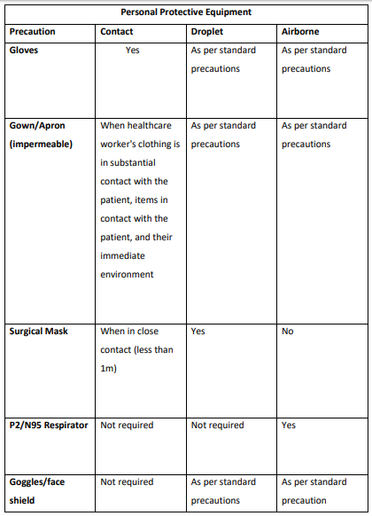
Types of PPE
- Disposable plastic aprons: are recommended to protect staff uniform and clothes from contamination when providing direct patient care and when carrying out environmental and equipment decontamination.
- Fluid resistant gowns: are recommended when there is a risk of extensive splashing of blood and or other body fluids and a disposable plastic apron does not provide adequate cover to protect HCWs uniform or clothing.
- If non- fluid resistant gowns are used and there is a risk of splashing with blood or other body fluids a disposable plastic apron should be worn underneath.
- Eye protection/Face visor: should be worn when there is a risk of contamination to the eyes from splashing of blood, body fluids, excretions or secretions (including respiratory secretions)
  - Surgical mask with integrated visor
  - Full face shield or visor
  - Goggles / safety spectacles
- Surgical Face Masks
  - Surgical Face Masks (Fluid Resistant Type 11R)

- Tips when wearing a surgical face mask
  - Must cover the nose and mouth of the wearer
  - Must not be allowed to dangle around the HCWs neck after or between each use
  - Must not be touched once in place
  - Must be changed when wet or torn
  - Must be worn once and then discarded as health care risk waste (as referred to as clinical waste)

Appendix 2 – Easy Read Information on Standard Precautions & Symptoms
How can I protect myself?
Wash your hands with soap and warm water | 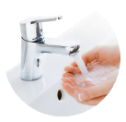
Dont touch your face with your hands
When you cough and sneeze, cover your mouth and nose with your bent elbow or a tissue
Put used tissues into a closed bin and wash your hands
Make sure to keep surfaces clean, especially surfaces people touch a lot
Don’t shake hands
Keep your distance and reduce the amount of time you are close to other people. Don’t go to crowded places

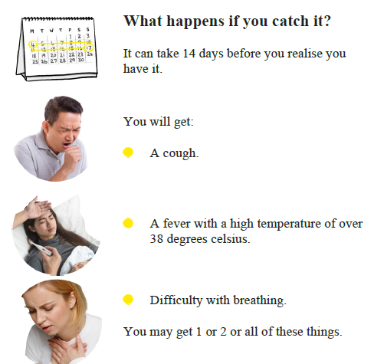

Appendix 3 – Self Isolation Guidance for Staff (HPSC)

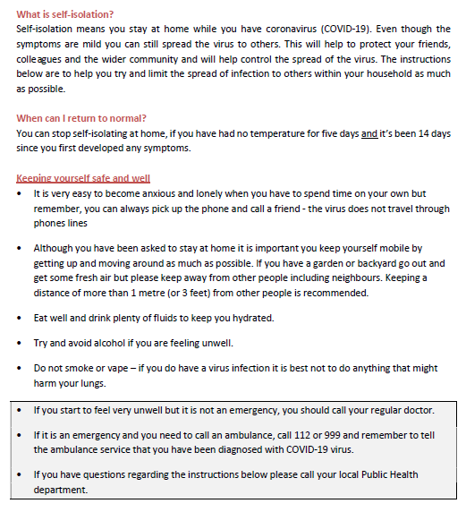

Appendix 4 – HIQA
COVID-19 Contingency Planning in Designated Centres
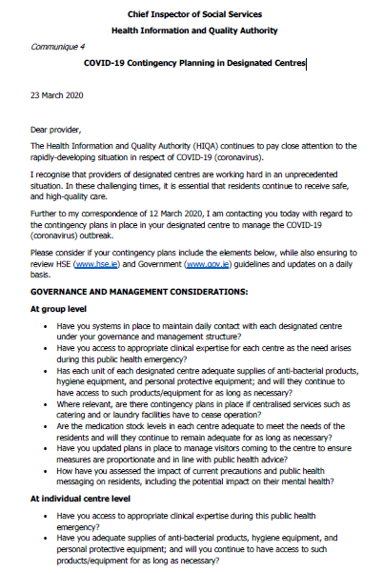
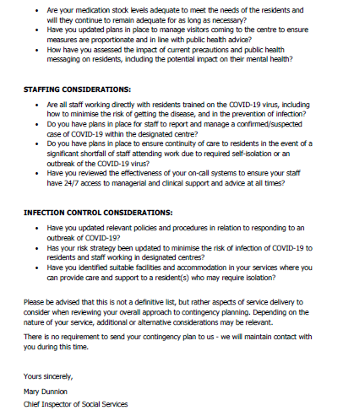

Appendix 5 – guidance on COVID-19 contacts
