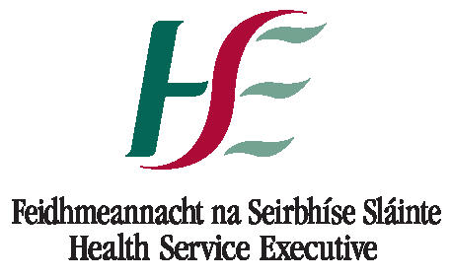 | HEALTH SERVICE EXECUTIVE – SOUTH  DEPARTMENT of PUBLIC HEALTH
SARI FUNDING COMMITTEE CORK AND KERRY
APPLICATION FOR FUNDING : 2015

PROJECT TITLE
PROJECT SPONSORS
TOTAL AMOUNT OF FUNDING REQUESTED
LEAD NAME (for contact purposes)
CONTACT TELEPHONE NUMBER
CORRESPONDENCE ADDRESS

Have you / your team previously applied for funding from the RICC?

If YES, please give details of project and funding amount

Please outline, briefly, the details of the project (further documentation and information may be supplied with this application). Please define how this project is relevant to Health Protection / Infection Control in Ireland and how you intend to apply the outcomes.
E-MAIL completed applications to Ms. Sharon O'Neill, Business Manager, DPH at sharon.oneill@hse.ie OR
POST to Ms. Sharon O'Neill, Business Manager, DPH, Floor 2, Block 8, St. Finbarr’s Hospital, Douglas Road, Cork.

