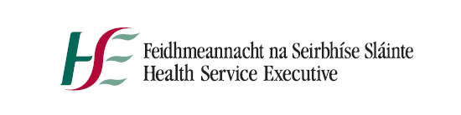
Additional Campaign Information
Campaign MWCH 21.075
Guidance Document NCHD July 2021 Intake

Dear Candidate,
If successful at interview and as part of the recruitment process please note that overseas police clearance is required for all states outside of Ireland that a candidate has lived in for a six month period or more. This documentation is not required at the time of application but in order to avert delay in the hiring process it is advised that these documents are submitted as quickly as possible.

In order to be placed on the correct point of the salary scale i.e. Senior House Officer, Registrar or Senior Registrar if relevant and if vacancies are applicable to a particular grade a verification of previous service letter will be required. This letter from your most recent employer should state
the title of your post, start and end date in the post, point on the salary scale and increment date if relevant. Historical service can also be submitted. This documentation is not required at the time of application but can cause delays in determining the correct point of the salary scale if not submitted as soon as possible.

If successful at interview it is advised that all immigration visas relevant to non EU/EEA applicants
are received and in date so as to avert delays to commencing duty.

Please refer to Job Specification for IELTS/OET English language requirements to be submitted with your application. If exempt please provide evidence of same.

