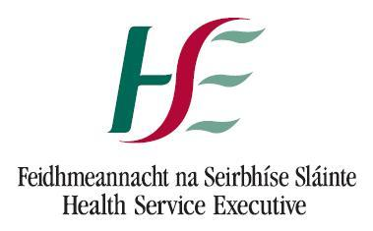

Medical Practitioner System (MPS including NER)
(Formerly the NATIONAL NCHD DATABASE)
SYSTEM ACCESS REQUEST FORM FOR CLINICAL SITE &
MENTAL HEALTH SERVICE USERS
This form is used to grant access to the MPSS. This form must be completed in block capitals by the user and signed by their line manager. Completed forms should be forwarded to the HSE-NDTP, Room 2.41, Dr. Steevens’ Hospital, Dublin 8. Email: doctors@hse.ie
USER DETAILS
Name:
Grade / Job Title:
Address:
Phone Number:
Fax Number:
E-mail Address:

REQUIREMENT FOR ACCESS
Please outline briefly why access to the MPS National Database is required:

USER DECLARATION
I hereby declare that I will use this MPS National Database (including NER) solely and specifically for the purposes of managing the employment, training and registration of NCHDs on my employment site. I shall not use or make available information held on the Database for any other purpose. Neither shall I provide any other individual with access to my account on the MPS National Database.

I understand that if I fail to comply with these requirements or abuse my access in any way that my access rights to the MPS National Database may be withdrawn indefinitely. I understand that all decisions in this regard are at the discretion of the HSE-NDTP and that all such decisions are final.
Name: | Signature: | Date:

LINE MANAGER APPROVAL
Line Manager Name:
Signature:
Telephone Number:
Date:

For HSE-NDTP Unit Use Only
Approved By:
Role Granted:
Date:

