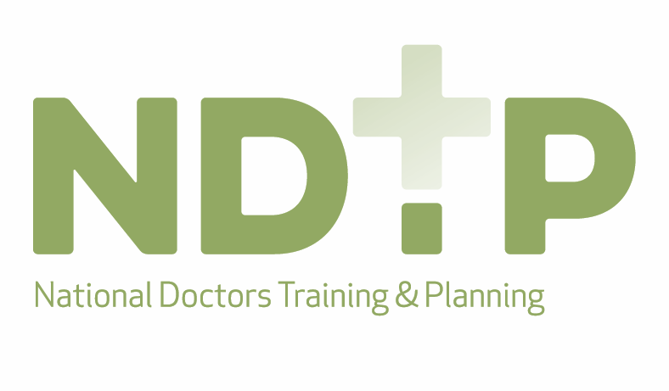

HSE-NDTP Development Funding 2021 Application Form
The HSE-NDTP Development Fund seeks to improve the careers of doctors by funding projects that develop doctors’ knowledge and practice, improve education and training, and enhance learning and working environments. The following form asks applicants to tell us about the overall aim of their project, what they will do to make this happen, and how the impact of the project will be demonstrated. Before completing this application form, please read the accompanying guidance notes to ensure your project is suitable for grant funding, necessary requirements are being met, and for more detail on the terms used in this form.

Please note funding provided under the development funding scheme is once off seed funding and is not an indication or commitment to continued funding for projects and initiatives. Therefore, when submitting applications, please ensure you consider the sustainability of projects.

The application will be marked out of 100, with each question indicating the maximum marks allocated to it.

Category | Marks
Purpose/Need | 20
Project Outcome | 25
Evaluation | 10
Value for Money | 15
Collaboration | 10
Scalability | 10
Sustainability | 10

Development Funding Timetable

Stage | Date
Applications Open | 31st March 2021
Applications Close | 10th May 2021
Panel Meet | Week commencing 7th June 2021
Applicants Notified | Week commencing 14th June 2021
Mid-Project Progress Review | 10th December 2021

Before completing this application form please ensure you read and fully understand:

- the conditions attached to the approval of applications (available at the end of this form) and;
- the guidance notes accompany this application form which outline further information on the process and application form.

Please return all completed application forms by email on or before COB Monday 10th May 2021 thomas.hynes1@hse.ie

Queries may directed to Thomas Hynes – Thomas.hynes1@hse.ie

Development Funding 2021 – Areas of Interest

Each year the majority of applications received for Development Funding focus on core elements of training e.g. moving content on-line, introducing tailored clinical courses, conducting research and initiatives relating to well-being, and the HSE-NDTP has funded multiple projects in these areas and invested substantially. As part of the Development Funding cycle for 2021, the HSE-NDTP would welcome greater diversity in terms of the traditional types of funding applications submitted. The HSE would encourage eligible applicants to think critically about some of the recurring issues facing both our trainees and non-trainees, and submit projects that may address such issues. Some of the preferred projects that the HSE will look favourably at relate to the following themes (this list is not exhaustive):

Theme 1
Developing Clinical Leadership
- The HSE would like to see an emphasis on roles such as Clinician Educators, Clinician Managers and Clinician Researchers and would welcome proposals for competencies/skills required for these roles to be incorporated into training (academic & practical), and perhaps dedicated tracks.
- Projects in the area of enhancing Management & Leadership skills, and competencies within training to provide the Medical Leaders/Clinical Directors of the future. This should be both academic and practical in delivery. A joint application collaborating with all Training Bodies is preferred for this area.

Theme 2

NCHD Welfare/Patient Safety

- Return to work structures for Interns/Trainees/NCHDs doctors after significant periods of absence e.g. due to illness, leave of absence etc.

- Less than Full Time Working (LTFT) – Medicine is an outlier in terms on careers in Ireland where LTFT is encouraged and common place. In addition Ireland is an outlier in terms of LTFT working in Medicine when compared with other Countries e.g. UK which has about 12% of trainees working LTFT. This is a serious welfare issue for trainees and one that the HSE would like to see addressed. Any idea/initiative aimed at increasing flexible working patterns for NCHDs would be welcome. A joint proposal from a TB and clinical site to pilot such initiatives would be optimal.

- Addressing any other obvious/perceived barriers to doctors participating in training. A joint proposal from a TB and clinical site to pilot such initiatives would be optimal.

- Standardised remediation process for doctors to include all relevant courses/certifications in addition to targeted clinical experience. A joint application collaborating with all Training Bodies is preferred in this area.

Theme 3

Equality, Diversity & Inclusion
Ireland has a very diverse population both in terms of healthcare workers and patients. It is thus essential to have a healthcare workforce that represents the tapestry of our communities as it relates to race/ethnicity, gender, sexual orientation, immigration status, physical disability status, and socioeconomic level to render the best possible care to our diverse patient populations. We welcome initiatives that nurture equality, diversity and inclusion in our health service.

Projects in the following areas are preferred:
- Development of EDI training modules for curricula across training bodies
- Practical initiatives to address issues of bias quickly and openly
- Piloting an equality, diversity and inclusion training as part of employee onboarding process at induction
- Developing resources and educational events to support trainers for example EDI training to all examiners at membership and fellowship exams
- Developing educational material on cultural competence training for all staff

Your Project Details

The objective and scope of this initiative is to:

- Developing doctors (e.g. increasing knowledge, skills, practice or professionalism)
- Improving medical education (e.g. curriculum & pedagogical development, trainers’ skills)
- Enhance environments (e.g. new facilities, new equipment)
- Developing Clinical Leadership
- NCHD Welfare/Patient Safety
- Equality, Diversity & Inclusion
- Other _________________________________

Project Name

Brief description of the proposed project

Purpose/Need: Why should we do this? (20 marks)
How do you know this project is needed? What unmet need will be resolved? Please note if the project is aligned to national strategies, identified challenges etc.

Project Outcomes (25 marks)
The outcomes the project is committed to producing, and when. Including specific improvements and changes, sought by your project, who will benefit and by when. This section should provide details of the following - aims and objectives, project endpoint, measurable outcomes and project design / methodology.

Evaluation: Measuring Success (10 marks)
What can be measured to show the goals, outcomes and outputs were achieved? How information on indicators will be collected. Please outline your metrics in terms of success.

Indicators | Measurement

Project Funding/Value for Money (15 marks) Please provide details of funding for this application, and associated documentation to support these costs, such as quotations/estimates provided (where appropriate).

Item | Quantitative Cost
xx
xx
xx
xx
Total
Please outline how these costs represent value for money and a return on investment for the HSE-NDTP.

Collaborating Agencies (10 marks)
Please list all organisations that will work together help deliver this project. Please provide details of the lead person and contact details within each agency.

Scalability (10 marks)
How/can the project be replicated in other regions or scaled up to make a national impact.

Sustainability (10 marks)
Please outline the sustainability of this project after initial development (seed) funding.

High Level Timeline

Project Governance
Please outline the proposed governance of the project including sponsor, stakeholders, project team
- Sponsor:
- Stakeholders:
- Project team (including proposed roles):

Sign off & Declaration (I/We declare that to the best of my knowledge all information and financial costs provided within this application are true and accurate.)
Lead agency
Training Body/Intern Network/Training Lead
Project Lead and Team
E-Mail & Phone Number
Signature of Project Lead
Date
Collaborating Agency 1
Training Body/Intern Network/Training Lead
Project Lead and Team
E-Mail & Phone Number
Signature of Project Lead
Date
Collaborating Agency 2
Training Body/Intern Network/Training Lead
Project Lead and Team
E-Mail & Phone Number
Signature of Project Lead
Date
Collaborating Agency 3
Training Body/Intern Network/Training Lead
Project Lead and Team
E-Mail & Phone Number
Signature of Project Lead
Date

Conditions attached to the approval of applications

- Approval is provided in respect of 2021 unless otherwise stated. Please note development funding provided by the HSE is aimed at providing seed funding for new initiatives and approval of projects is generally for the current training year. Multi-annual funding up to two years may be considered.

- Approval is subject to the Training Body/ University awarded having agreed and signed a Service Level Agreement with the HSE for the relevant period. Confirmation of funding for development initiatives may be provided as an addendum to the previously signed SLAs. Please note this condition is not applicable for NDTP Training Leads.
- Ordinarily, approved projects will be funded on the basis of a 70%/30% split, with 70% of the total awarded initially and payment of the remaining amount subject to satisfactory progress of the project as demonstrated at agreed review points throughout the period, using the NDTP project interim report form.. Funding must be sought from NDTP using the NDTP Development Funding Claim Form. Some projects may be funded to totality upfront in exceptional circumstances.
- Any appointments/assignments made by Training Bodies / Medical Schools / Universities in the context of these programmes and the approval notified must have regard to conditions (1) and (2) above.
- Programmes / outcomes must be evaluated against the stated quantifiable educational and training outcomes as included in the proposal. A copy of the evaluation of each project must be submitted to the HSE on completion of the programme and/or at other intervals as may be determined by the HSE having regard to funding and review arrangements for the particular programme.
- Individual programmes must note in all advertising, course material etc. that these programmes are funded by NDTP.

- Individual Training Bodies / Medical Schools / Universities/Training Leads awarded development funding must agree to prepare a short abstract (300 words approx.) after completion of the project to be utilised by the HSE for information purposes on relevant websites and/or reports.

- Furthermore, Individual Training Bodies / Medical Schools / Universities/ Training Leads awarded development funding may be required to produce a poster of their project/initiative upon its completion.
- Where appropriate, participation in programmes provided by individual Training Bodies / Medical Schools/ Training Leads must be made available to trainees in the other approved training schemes and, where appropriate, on a multidisciplinary basis.

- Individual Training Bodies / Medical Schools / Universities/Training Leads will ensure that robust and comprehensive governance and accountability arrangements are in place in respect of programmes/projects approved under this funding stream.

- Training Bodies / Medical Schools / Universities/Training Leads will cooperate and collaborate with any HSE-appointed representative to liaise with training bodies in relation to individual projects and/or any HSE representative who may be nominated to a project steering group.
- In light of the significant expenditure by NDTP on development funding initiatives, NDTP reserves the right to appoint an Audit Team to conduct an audit of a selected number of approved projects having regard to delivery against approved objectives, participant feedback, costs etc. Each individual Training Body / Medical School / University/Training Lead will fully co-operate and support this Audit Team in respect of programmes funded under this work stream.
- Funding (full or part) for the approved project is not being sought nor has been given from any other public funding source including DoHC, HEA etc.

- Failure to provide a review to include evidence of progression of project may result in the requirement for reimbursement of funding.

- The HSE reserves the right to comment on, and provide input into, all projects funded under the development programme and to request the broadening of access or application of any project. The funding provided in relation to costs associated with development and establishment of projects does not indicate any commitment to further funding associated with on-going costs.

