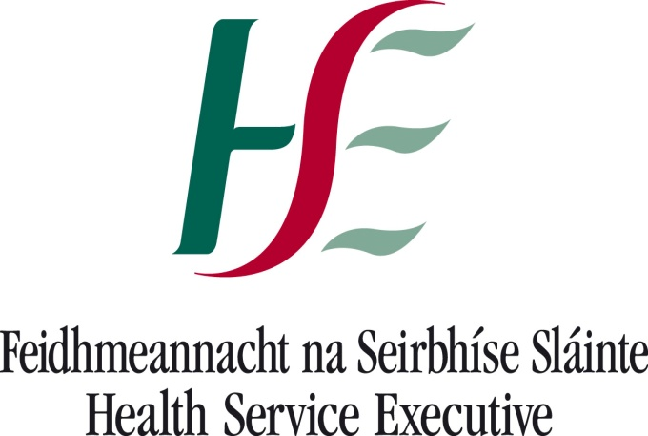

**0**

**LEAD NCHD AWARDS**

**2016**

|  |
| --- |
| The Lead NCHD Programme is a joint collaboration between the  HSE’s Quality Improvement Division (QID) and HSE - National Doctors Training and Planning (NDTP) |

**Purpose of the Awards**

The Lead NCHD role is a new initiative in the Irish Health Service to develop and strengthen the linkages at management level between NCHD cohorts and the clinical directorate/hospital management structures. The Lead NCHD Awards are designed to acknowledge the work undertaken by Lead NCHDs during the course of their tenure on their clinical site.

**Award Categories**

Lead NCHDs are invited to submit initiatives for the awards that they have implemented on their clinical site, during their tenure as Lead NCHD.

The award categories are:

* Enhanced communication between NCHDs and other colleagues
* Local NCHD education/training
* Policy/process development
* Quality improvement initiative
* Patient centred initiative

**Closing Date for Receipt of EntriesC:\Users\louisedoyle3\AppData\Local\Microsoft\Windows\Temporary Internet Files\Content.IE5\36H8TS6T\blockpage[1].gif**

**Thursday 30th June 2016 at 5pm.**

**The Award**

There will be an award of a voucher to the value of €500 for the top three placed entries. C:\Users\louisedoyle3\AppData\Local\Microsoft\Windows\Temporary Internet Files\Content.IE5\OJJUBPOL\blockpage[2].gifC:\Users\louisedoyle3\AppData\Local\Microsoft\Windows\Temporary Internet Files\Content.IE5\PX0KN7MC\blockpage[3].gif

**Judging Panel**

Prof. Eilis McGovern, Director, National Doctors Training and Planning, HSE.

Dr. Philip Crowley, National Director, Quality Improvement Division, HSE.

Dr. Julie McCarthy, Clinical Lead, Clinical Director Programme, Quality Improvement Division, HSE.

**Applications Process**

* Complete the entry form below.
* Submit a poster as a PDF file along with an accompanying abstract (300 words) that explains the initiative.

Poster guidelines:

Applicants are free to represent the following on their poster as they see fit:

1. Objectives of their initiative
2. Implementation of the initiative
3. Outcomes of the initiative
4. The difference the initiative made to the NCHDs on the clinical site
5. Quantifiable/tangible benefits that arose, including any cost savings if applicable
6. How the initiative has been/could be continued on the site
7. How the initiative could be transferred to other sites
8. The name of the Lead NCHD and the name of the Hospital should be included on the poster

Poster dimensions are A1 size (59.46 x 84.09 centimetres) or (23.41 x 33.11 inches).

Posters should be designed in PowerPoint.

Posters should be submitted as PDF files.

Abstract guidelines:

The abstract should cover the first 7 points in a maximum of 300 words.

**Lead NCHD Awards 2016 Entry Form**

**Closing Date for Entries: Thursday 30th June 2016 at 5pm.**

**PLEASE PRINT IN BLOCK CAPITALS**

|  |  |
| --- | --- |
| **Lead NCHD Name:** |  |
| **Job Title:** |  |
| **Hospital:** |  |
| **Time period as Lead NCHD:** |  |
| **Contact phone number:** |  |
| **Email address:** |  |

**Please select category entered: (please select only *one* category per entry)**

Enhanced communication between NCHDs and other colleagues

Local NCHD education/training

Policy/process development

Quality improvement initiative

Patient centred initiative

**To be submitted along with this entry form:**

PDF version of the poster

Abstract of maximum 300 words as a Microsoft Word document

**Submissions can be emailed to: Louise Doyle, Business Manager, NDTP, HSE at** [**louise.doyle3@hse.ie**](mailto:louise.doyle3@hse.ie)