Workplace Breastfeeding Support

By law breastfeeding employees are entitled to 60 minutes time off or a reduction in work hours in an eight hour working day, without loss of pay for up to 26 weeks after birth. Part-time / shift workers are entitled to the same rights calculated on a pro-rata basis.

This time off work may be taken in the form of breaks, where facilities at work exist, or a reduction in the working day, where facilities don’t exist, comprising of:

 | One break of 60 minutes per day  Two breaks of 30 minutes each per day  Three breaks of 20 minutes per day  Or in such other manner as agreed between her and her employer | 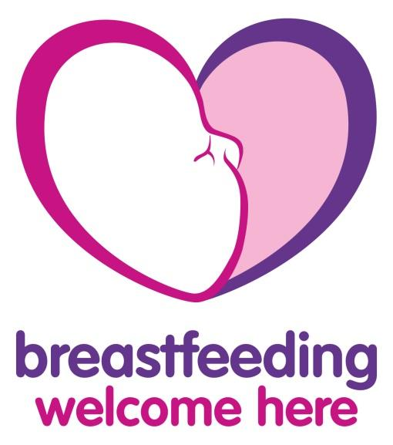

There are many benefits of a breastfeeding friendly workplace, therefore, while currently there is no legal entitlement after 26 weeks, engage with your line manager/ employee about suitable arrangements that work for all parties involved, for example flexible hours, part-time, job-sharing, working from home or parental leave.

A useful guide for parents and employers, Breastfeeding and Work, can be located at:
https://www.healthpromotion.ie/hp-files/docs/HPM00365.pdf
Further help for breastfeeding awareness is available at the following websites:

www.hse.ie/eng/staff/resources/terms-conditions-of-employment/revised-guidelines-on-terms-and-conditions-of-employment-march-2017.pdf

www.hsa.ie/eng/Publications_and_Forms/Publications/General_Application_Regulations/

www.breastfeeding.ie/  www.cuidiu.ie/index  www.breastfeedingnetwork.org.uk/  www.nhs.uk/start4life/baby/breastfeeding/ | 