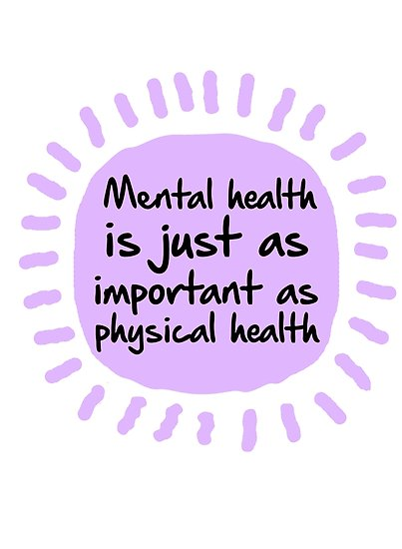 | “Mental health is a most important, maybe the most important, public health issue, which even the poorest society must afford to promote, to protect and to invest in.” (World Health Organisation, 2003)  Take charge of your mental health – Empower yourself
People with mental health problems say that the social stigma attached to mental ill health and the discrimination they experience can make their difficulties worse and make it harder to recover. |  | 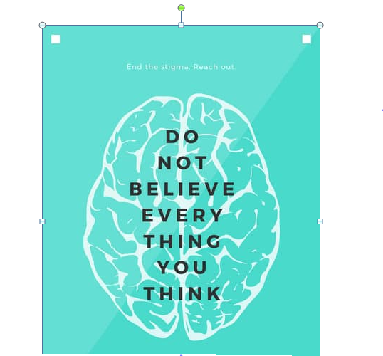
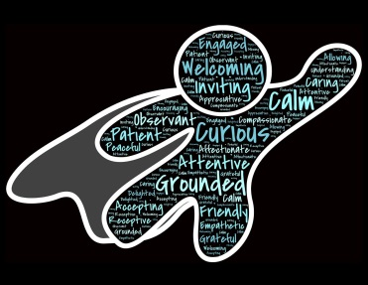 |  | Mental illness is common. It affects thousands of people in Ireland, and their friends, families, work colleagues and society in general.  - One in four people will experience a mental health problem at some point in their lives.  - Around one in ten children experience mental health problems.  - Depression affects around one in 12 of the whole population.  - 450 million people world-wide have a mental health problem.
Most people who experience mental health problems recover fully, or are able to live with and manage them, especially if they get help early on. |  | 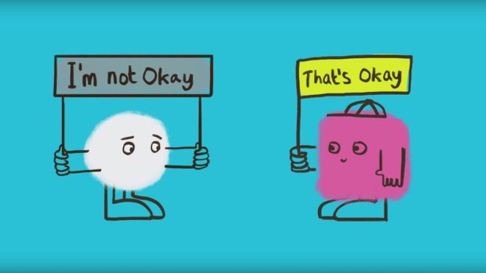
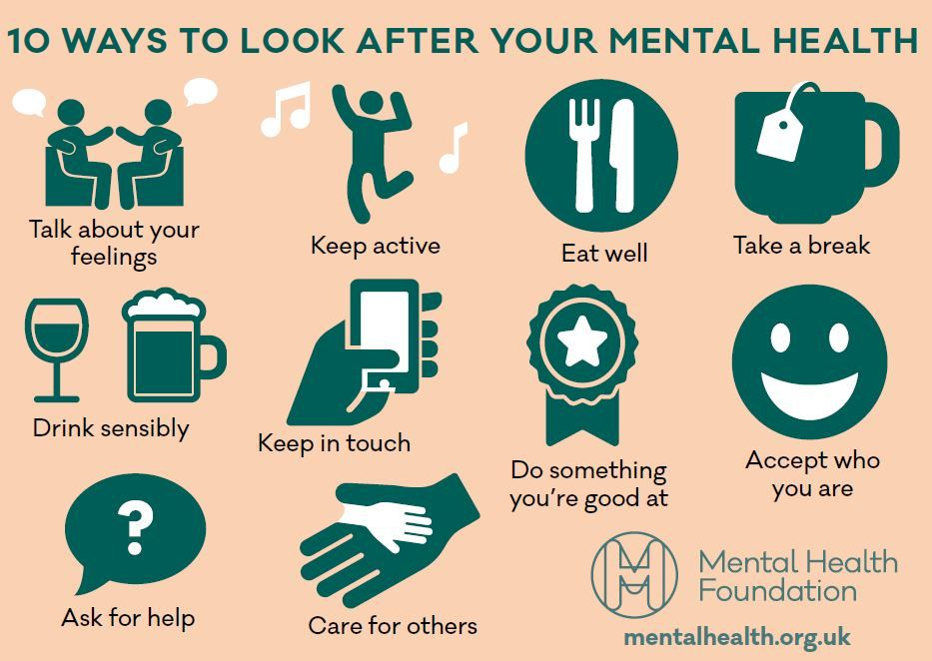
Occupational Health Providers List: Please open link  https://www.hse.ie/eng/staff/workplacehthwellbng/stfsuprts/occhealth/occupational-health-listing-0207.pdf  Employee Assistance and Counselling Service Providers List:  Please open link  https://www.hse.ie/eng/staff/workplacehthwellbng/stfsuprts/eacounsell/eacs-providers-150617.pdf  The Samaritans  The Samaritans  www.samaritans.ie  Tel: 116 123  Text: 087 2 60 90 90  Email: jo@samaritans.ie | 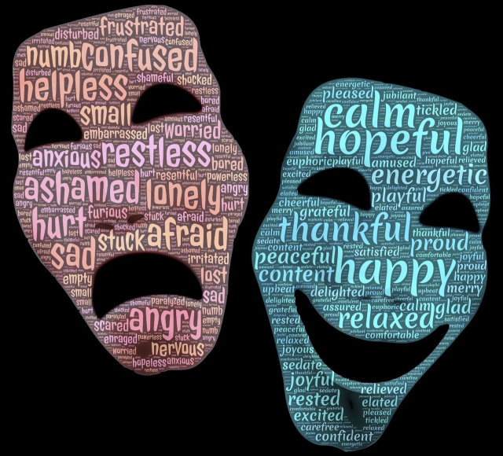 | Aware (Depression & Bi-Polar Disorder)  www.aware.ie  Tel: 1800 80 48 48  Email: supportmail@aware.ie  Pieta House (Suicide & Self-harm)  National Suicide Helpline (Pieta House) 1800 247 247  www.pieta.ie  Tel: 01 623 5606  Amen Support Services Ltd.  amen.ie  Helpline: 046 902 3718  Irish Advocacy Network (Peer advocacy in mental health)  www.irishadvocacynetwork.com  Tel: 01 872 8684

