**MEDICAL CONSULTANT RECRUITMENT COMPETENCY FRAMEWORK**

This recruitment competency framework is for use in the recruitment and selection of permanent consultants in all medical specialities including Anaesthesia, Emergency Medicine, Obstetrics and Gynaecology, Medicine, Paediatrics, Pathology, Psychiatry, Radiology and Surgery. The competency headings are:

1. Delivering Clinical Expertise
2. Leading and Governance
3. Engaging Staff, Patients and Family
4. Improving Future Care
5. Other HSE and/or Medical Council Competency Requirements.

Use the competencies to assess candidates across all the competency areas. This covers the current Clinical, Organisational and Interpersonal requirements for the role as well as the future focussed direction of the role.

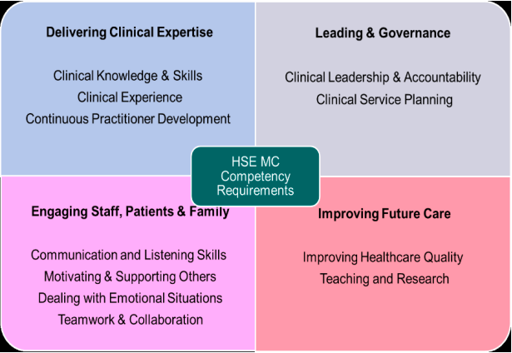

**Skills, competencies and knowledge**

**Clinical Competence – Delivering Clinical Expertise**

*(Incorporating clinical knowledge & skills, clinical experience, Continuous Practitioner Development)*

* Possesses a detailed knowledge and understanding of the relevant specialist domain
* Has a clear understanding of the clinical challenges facing relevant population groups
* Demonstrates leadership skills to enhance patient care and safety
* Applies knowledge effectively to make clear and proactive decisions
* Anticipates rather than reacts; maintains knowledge of current research and practice
* Recognises and respond to the complexity, uncertainty and ambiguity inherent in medical practice
* Has track record of doing things thoroughly in challenging cases / complex referrals
* Adopts a patient-centred approach to understanding patient needs and delivering their care
* Makes a clear and decisive contribution within the multi-disciplinary team
* Regularly engages in further education to develop self and practice

**Organisational Competence – Leading & Governance**

*(Incorporating clinical leadership & accountability, clinical service planning)*

* Sees self as accountable for relevant issues related to clinical outcomes, patient safety, risk, quality, stewardship of resources and change management
* Manages people by providing direction, reviewing performance, motivating others and promoting equality and diversity
* Recognises respective areas of accountability of the CEO, General Manger / Service lead and others
* Efficient and organised; employs effective processes to manage and prioritise workload
* Open and honest; willing to admit mistakes and learns from experiences
* Is aware of resources available and manages these appropriately to ensure the delivery of safe and efficient services
* Contributes to the development of business and service plans to achieve service goals • Reviews and monitors service provision
* Adequately identifies, assesses, manages and monitors risk within their area of responsibility

**Interpersonal Competence – Engaging Staff, Patients & Family**

*(Incorporating communication & listening skills, dealing with emotional situations, teamwork & collaboration, motivating and supporting others)*

* Listens attentively and accurately to others and tailors his/her communication to suit the individual and the situation (oral and written)
* Encourages people to collaborate towards a common goal or vision
* Helps people to identify and develop their strengths, supports people when things go wrong
* Demonstrates self-awareness; understands own limitations
* Manages own emotions and is resilient, remains calm under pressure
* Adopts an inclusive, collaborative approach / understands and respects others’ roles within the wider multi-disciplinary team / treats people with respect at all times
* Sees self as a team member; is willing to take as well as give direction / works within teams to deliver and improve services
* Effectively influences and persuades others

**Future Focused Competence – Improving Future Care**

*(Improving healthcare quality, Teaching & Research)*

* Identifies the contexts for change, demonstrating awareness of the political, social, technical, economic, organisational and professional environment
* Encourages improvement and innovation, creating a climate of continuous service improvement.
* Applies knowledge and evidence, gathering information to produce an evidence-based challenge to systems and processes in order to identify opportunities for service improvement
* Makes sound evidence based decisions consistent with the values and priorities of the organisation and profession
* Measures and evaluates outcomes taking corrective action where necessary and is accountable for decisions
* Contributes to an ongoing process to improve health in the community / population s/he serves, with a strong appreciation of the service user
* Shares learning with colleagues via formal and informal methods (thinking aloud)
* Makes time to coach and support others; shows empathy for the concerns of learners, promotes a safe learning environment

**HSE and/or Medical Council Competency Requirements**

Include anything additional here identified in the HSE letter of approval for the post, the clinical programme for the specialty, organisational requirements, Medical Council specific requirements that is not covered under one of the four main competencies.